**Enhancing Resilience and Social Cohesion among Refugee Women**

**And Combating GBV including Child Marriage**

**Training Manual**

**Why the Training Modules?**

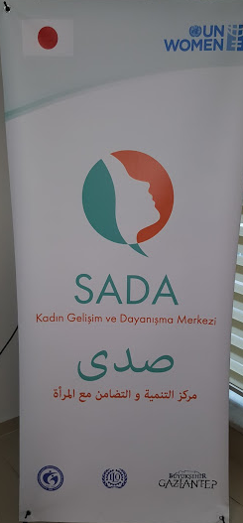The purpose of this basic training manual is to support SADA Women Empowerment and Solidarity Center in their tasks of providing counselling and services for refugee women and girls, as well as other women, in the neighbourhood.

SADA means ‘sound’ in Turkish, and ‘echo’ in Arabic. The aim of the Centre is to give women a voice, and ensure that women and girls actively participant in economic, social and cultural life at the Centre. This will be through the variety of services that SADA offers to Refugee Women, and local women, such as trainings on gender equality, psycho-social support, livelihood and language skills courses. The aim is to encourage women’s participation in social and economic life.

SADA is supported by the ‘Association for Solidarity with Asylum Seekers and Migrants’ (ASAM) and UN Women, in cooperation with Gaziantep Municipality, in partnership with the International Labour Organization (ILO), and financial support from the Government of Japan.

**Background Information on the Project**

The UN Women Project ‘*Gaziantep Women-only Centre: Providing Livelihood Support’*, aims to support the social and economic stabilization of refugee women, and to contribute to their self-reliance and ability to co-exist with women from the host community, by creating a women-only centre/oasis that provides Syrian and host community women with: (i) a protected social space with childcare, referral services and language/vocational/empowerment skills development; (ii) a platform for dialogue, co-existence and the development of joint empowerment activities.

*“I believe that my life will change at this women-only center. With the trainings we receive, I will stand on my feet and look after my children. I am thankful that the Centre supports us. I am not lonely anymore and I have a family,” said one of the beneficiaries of SADA Women-only Centre during the launch.*

The importance of the creation of women-only spaces is to break women’s isolation, give them confidence, help them overcome traumas and make them feel ready to integrate into the social and economic life of their new communities. The space “SADA” provides women with skills development, protection and social support to allow them to recover their dignity and sense of self-worth. That is why this Women-only center is important for refugees.

SADA has been a very important and successful intervention for the beneficiaries. In January 2017, Ms. Yasemin Kalayliolu, UN Women National Gender Training Consultant, interviewed the beneficiaries at SADA to capture their perspectives of the center and understand their future needs.

Beneficiary women expressed that they have enjoyed the current trainings so much that they don’t want to stop coming to the center, leave either their friends or course lecturer after they accomplish the courses.

Ms. Seda Dolaner, Project Coordinator, SADA, explained that the women requested further vocational and life skills trainings, and advanced language courses that will help them eventually to find jobs and better integrate in the community.

**The “Enhancing Resilience and Social Cohesion” training at SADA**

*Plenary Session held with women groups at SADA:*

12 February 2018, SADA: Members of the Syrian Women Committee of the Future (SWCF) network were the first beneficiaries. Established on 16 October 2015, this women movement in Gaziantep came together as Syrian women who were obliged to leave Syria due to the accelerating war.

*When we fled to Turkey, in 2014, we were in a terrible psychological status. The future looked grim and we didn’t know what to do. We started getting together to share our stories, our problems and try to find solutions together. Gradually, we began to feel more empowered, and not just weak and vulnerable. Since, establishment, we meet every week at 2.30, and have never missed a meeting ever since. We are proud that we have become well known. There are several articles that have been written about us. We have been described as a role model women’s association, and hope to become a role model association for the Middle East and North Africa”. (Huda Abdallah).*

In addition to UN Women, several local and UN agencies, including UNHCR, provided us with awareness raising sessions to help us build our self-confidence and self-esteem.

Was it easy for you to get together as a woman group?

The women spoke about their experience in establishing a women’s group. It is a new experience for them at different levels: They have never been in women’s movement before; most of them have never participated in public life; most of them were housewives back in Syria and rarely used to go out; they faced resistance and had to convince their husbands and family members to allow them to participate. It made them stronger and increased their self-awareness and confidence; they conduct a lot of advocacy work in the community, especially among Syrian women who still find it difficult to come out of their houses;

*“It wasn’t easy at the beginning. The family, especially the husband, wasn’t very happy about going out. In the beginning they thought of it as a waste of time. They would say that they are using you, and for nothing.”*

*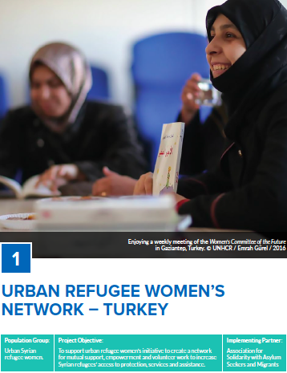“My husband knows how important the Committee is to me, and how I look forward to our weekly meetings. Whenever we have a debate, he blackmails me ‘emotionally’ not to come to the meeting”.*

Whereas another committee member proudly mentioned how she ‘threatened to leave the house, when her husband told her that she couldn’t go to the meetings, and in the end, she got what she wanted and became a member in the committee and attends the meetings on regular basis.

*“Back in Aleppo, most women, in the conservative districts, stayed at home whereas the men went out to work and even do the everyday shopping. That is why I have never gone to the market by myself, whereas in Gaziantep, I have to do my own shopping. At first it was strange and I wasn’t comfortable. Gradually, it became easier, more normal, and I started enjoying it”.*

What are the main achievements of the Committee?

*“What ever awareness rasing training we needed, UNHCR and other organizations provided it for us. We received several awareness raising sessions related to combating GBV, domestic violence, early marriage, reproductive health… etc. We also provided awareness raising to other women”.*

Part of their work and activities is volunteering to get messages and awareness raising across the community members.

*“We developed surveys and questionnaires to draw a good picture of the status of Refugee Syrian Women. We would do house visits, talk to mothers to refrain from marrying off their girls at an early age, and help them find solution for domestic violence and to understand more about their livelihood status. We found that all is much related to each other.”*

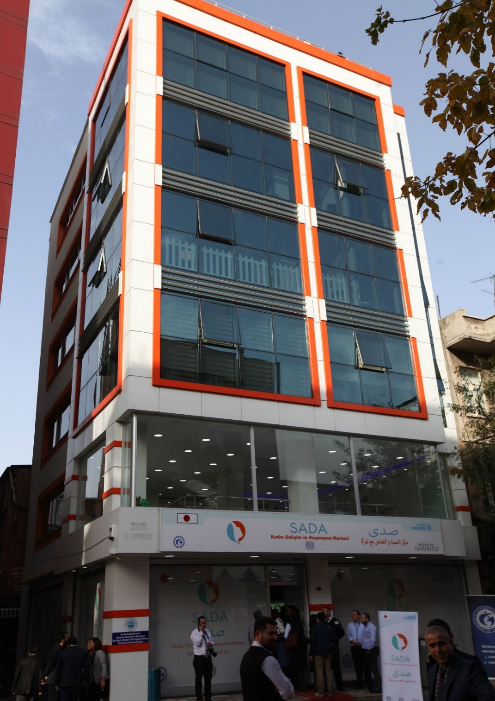The women also had a go at becoming writers, trying to reach their voices and messages across and distributed to as many women as possible.

*“We produced the “Future Women” Magazine with articles that highlight ‘What it means to be a refugee woman’. Articles include stories of women lives in Gaziantep and how they are coping, stories of women who have experienced domestic violence, and an article on Women’s Rights. We hope the next issue will include more articles on Violence Against Women including the negative impacts of Early Marriage”.*

For the 8 March celebration, they will put on a play. “It is the best way to get the message across to our audience. Last year, to celebrate the International VAW Day, we also put on a play. When the women spoke about the different type of violence through the play, many women in the audience started crying. We discovered that there was a stigma

*“This year we also plan to do a musical theme, in cooperation with SADA. We will play songs and music from Syria. We have also asked our Turkish and Afghan friends to play their music and songs. It will be good to get all together”.*

What are your hopes for the future?

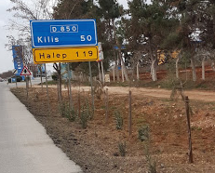Most women expressed their hopes in returning safely to Syria. As most participants are from Halep, they feel nostalgic about the fact that their homes are relatively near, yet they cannot return. However, in the meantime, they are making the most out of their stay in Gaziantep.

*“Now that it is becoming normal for us to go more often outside the house, we want to find work. This will help our families and help to give us more self-confidence and stability. It will also help us to better integrate in the community”.*

The women mentioned several enterprises they hope to start including: ‘A Café Shop for women to come together, drink coffee and chat. Also, a consultation centre for women that provides both legal, social and psychological related consultation in Arabic.

*“Back in Syria, it was difficult for women to start an enterprise outside their homes. Now that we are allowed to go out of our homes more frequently, we have also started dreaming of starting our own enterprise. We have written our own projects”.*

Among the vocational courses that the women requested were: fabric shoe making; soap making and a kitchen to cook their traditional food.

*“There is more hope that women and girl can continue their education both at school and at the University, or by attending courses”.*

Have the men attitude towards the women changed?

Most women noticed that men members in their family have changed, after fleeing Syria and coming to Gaziantep.

“We see change in the men. When the economic situation allows, they support women and girls more to get an education or start an enterprise.”

They have also started to get rid of bad practices, that were considered ‘ok’ among their families and community back home.

“I believe that domestic violence is decreasing. Probably because men know that in this country there are laws against violence that are implemented.”

A number of husbands have even started to assist their wives in their community work.

“When I needed help to reachout to the Syrian community in Gaziantep, my husband called his friends to tell them about the Committee and asked for their help. He actually helped me to do my work, something I never thought he would be interested in.”

The women in the group all agreed that the attitude of men is closely linked to the economic status.

“When a man can find a job and can hence go on and provide for his family, he becomes supportive. When he doesn’t he feels worthless, and this reflects negatively on family members”

What are your training needs?

Based on the identified capacity building needs of SADA beneficiaries, and in accordance with UN Women, a plenary session was held with 16 members of the *Syrian Women’s Committee of the Future (SWCF)*. Different issues were discussed during the sessions including: Women self-awareness and self-confidence in their new community; the new roles and responsibilities they are encountering; how they manage to integrate in the new community; how they can further integrate and help their children and family members to integrate; the role of women in enhancing social cohesion among different groups of refugees and women from the host communities; and their role in enhancing resilience. Other issues discussed included: Child Marriage, Violence Against Women (VAW), men as role models and their role in combating VAW.

The network of 16 members shared a lot of their experiences and stories. They mentioned how they conduct home visits to refugee women, to encourage them to come out of their homes and participate in the different activities conducted for refugee women, to empower them and help them integrate in the community. Hence, they requested more in depth discussions to enhance their knowledge and be capable of further helping other women in the community, especially those who are newcomers and/or have not managed to integrate in the new society. Upon suggestion, the women mentioned that they would prefer a Training of Trainees (ToT) program, as this will enable them to better approach the women who need awareness raising sessions.

*We received several capacity building sessions that helped us to improve our knowledge and reach out in a better way to other refugee women in the society as an effective support group. We still need more sessions to understand issues such as International Human Rights and women’s rights. This will eventually help us to become in a better position to participate in negotiations related to Syrian crisis, especially on the status of women. (SWCF participant, Plenary Session)*

Speaking about social cohesion and networking with refugee women from other communities, SWCF members stated that they would like to get to know women from other communities more. However, there is still a language barrier for most of them. They want to organize a music event together with women from the Afghan community and host community. Each community plays its music and songs to the other communities. After all, music bonds people together.

Discussions during the vocational training class

13 February 2018: A plenary session was held with Syrian Women attending SADA hairdressing class. We selected “Look at the Full Half of the Cup” as the title of our session. The intention was to see how, despite all the problems and challenges we are facing in our new community, there are still opportunities and chances we must notice and make use of, not just for ourselves, but also, and most important, for our children.

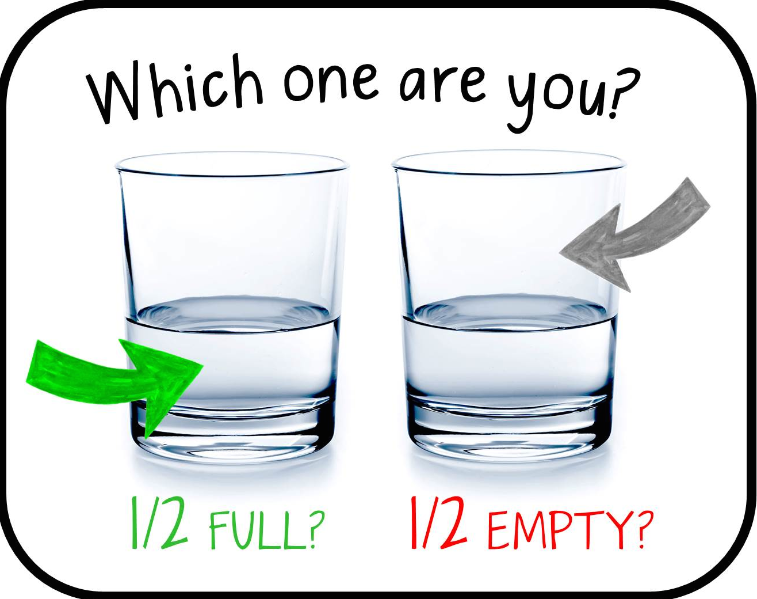Different issues were discussed including integration in the new community, child marriage, VAW, and building solidarity among Syrian and other Women in the community. Several participants mentioned that early marriage was on the rise, especially when they first came to Turkey. This was due to several factors such as: the fact that Child Marriage is widely practiced in a lot of communities, back in Syria, where the women come from “e.g. conservative and rural parts of Halap and Idleb. Hence, most of the women were married off at a young age, and the society expects them to marry off their daughters the same way. However, it was also noticed that the participants, in general, were against early marriage. One of the participants mentioned how she was still in mid school when she was told that she has to get married, although she was doing well at school and wanted to continue studying.

*“Till today, I regret having been forced to leave school to get married. I am trying to prevent my daughter from getting married at an early age. I want her to continue her study, especially now she is in a new society with a lot of new opportunities. I believe there is a need to change the mindset on what is the role of women in the society.*

*(Syrian participant, Plenary Session)*

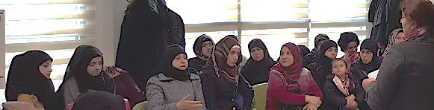

Another important issue raised by the women, during the plenary session, was how coming to Gaziantep provided them with new opportunities and the chance to come out of their homes and become more involved in activities, including going to the markets and even seeking new livelihood opportunities. Most of the women mentioned how back in Syria, they were at home most of the time. Their roles were limited to bringing up their children, looking after the house, cleaning, cooking… they didn’t even go to the market alone. It was very challenging for them at the beginning to go to the market and buy things alone, but now they are happy to be able to participate outside and be more involved. Some women were even able to resume a business they had started back in Syria, or start a new one because they need to contribute to household expenditure. However, they also had to learn the new procedures and requirements to operate a business in the new society.

*I had my own coiffeur shop in Syria for 20 years. When I fled to Gaziantep five years ago, I left everything behind. After a while, I worked as an employee in a coiffeur. It was difficult to work for someone after being your own boss. Eventually, I saved enough money to open a small coiffeur. Yet, I learned that I needed to submit certain papers and certificates. It took me more time than I’ve planned. Eventually, I was able to start my own coiffeur business.*

*(Syrian participant during the Plenary Session)*

One of the participants, a lawyer who had a good position in Halap, mentioned how she had enrolled in the Hairdressing Course because this was one of the few chances to engage with Syrian women in Gaziantep. However, she believes that in addition to vocational training and language courses, there is also a need for

Other discussions raised during the vocational training class

Participants expressed their gratitude to the SADA initiatives for giving them new opportunities and experience:

*‘The Center offered a unique opportunity to come out of our houses. This is something we haven’t done back at home. Most of us just stayed at home all days and never participated in any activities apart from family gatherings’.*

The experience they received goes beyond the mere attending of courses, and the feeling that they are integrating more in the society:

*‘Back at home I never attended any courses. This is my first experience of doing something new’.*

The centre has a multi-purpose role that goes beyond merely providing courses and trainings:

*‘Coming to the center and meeting with the other women has really helped in improve my psychological status. I was in a very bad status before I came to the centre. Talking to other women really helped me to come out of my bad mood and become more lively’.*

It is a place where women feel safe and undisturbed

*‘There is no excuse for the men to not allow us to come since there are no men at the centre. This is a place where we feel safe and the men cannot disturb us’.*

The center is also a place where women receive the information they need

*‘This is probably the only place for information and knowledge for most of us women since one of the aim is to provide women with needed information. Hence, it helps us to understand more about the procedures and papers work we need for our stay in Turkey. ’.*

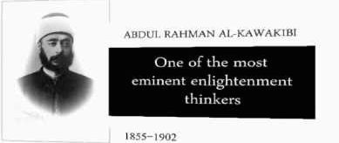14 February 2018: A plenary session was held for both Syrian and Afghan Refugee women. The session took place after the ‘ILO Role Model’ Session. The session was a chance to help Syrian and Afghan women to better understand each other and find common grounds to start communicating together. There were around 30 Syrian and 10 Afghan women in the class. One of the Syrian participant mentioned that language was the main barrier in getting to know and communicate together. Still, a few questions were raised to find out how much the Syrian women know about Afghanistan. Questions included:

*I came to Turkey because it was difficult for women to live a normal life in Afghanistan, to go out, study and find a job. Furthermore, the family control the life of girls, and they determine whom she must marry. Here, I am able to go out, work, and control my life.*

*(Afghan participant, Plenary Session)*

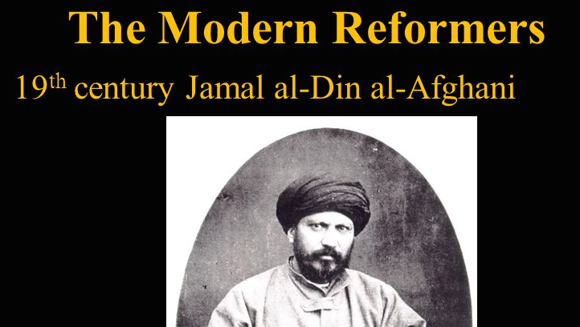*Where is Afghanistan located? How far from Syria? What is the language used? What famous ‘enlightenment’ scholar came to Syria and Egypt? What are some of the famous products? What is the main religion? What is the status of women in Afghanistan?*

The questions were a chance to realize that there are more in common between Afghanistan and Syria, than they realized. In fact, the Syrian women remembered how one of the main intellectual enlightenment figures who influenced the Arab Countries, was Jamal Al-Deen Al-Afghani. His ideology is based on an Islam that relinquish bad traditions, and adopts Western approach to sciences and institution building, as this would help to strengthen Islam. Al-Afghani inspired, and was inspired by, a number of intellects in the Arab World and Syria, including the famous Abdel Rahman Al-Kawakibi, from Halep. Al-Kawakibi also believed that Islam should move forwards in pillars of reason, freedom, and justice. It is only by considering Islam at its authentic best and not in terms of its periods of decadence that a fair assessment of these three aspects of Islam can be made. A religion replete with false beliefs cannot exist in one and the same head with an enlightened mind. Both intellects believed that giving women their rights, including right to education, is part of the overall development of the Society.

Other issues raised during the model session

Violence in the family has decreased, however, men still hold on to their right to be head of the household, which means that he has the last saying in all decisions…

Several women are alone in Turkey, separated from their husbands. They want a divorce but cannot obtain it since the husband is in another country. The husbands have moved on with their lives, but they are still stuck… neither married…. Nor separated.

*“My husband is in Lebanon, he has to go to Syria to officially file a divorce. It is too dangerous and costly for him, and he doesn’t care. He got married again and has kids, whereas I can’t move on with my life…”*

Several women have been exposed to harassment while searching for a job

*‘I wanted to help my son to find a job. However, they will tell me that they will hire young women and not young men. I know because it is easier to control young women and they will accept a lower salary’.*

There is also discrimination against women in terms of payment.

*‘I had to leave several factories before I finally found one that I feel comfortable enough to work in. It was always the same story, they wanted me to work for long hours yet pay me very little, much less than what they would pay men. They know that we refugee women don’t know how to bargain. Most of us never had to work back home’.*

What were the identified training needs?

* The women, especially the new comers, welcomed the idea of awareness raising sessions

*I want to get to know my Afghani colleagues better, however, I have to wait till we learn enough Turkish to communicate together*

* They wanted to know better how to reach out to other women in the communities, to other refugees and women from host communities;
* Most of the women have been here for over three years and have started to change in the way they address issues such as: early marriage, girls’ education, girls’ rights and right to work. They wanted to learn more about the issues.

Other trainings identified

*‘In my family, as it is in most families I know, it is ok for a man to use a bit of violence when it is necessary. This has always been the case. But I’m starting to think this needs to change’.*

(Two Women, in their 50s from Aleppo)

* Self awareness and self confidence
* Building solidarity among women (refugees &Host)
* Gender awareness & Gender equality
* Women’s human rights
* Gender Based Violence (GBV) & early/forced marriage
* Role of men in preventing GBV
* Protection and Prevention of GBV

Self-awareness & confidence

*I really want to help my children to make it through this new society. I want to be strong enough to be able to support them*. (A mother of two young children from Aleppo)

* + Building confidence
  + Building self confidence and self awareness
  + Ability to speak out
  + Support from family/ other women
  + Skills and knowledge (including leadership skills)
  + Helping family members to build self confidence

Building solidarity among women refugee and hosting communities

* Having the needed communication skills

*I believe it would be helpful if we had vocational classes with 50% refugees and 50% hosts. This way we will integrate more quicker and in a better way... However, this needs to be facilitated* (Two women during the hairdressing class)

* Verbal and non verbal communications
* Building trust through sharing stories
* Active listening
* Being non –judgmental
* Talking about grief
* Cross cultural communication

*The Training of Trainees (TOT) Workshop*

19 – 23 March 2018; A three full days TOT workshop was developed and conducted to the 16 members of the Syrian Women’s Committee of the Future. The sessions took place in SADA meeting room from 9.00 – 14.30. Based on a participatory approach, the sessions were a mix of theoretical presentations (Gender, gender roles, gender equality and equity, Human Rights, CEDAW, Beijing Plan of Action, Gender Based Violence…); and socially debated issues were also discussed (Building self awareness and confidence; building solidarity and cohesion among refugee women and women from host communities.

*We are already providing awareness raising to new comers but need to do learn how to do it in a more systematic way; to learn more about gender; and to learn about the international conventions for women’s human rights.*

On the fourth day, the participants divided the sessions and conducted the workshops among themselves. On the fifth day, they conducted the workshop to a group of 20 women from one of the vocational training held at SADA.

|  |  |
| --- | --- |
| 1- Mariam | Self awareness & self confidence |
| 2- Wafa | Solidarity and cohesion |
| 3- Fatoon | Introduction to gender |
| 4- Ratiba | Gender equality/ equity |
| 5- Rawda | Gender roles |
| 6- Zainab | Empowerment/ discrimination |
| 7- Huda Ab | Conflict and conflict resolution |
| 8- Riham | Different forms of violence |
| 9- Ibtisam | Child Marriage |
| 10- Wissal | Human Rights |
| 11- Nibal | CEDAW |
| 12- Fatima | Beijing PoA |
| 13- Mirvat | Gender Based Violence (GBV) |
| 14- Nahla | Men role in combating VAW |
| 15- Zuka | VAW… It’s not OK |
| 16- Huda Is | Role of women as a group |

Hence, the modules are developed based on the needs of the beneficiaries at SADA, and intended to support the empowerment of the women, to create dialogue between refugee women and women living in the region and to strengthen social solidarity.

The exercises

After each session, the participants were asked to do a group work to further enhance their information and develop their ideas. The exercises, with feedback from the participants, were as follow:

*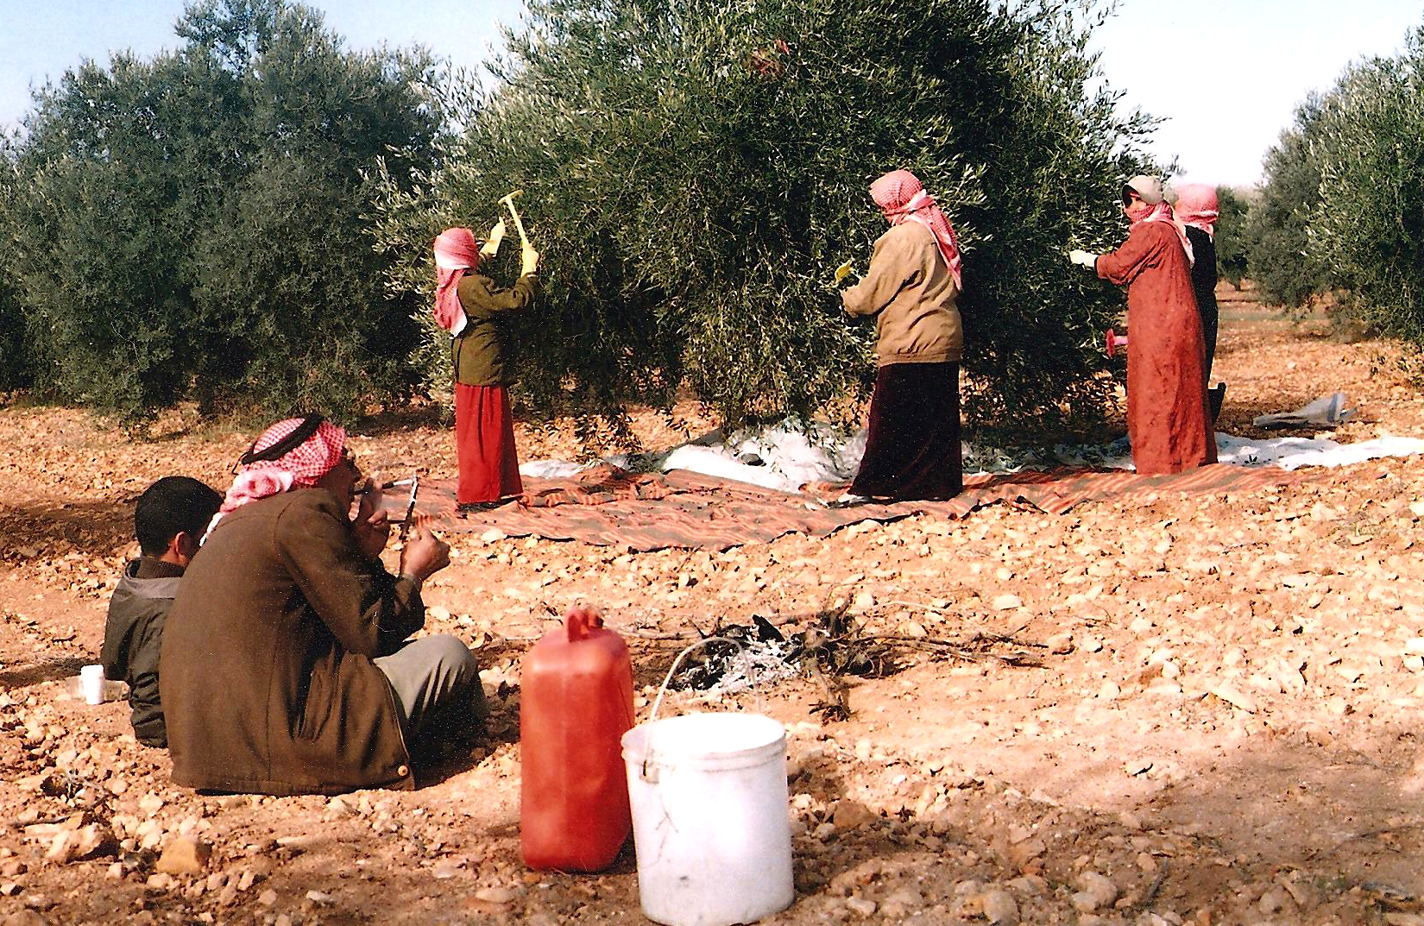What do you think of the following photo?*

The participants identified with the photo. Several women, especially those from rural areas in the north east of Syria mentioned how women were required to do most of the harvest work, while men would watch over, market the product, and keep the money. Hence, women work was mostly unpaid. Furthermore, they also required to continue their everyday work of cooking for the family, cleaning and taking care of the children.

On the other hand, there are other villages, mostly in the North West and around Idleb and Halep, where women do not participate in the harvest, because they do not work outside the houses. Hence, men do all the agriculture related work while women stay at home and do the household tasks.

*You were asked to draft a ‘code of co-existence’ between refugee women and women from host communities, what are the principles you will include?*

* + - Respect the ideas and thought of the others, even when they differ from ours,
    - Respect different religions, believes and way of thinking,
    - 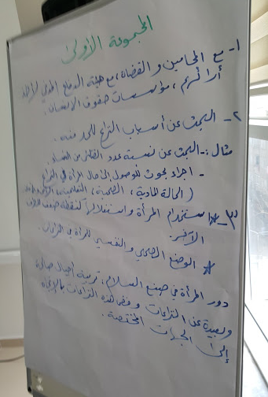Share experience, listen to the others, and try to understand them,
    - Be open minded to different cultures and accept the differences
    - Never judge others, or use their weak points against them, or do harm to them

*In what way does gender inequality impact women/girls?*

1st Group: Economically

Problem: There are less women than men participating in the economy; women are not given the same opportunities as men at work and they are paid less;

Solution: A campaign to highlight the importance of women’s work and ensure that women are given equal access to work, with equal payment and decent work.

To provide more vocational training for women so that they can access work, and open their own business.

2nd Group: politically

Problem: women do not participate in politics and very few women are in political posts. Even after the crisis, there are very few women who are participating in any political negotiations or peace related initiatives.

Solution: More women should participate in politics, and especially in peace negotiations and decision-making

3rd Group: on Health

Problem: Women sometimes don’t like to go to a doctor, if it is a man. Also, because women doctors are still quite new, they still don’t believe in their skills and capacity. This is also because more male doctors than female doctors have the chance to attend meetings and conferences and hence build their skills.

Solution: more equal upbringing between girls and boys to believe in their skills and capacities when they grow up. Give more opportunities to women to further develop their skills and facilitate their participation in conferences, e.g. allow them to bring their kids and have care provided for them.

What are the positive vs. negative impact of early marriage?

|  |  |
| --- | --- |
| Positive impact | Negative impact |
| * + - Marrying of an orphan to protect her     - To run away from violent parents     - To have more kids     - Kids will be at similar age with the mother     - A solution when the war erupt | * + - An orphan should be protected and educated to become independent, rather than marry her off     - Girls may be subject to more violence, if she marry to get away from a problem     - Having kids at an early age is bad for the body,     - Having kids at an early age also decreases the complete feeling of a mother/child relationship     - This coping mechanism has destructive impact on the long term |

What are the roles of men in combating Violence Against Women?

* + - Men could be role models, distributing messages to other men on how it is not ‘manly’ to be violent
    - Men need to know the negative impact of violence, not just on women, but also on men themselves, e.g. becoming more isolated, not being trusted, lose the support of family member, developing a hate relationship… etc.
    - Men could participate in a campaign to stop violence at home, and they can teach their boys to respect girls.
    - Men could help in providing counselling and a chance to listen to other men and conduct group talks

**About the modules**

The 32 sessions of the seven modules are intended to fit the training needs of the above-mentioned targeted groups. Each module contains 4 sessions, and each module requires 1-2 days training (depending on the background knowledge of the participants on the issue, and hence how much time the discussions and working groups will require), eight hours daily. The training uses a participatory approach promoting interaction and engagement in the learning process. The role of the facilitator is therefore to encourage participation without being judgemental. The modules, and hence the trainings, include group work, role-plays. Accordingly, the whole training program requires 10 days.

Each module can be a training program in itself, or a number of modules together, as needed. Prior to the modules, there will be an introduction session to introduce the main terms and concepts related to GBV and the obligation to address it in Humanitarian work.

The training guidelines on **“*How to Design the Training Programme for ‘Enhancing Resilience and Social Coherence among Refugee Women, and Combating GBV including Child Marriage”***is intended to assist different IP and stakeholders, including project staff and legal persons on how to develop a training program to assist GBV survivors, and girls & women at threat of GBV…

The training aims to put the beneficiaries at the centre, not just as mere receiver of information, but also as participants to enhancing the materials through sharing experience and providing case studies, which are relevant to the issue discussed. The exercise further provides feedback and more information from the participants. Accordingly, the modules were developed to reflect and provide more information on the issues discussed as follow:

Designing a Training Programme for Enhancing Resilience and Social Cohesion

Session One: Preparing the training, the techniques and methods

Session Two: The role of the trainer/facilitator

Session Three: Evaluating the training session and follow up

Session Four: Gender related terms and references crosscut across the modules

**Module One: Women’s role in Building Resilience and Social Cohesion**

Session One: Understanding the impact of the crisis on Syrian Refugee Women

Session Two: Women’s Role as potential leaders in their communities

Session Three: Accepting the others

Session Four: Building confidence and self awareness

**Module Two: women’s human rights and deconstructing discriminative gender norms**

Session one: GBV in international framework on women’s rights

Session Two: The Declaration on the Elimination of VAW

Session Three: The national frameworks on EVAW

Session Four: UN Women tools and frameworks on EVAW

**Module Three Girl Child Rights**

Session One: Girl Child Rights in international standards

Session Two: Combating Child Marriage

Session Three: Consequences of Child Marriage

Session Four: Addressing Syrian Women Refugees need in Turkey

**Module Four: GBV basic case management**

Session One: Prevention, protection and response, Addressing GBV

Session Two: Basic case management and psycho-social skills, training skills,

Session Three: Community Engagement and Mobilization

Session Four: GBV Case Managers

**Module Five: Gender sensitization, and the role of men and boys as role models**

Session One: Gender sensitization, and the role of society in addressing GBV

Session Two: the inhibiting notions of masculinity/manhood

Session Three: breaking the cycle of violence: men & boys role to prevent GBV

Session Four: training the police on addressing GBV related issues

**Module Six: GBV Survivors Human Rights**

Session One: GBV survivors and human rights

Session Two: GBV survivors means and approach to access justice and services,

Session Three: empowerment of GBV survivals to overcome trauma

Session Four: States role in preventing Human Rights violations

**Module Seven: developing information, education and communication (IEC) materials**

Session One: developing IEC materials for IPs and stakeholders training

Session Two: The importance of Communication skills for GBV training

Session Three: Developing a Communication Plan to Address GBV

Session Four: Considering different IEC materials to address GBV

**Designing a Training Programme for GBV survivors access to Justice**

Session One: Preparing the training, the techniques and methods



First, and foremost, make sure that the necessary authorization and permits to hold the workshop has been formally obtained, from the local government authorities or relevant ministries.

*The Method of training*

The method of training for each session are to be interactive, geared towards self-directed learning and reflection through work in small groups, 3-5 participants per group. It is recommended to tailor and structure each session in the following manner:

1. **Becoming acquainted with the modules**

During the 30 minutes introduction session, trainers will become more acquaint with the subjects and the modules. They would have already received the agenda and the concept note, at least five working days before conducting the workshop. The facilitator will introduce the main key points and core principles for the workshop in a clear and brief manner.

When preparing the training, facilitators should go through the materials in detail and take into consideration the following regarding GBV issues in the targeted community:

* What words and terms are used, which are culturally appropriate?
* What words and terms cannot be used, which are culturally insensitive?
* Who are the targeted groups, are they at the senior, decision-making levels?
* How much are the participants involved in GBV related issues, including Child Marriage?
* How can the topic be best presented to the targeted group?
* What is the legal framework for GBV in the local/ national context?
* Is the cost of GBV estimated? Are there indicators to assess the cost?
* What services are available for referral in this context?
* What are the available national ‘gender sensitive’ programs and legal frameworks?
* What are the recognized international ‘gender related’ procedures?
* What are the Psychological, social and physical services available for GBV Survivors?
* Have GBV prevention mechanisms been developed?
* What are the procedures within the community regarding confidentiality?
* What are the formal systems available to deal with GBV?

You can also use a checklist to monitor and follow up on the GBV in humanitarian setting

|  |  |  |  |  |  |
| --- | --- | --- | --- | --- | --- |
| **checklist questions to monitor the content of the training** | **Yes** | **Explain How?** | **No** | **Explain Why?** | **Not sure** |
| Are the services - available for GBV survivors - efficient and able to respond appropriately? |  |  |  |  |  |
| Are humanitarian services provided to GBV survivors based on gender equality? |  |  |  |  |  |
| Are services based on: humanity, neutrality, independence, and impartiality provided to GBV Survivors? |  |  |  |  |  |
| Are GBV survivors treated with dignity and respect? |  |  |  |  |  |
| Are GBV survivors given the right to choose their needs? |  |  |  |  |  |
| Are the practical needs of GBV survivors met? |  |  |  |  |  |
| Are the strategic needs of GBV survivors met? |  |  |  |  |  |
| Are GBV survivors told what to do or they provide formal informed consent? |  |  |  |  |  |
| Are minimum standards to response to GBV, especially in emergencies, in place? |  |  |  |  |  |
| Are formal support systems available for dealing with incidents of GBV? |  |  |  |  |  |
| Are traditional support systems available for dealing with incidents of GBV? |  |  |  |  |  |

**2) Main requirements for each session:**

Each session will include:

|  |  |
| --- | --- |
|  | The facilitator will ask ‘open ended’ questions at the beginning of each session to introduce the discussion, and encourage brainstorming.  She/he will also ask questions throughout the session to encourage participants to share information and introduce each topic.  The questions are intended to create a debate and understanding of the different issues related to GBV and women’s access to justice |
|  | The facilitator introduces the main objective of the session briefly and clearly, i.e. what is expected to be achieved by the training activities |
|  | Each session will need around 20 – 30 minutes presentation to be followed by 20 minutes discussion and 30 – 45 minutes of group work. Ensure that the participants stay focused.  Take into consideration the timing and date of the sessions. For example, workshops may need to be held in the afternoon so that those who commute to work in urban centers do not need to miss a full day’s pay to attend, say, 1:00PM-5:00PM, with a tea break, and ending usually with a sandwich or small meal, brought in by the facilitator at the start of the workshop (Massoud 2008). |
|  | The main concepts and terms to be introduced to in each session will be highlighted to avoid ambiguity or misunderstanding among participants. |
|  | There are issues that need to be addressed with caution due to the sensitivity of the topics. Facilitators should be well aware of the norms and tradition of the community they are addressing. They should also be well informed of the facts and figures regarding the topics they are addressing. Make sure that you are in control of the dialogue and that you convey the main messages in the right manner. |
|  | There are a number of related Quotation and sayings that will be used throughout the module. They will help emphasize the theoretical material and show its relevance on ground, |
|  | There will be at least one key group exercise (between 30 – 40 minutes) related to the subject discussed. It requires group work. |
| mage result for powerpoint presentation | Flipchart, coloured papers, felt pen and tape, case studies, and/or exercises. Some group work may require extra materials such as a ball or strings, |
|  | Recapping of main points raised, clarifying remaining questions and summarizing the main three to five key points learned during the session  This will also help the facilitators to understand what was most important ‘and drew the attention’ of the participants for each session. |
|  | Extra reading materials to further refer to and references |

**Session Two: The role of the trainer/facilitator**

Facilitators of the training must have knowledge of local cultural norms and legal framework and procedures. They should have/develop in-depth knowledge in more than one of the following: psychological support,

The role of the facilitator is to design a training program. A training program comprises the curriculum and plans for its implementation to achieve specific training needs. The following are the main elements of the training programme:

* Training needs assessment
* Designing of training curriculum
* Setting the training objectives
* Developing the training content
* Developing the training guidelines

Planning the implementation

* Scheduling the training activities
* Identification of training resources
* Facilitation of training
* Monitoring and Evaluation

*Setting Training Objectives*

The Training objectives describe the terminal behaviour of the learners. It presents what is expected to be achieved by the training activities. They form the framework of the training programmes from where other training decisions are made and particularly determine the following:

* The content (because the content is meant to facilitate the objective)
* The method to be used in order to achieve the objectives

Objectives should be made very clear because of the following reasons:

* To help the learner to have a clear goal during the training
* The trainer should be clear about what the learners should do after undergoing training
* The trainer should avoid gaps and unnecessary duplication
* To help the trainer in selection of approach, methods and materials

Developing the Training Content

Features of training content

The training content should have the following characteristics:

* It should respond to the training needs identified
* It should be pegged to training objectives.

Prioritizing content materials

* Content reflects the objective and prioritized training needs. It should be ranked according to its importance in achieving the training objectives.

Putting content in sequence

Training content should be organized systematically for learning to take place. The following are the main ways of sequencing training content:

* From general to specific
* From specific to general
* Logical sequencing – e.g. simple to difficult
* Frequency – skills the learner uses more frequently

Preparing the Training Guidelines: The eight steps method

Training approaches, strategies and methodology vary from one trainer to another. However, these factors should be considered when developing the guidelines:-

* Focus on the learners’ training needs
* Suggested training methodology should be based on the objectives
* Flexibility of the learning environment
* Time frame for carrying out the training

Suggested Training Methods

The following training methods can be used singly or in combination: brainstorming, discussions, lecture/talk, question and answer, role-plays, case study, demonstrations and training visits.

The following training methods can be used singly or in combination:

|  |  |  |
| --- | --- | --- |
| * Brainstorming | * Discussions | * Lecture/talk |
| * Question and answer | * Role play | * Case study |
| * Demonstrations | * Training visits | * Active listening |

1. Brainstorming

What is brainstorming?

A topic is written on the flip chart. Participants give their ideas on the topic. These are listed on the flip chart. The ideas are then sorted out and linked to the main subject of the topic.

Why use brainstorming?

* To switch the course from one subject and focus on the next
* To examine the width of a subject
* To create a lively atmosphere
* To get 30-40 ideas quickly

When to use brainstorming?

* At the start of a new topic
* When learners are encouraged to come up with new ideas

2. Discussions

Be flexible with the timing and sequence of the discussion phases:

* Reconvene the meeting
* Identify: the meeting; the problems; and the cause
* Identify how the problem could have been avoided, and
* Identify possible solutions

3. Lecture/talk

A lecture is where you stand in front of your audience and deliver the material by talking to them.

4. Question and answer

Why use question and answer?

* To maintain interest in a topic
* To find out about the experience of the group
* To check their understanding
* To help someone come to a conclusion

When to use question and answer

* Whenever you are talking to a group of participants and want to keep everyone involved and thinking
* To introduce a new topic

5. Role play

A role play is a method whereby participants use drama to convey a message. This is in order to have a simulation of a real life situation in an interesting manner.

Why use a role play?

* To allow a player to practice reacting to conflict and other stressful situations
* To gain insight into human interactions
* To help a learner modify his/her own behavior patterns by getting feedback from others who have watched him/her play a role
* To open up communication channels to release some of the inhibitions which may otherwise hinder open and relaxed discussions on some gender issues.

When to use the role play?

* Effective role playing can take place in almost any setting
* Role playing is a very useful training technique, which can be employed in almost any training context.

6. Case study

A case study is where a real-life situation is summarized in the form of a story so that participants can identify the issues in it and suggest appropriate courses of action.

7. Demonstrations

You show the participants a practical example of how something is done and then practice how to do it.

Why use demonstrations?

* To aid understanding by enabling participants to see for themselves how something is done, e.g. gender discrimination in an office
* To show participants how to perform a task e.g. how to engender discrimination in an office

When to use demonstrations

* At any time during the middle of a presentation
* After a discussion of the theory

8. Training visits

Why use a training visit?

* To help participants identify key points by examining a real situation
* To encourage discussions on practical situations
* To learn from others

When to use a training visit

* During the body of a course.

9. Active Listening

* Maintaining eye contact (if this is culturally appropriate)
* Using clarifying questions and summarizing statements
* Avoiding giving opinions or arguing
* Trying not to be distracted
* Focusing on what the person is saying, rather than guessing, or preparing what you yourself will say next
* Using your own body language to convey your attention
* Using words like ‘yes,’ and ‘hm,’ and ‘go on’
* Using appropriate facial expressions
* Keeping your posture relaxed and open
* Being awake and attentive – maintain high energy levels
* Allowing time for silence and thoughts

Working in pairs:

* In each pair, one person takes the role of active listener (helper – GBV Case Worker…etc.), and the other the speaker (survivor).
* The speaker chooses one of the case studies and uses the story as the basis for the role play. It shouldn’t take more than 15 minutes to do a role play.
* Swap roles and do a second role play.

Questions to consider for debate

* How was this different from everyday conversation?
* How did you feel when there were silences?
* Were you more comfortable as the speaker or the listener
* What might hinder you from giving 100 per cent of your attention?
* What factors might enable you to give the speaker your full attention?

|  |  |  |  |
| --- | --- | --- | --- |
| **The training Planning Checklist** | Yes | No | Not sure |
| Have the objectives and outputs of the training been clearly identified? |  |  |  |
| Has a team of trainers been developed? |  |  |  |
| Is your strategic plan turned into work plans? |  |  |  |
| Is the aim a “training-of-trainers” (TOT) to ensure that those who attend ultimately impart knowledge to others in the community? |  |  |  |
| Is your objectives shared? |  |  |  |
| Are your materials/ resources ready? |  |  |  |
| Are your presentations ready? |  |  |  |
| Do you have enough exercises to ensure the effectiveness? |  |  |  |
| Have you identified the target group? |  |  |  |
| Have you identified the venue? |  |  |  |
| Over what timescale will the plan be developed? |  |  |  |
| What process will you use? Will it be interactive? |  |  |  |
| What help are you likely to need? |  |  |  |
| Will you have a budget? |  |  |  |
| Who will sign the plans off? |  |  |  |

The trainer

The roles of a trainer are summarized below:

*Before training*

* To interpret the training programme and curriculum
* To plan and develop the training sessions
* Identify the appropriate training resources
* Decide on the relevant training approach and methods
* Decide on the presentation style and steps.

*During training*

* Setting the training arrangement including the sitting pattern
* Carrying out the actual training
* Guiding and directing the learning process
* Ensuring full involvement and participation
* Controlling the patterns of learning interactions and contributions from the learners
* Carrying out continuous assessment of the way learning is taking place and taking immediate action to retain orderliness and proper learning
* Carrying out an evaluation at the end of each session and module.

*After the training*

* Carrying out an analysis of the evaluation results
* Noting the areas that need to be corrected in future
* Compiling a report of the training.

Getting ready to start a Training Session

When preparing a training session, take the following factors into account

|  |  |  |
| --- | --- | --- |
| **Target group** | **Learners background and their needs** | **Trainer’s Comments** |
| **Objectives** | Why are you giving the session? *(The objective should be clear to you. Avoid vague terms. Use concrete action words).*  What content must your target group know?  What are the main focused messages you want to convey? |  |
| **Content** | What are the topics, which will satisfy their needs and the objectives of the workshop?  What activities will be needed? *(Case studies, exercises,*  *Role play, group work…)* |  |
| **Participants** | Who are your participants?  Are they in Management posts, or able to influence decision-makers?  How much do they know about GBV related issues, especially in humanitarian settings?  How much will they use the information provided at work? |  |
| **Methods** | How will you present the sessions? (Lecturing or  Which methods will you use?  Will there be one or several methods?  Will there be exercises and/or case studies? |  |
| **Duration** | When will the sessions be held?  How long will the sessions take? |  |
| **Venue** | Where will the sessions be held, in a room or in the field?  Are there NGOs/ CSOs where the training can take place? |  |

*Evaluating the Training Session*

Training can be evaluated at three levels as follows:

* After each session
* At the end of the training workshop
* Continuously at the work place

An adaptable sample of an evaluation form is appended at the back of this manual.

The facilitator should introduce herself/himself and her/his assistant(s) in a friendly and professional manner, take 2-3 minutes to describe relevant experience, introduce your assistants, and then ask the participants to introduce each other as follow:

*Example on how to introduce yourself and participants (icebreaker)*

*“Good Morning, my name is …… and I will be your facilitator for this workshop. I am a gender advisor and have ten years of experience in Gender Based Violence issues. I have worked in… and provided training on… I also have experience on the following related topics. Now, I will now ask my two colleagues who will assist me to facilitate the workshop to introduce themselves, and tell you a bit about their role in this workshop.*

*Let us now get to know each other. To do this, I would like you to get into pairs and you have two minutes to ask your partner the following questions:*

* *What is your name, and your professional background?*
* *What are your expectations for this training?*
* *What experience do you have on issues related to GBV?*
* *What is your best childhood’ memory (sharing more personal fun type of information to break the ice and get to know each other more)*

*Now, I would like each person to introduce her/his partner”.*

Clarify expectations at the beginning of the training helps to avoid disappointingparticipants about the training content. The training focuses on certain core elementsand cannot cover everything. If participants are interested in specific areas that arenot part of the training, give them recommendations and advice for further reading ortraining.

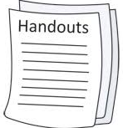Handouts should include a copy of the training program (best to be shared five days before the workshop) and a 1-2 pages concept note brief on the objectives and expected outcomes from the training program, and any other important relevant information such as a briefing on the status of women and girls in the community based on facts and figures. Give a quick overview of the program for the next two days and answer any questions, link the program with the expectations that participants have identified for themselves.

**Session Three: Evaluating the training session and follow up**

Always ensure that the message you want to convey is what you close the discussion with. For example, if the discussion among participants only revolves around ‘how GBV only has negative consequences for survivors, the facilitator should emphasize hoe the negative consequences of GBV effects all members of the household, and even the entire community. The main message with which participants leave should be that GBV is everyone’s problem.

Another example, if the discussion revolves around how women are the ones who instigate violence, the facilitator must intervene and encourage participants with opposing views to speak up. Strongly emphasize that GBV is a result of existing power imbalances between men and women. Violence is not acceptable in any cases or circumstances whatsoever and women should not be blamed for the violence used against them.

Impact of the training

There are four levels of evaluation for training programs known as the *Kirkparick’s Model*, pioneered by Donald Kirkpatrick, past president of the American Society for Training and Development (ASTD)

The participants should ‘in most circumstances’ feel welcomed to contact the facilitator after the course is over if they need further materials and/or assistance in preparing for sessions.

There should always be an ‘Evaluation sheet’ for participants to fill and give their feedback on the training and help the facilitator to further improve the training program

|  |  |  |  |  |  |  |
| --- | --- | --- | --- | --- | --- | --- |
|  | Very satisfied | Satisfied | Undecided | Dissatisfied | Very dissatisfied | **%** |
| Course objectives were clearly explained |  |  |  |  |  |  |
| Course planned and organized adequately |  |  |  |  |  |  |
| Course target met expectations |  |  |  |  |  |  |
| Material used was sufficient and helped to clarify training objectives |  |  |  |  |  |  |
| Exercises and case studies helpful |  |  |  |  |  |  |
| Facilitators are qualified and have full knowledge of the issues |  |  |  |  |  |  |
| Facilitators encouraged interaction and sharing experience |  |  |  |  |  |  |
| Overall quality of the training |  |  |  |  |  |  |

Describe what was most useful about the course

1-

2-

Describe what wasn’t useful about the course

1-

2-

Give suggestions for improvement

1-

2-

**Session Four: Gender related terms and references crosscut across the modules**

**Definition of gender**:gender refers to widely shaped beliefs, ideas and expectations concerning the roles and even appearances of women and men. These include ideas about typically feminine/female and masculine/male characteristics and abilities, and commonly shared expectations about how women and men should behave in various situations. Women are expected to be weak, shy, obliging, caretakers; while men are expected to be strong, confident, self-reliant, decision-makers …etc.

**Gender equality:** is a social condition, where men and women, girls and boys, experience a balance of power and opportunities. In this way they have the same prospects of realizing their human rights, and potential to contribute and benefit from all sphere of society.

**Gender equity:** is the process of being fair to men and women in order to achieve gender equality or to address gender inequalities.

**Gender-based violence (GBV):** refers to any verbal or physical act that results in bodily, psychological, sexual and economic harm to somebody just because they are female or male. GBV happens because one person chooses to exercise power and control over another person. There are four types of GBV: Physical violence, sexual violence, psychological (mental harm or suffering) violence, economic violence, and other deprivations of liberty (IASC GBV Guidelines 2015). Violates a number of universal human rights protected by international instruments and conventions (DEVAW 1993).

**Violence against women (VAW):** refers to any act of verbal or physical force, coercion, or life threatening deprivation, directed at an individual woman or girl that causes physical or psychological harm, humiliation or arbitrary deprivation of liberty and that perpetuates female subordination.

*Gender Classification of Policies:*

* Gender-blind policies: recognize no distinction between the sexes. They make assumptions, which leads to a bias in favour of existing gender relations. Therefore, gender-blind policies tend to exclude women.
* Gender-aware policies: This type of policy recognizes that women are development actors as well as men;

*Neutral, specific, and redistributive policies*

* *Gender-neutral policies* use the knowledge of gender differences in a given society to overcome biases in development interventions, in order to ensure that interventions target and benefit both sexes effectively to meet their practical gender needs. Gender-neutral policies work within the existing gender division of resources and responsibilities.
* *Gender-specific policies* use the knowledge of gender differences in a given context to respond to the practical gender needs of women or men; they work within existing gender division of resources and responsibilities.
* *Gender-redistributive policies*are intended to transform existing distributions of power and resources to create a more balanced relationship between women and men, touching on strategic gender interests. They may target both sexes, or women or men separately.

*Gender related concepts crosscut throughout the modules*

* *Gender Mainstreaming:* a strategy for making women’s as well as men’s concerns and experiences an integral dimension of the design, implementation, monitoring and evaluation of policies and programmes in all political, economic and societal spheres so that women and men benefit equally and inequality is not perpetrated. The ultimate goal is to achieve gender equality.
* *Gender Analysis:* examines the distinct reality of being male compared to being a female and the relationship between males and females

*Why the gender analysis?*

Gender analysis enables us to understand:

* + The different roles, experience, needs and interests of W,G,M,B
  + The constraints and barriers they face
  + How policy and programme interventions impact W,G,M,B because of the differences

In order to:

* + Better inform design and delivery of policy and programmes that meet the needs of all people/target audiences
  + Promote equal participation, benefits from policies & programs

And, at a broader level to:

* + Address and ultimately eliminate discrimination and unequal power relations
  + Enable individuals to realize and maximise their capabilities and choice

Theory of Change on ending GBV including Child Marriage and contribute to community development (according to LEAP)

The Theory of Change on ending GBV consists of a diagram and accompanying narrative. Together they provide an overview of the interventions, outputs and outcomes that can reduce and ultimately eradicate GBV, to map the multiple pathways to tackling GBV and provide a starting point for programmes to develop their own theories of change.

According to the LEAP (learning, evaluation and planning) planning and evaluation cycle, the framework is built on seven critical questions:

1. What is the need we are trying to address?

2. What specifically needs to change?

3. How will we know if change has taken place?

4. What will we actually do?

5. How will we make sure we're doing it as planned?

6. How successful have we been and what have we learned?

7. What now needs to change?

|  |  |  |  |  |  |  |  |  |  |  |  |  |
| --- | --- | --- | --- | --- | --- | --- | --- | --- | --- | --- | --- | --- |
| **Objective** | **GBV survivors, including those who were forced into child marriage have access to justice** | | | |  | **GBV survivors, including girls who were forced into marriage, have access to protection and prevention** | | | | | | |
| **Impact** | Women and girls are free from all forms of GBV, including Child marriage | | | |  | Enhanced safety and security for women and girls from Gender-Based Violence (GBV) | | | | | | |
| **Outcomes** | 1) GBV survivors have increase access to justice  2) Judiciary and legal practitioners capacity are enhanced to work with refugees, to understand their social backgrounds, and assist them to understand and implement the country’s laws | | | |  | 1) GBV survivors access to services increased  2) Favourable social norms, attitudes and behaviours are promoted at community and individual levels to prevent GBV  3) Women’s rights groups promoted to work with refugees  4) Child marriage is combated | | | | | | |
| **Outputs** | Access to formal justice mechanisms, and ensure that law persons are trained on dealing with refugees | | Access to traditional mechanisms of justice, and ensure that it complies with standards | |  | Survivors Access to health service | GBV survivors Access to psychosocial services | | | Increased access to IGA | | Increased awareness raising to prevent GBV |
| **Intervention** | More reach out to vulnerable and isolated groups, especially in rural areas | Implement national policies that complies with Int. standards on addressing GBV | | Raising awareness and capacity building on int. and national law standards of GBV |  | Change social norms, work with media and men to speak out about GBV and change the mindset in regard to prevailing violence | | Economic Empowerment of women and ensure that community is trained to accept women’s leadership | | | GBV survivors are empowered to use available, accessible & quality essential services & recover from violence | |
| **Barriers** | Non integration and isolation in the community | | Dominant social norm still supporting male dominance | |  | Lack of resources or/and lack of willingness to allocate them | | | Lack of data and researches to understand the magnitude of the issue | | | |
| **Problem** | GBV is on the rise as a result of the forced transfer to the new environment, and the lose of livelihood and gradually falling into the vulnerable groups | | | | | | | | | | | |

**Module One: Women’s Role in Building Resilience and Social Cohesion**

*The training on this module is to understand the role of refugee women as agent of change, and hence can help to build resilience and social cohesion in their households, and among other family members, friends and colleagues in their host communities.*

|  |  |
| --- | --- |
|  | *Ask the participants the following questions and facilitate a discussion:*   * *Who are you? And who are you in the eyes of your child, family member, community?* * *Who do you want to be? How can you reach what you want to be?* * *How good am I at communicating with people from my own community, from different communities?* * *What are the ‘personal’ skills I’m missing, and how can I obtain them?* * *What are my bad habits, in terms of communicating to people, from my community, and from different communities?* * *How much do I understand ‘the other’, and how much tolerance do I show towards ‘the other?* * *What do I teach my children about ‘accepting the others’?* |
|  | *At the end of the session, participants will be able to:*   * *Identify their skills and capacity in terms of communicating with other women from different communities* * *Identify their roles/ other women roles in building resilience and social cohesion among member of the family and surrounding community* * *Understand what it takes to build self-confidence and self awareness in themselves to be able to pass it successfully to their children* |
| 100 – 110 | 30 – 40 minutes presentation;  20 minutes discussions, questions and answers,  30 minutes group work*: Code of co-existence between refugee women and women from host communities*  20 minutes presentation of the group work |
|  | Resilience generally refers to an individual’s psychological ability to overcome, learn from and adapt positively to life’s adverse events (Riley and Masten, 2005). Resilience is often seen as the atypical ability to revert or ‘bounce back’ to a point of equilibrium despite adversity. Resilience is also simply defined as “The capacity to successfully adapt to external problems or threats.” (Ryan 2015)  Social Cohesion describes a cohesive society as one which “works towards the well-being of all its members, fights exclusion and marginalisation, creates a sense of belonging, promotes trust, and offers its members the opportunity of upward social mobility (OECD).  Vulnerability is the quality or state of being exposed to the possibility of being attacked or harmed, either physically or emotionally. Furthermore, it is the diminished capacity of an individual or group to anticipate, cope with, resist and recover from the impact of a natural or man-made hazard. The concept is relative and dynamic. Vulnerability is most often associated with poverty, but it can also arise when people are isolated, insecure and defenceless in the face of risk, shock or stress (Red Cross/Red Crescent)  Gendered Roles are the socially ascribed roles for men and women in any given society, e.g. men are the head of the households, they are the breadwinners and hence their role is outside. Whereas women are housekeepers and hence their role is at home, they follow the man.  Transformation of gender hierarchies refer to the changing gender roles as the result of sudden migration or change in the social structure, which leads to women taking on new gendered roles, such as becoming head of the households, and/or becoming the main breadwinner for the family. |

**Session One: Understanding the impact of the Crisis on Syrian Refugee Women**

*Ask participants to describe, in their own words, the impact of the crisis on them? What factors contribute to your, and your families, resilience?*

Why the focus on women refugee?

There is, however, limitation in specific data about resilience of women (in Azraq camp for Syrian refugees), due to the lack of such reports by International humanitarian agencies. Women refugees are not only vulnerable, they are resilient too, and their resilience can impact family Resilience positively (Khalifeh 2017).

A study carried out on the “changing gender roles among Syrian refugees in Lebanon’ shows how … Before the crisis, they had traditional gender roles. They did most of the household chores, even the minority of women who also had jobs outside of the house. Men were mainly responsible for supporting the family financially and made most of the decisions about the running of the household. The crisis in Syria and their new status as refugees has changed these gendered roles. Some women reported having more mobility in Lebanon, mostly out of necessity (El Masri, Harvey & Garwood 2013).

Patterns of mobility and lifestyles have changed, and both women and men are being forced to redefine core aspects of their identities. However, perceived threats to established masculine and feminine identities have exacerbated the stress that women and men are experiencing, with overwhelming feelings of powerlessness and desperation. Furthermore, women’s sense of self-worth is closely linked to their traditional gender role. There are noticeable changes in their roles and responsibilities as the result of the crisis. However, household chores are still to a large majority the responsibility of women’s with added responsibilities.

Hence, women’s experiences in Syria before the crisis and as refugees in Turkey will have an impact on their long-term ability to claim their rights in areas from economic and social independence to political participation. The gender situation and vulnerability assessment aimed to understand the differential impact of the conflict and its consequences on women and men.

Who am I? Am I a strong or weak person?

During the TOT program (19 March 2018), I asked the participants, who were all Syrian women refugees, mostly from Halep and Idleb, to introduce themselves and describe if they believed themselves to be strong or weak. The answers received were as follow:

*“I’m strong, I took on new responsibilities”*… Back in Syria, I never had any responsibilities outside the house. I was the only girl among three brothers. When I came to Gaziantep, I had to rely on myself. I was afraid to go outside. Now, I find myself strong enough to go out and take on new responsibilities.

*“I’m strong, I was got back on my feet”*… Back in Syria, my marriage was a failure, and I felt completely lost and on the verge of breaking down after I got a divorce and was in a totally new environment in Gaziantep. But I knew I had to get back on my feet for my daughter’s sake. So, I pulled myself together and eventually was able to find a job as a translator.

*“I’m strong, I used my skills in the new environment”*… Back in Syria, I was a nurse and midwife with a good career. When we suddenly had to leave everything behind and flee to Gaziantep, I started from scratches. Despite the language barriers, and a bit of unfriendly environment at the beginning, I was able to reach out to the community. Eventually, women started coming to me for injections, pressure checking…etc.

*“I’m strong, I’m more than just a mere housewife to my children”*… Back in Syria, I was a mere housewife and a mom in the kitchen. When I moved to Gaziantep, and as my kids started to grow up in a new environment, I wanted my kids to see me as a strong mum. I joined the Syrian Women’s Committee of the Future. Exchanging stories and sharing our problems together really helped to strengthen me. Eventually, I started writing and one of my articles was published in the Magazine. My friends were so proud of me, so were my children.

*“I’m strong, I made my neighbour change her mind about the Syrians”*… When I first came to Gaziantep, fleeing from Syria, the neighbours weren’t at all friendly. In fact, they wouldn’t even salute us back. I was determined to keep on saluting them with a nice smile, and do everything it takes to win them over. Eventually, they started to warm up, and came for a visit. They discovered that there was a lot in common between us, and soon became good friends. In fact, my neighbour’s son married my sister-in-law.

*“I’m strong, I became involved in community work”*… Back in Syria, I was always at home. When I came to Gaziantep, I volunteered in my Community’s Committee. This really helped me to mix with both Syrian refugees and host communities.

*“I’m strong, I refused to stay in an abusive relationship”*… Back in Syria, I was married off at an early age, and my in-laws treated me as if I was a servant. Unfortunately, I could not have children and for this I was further humiliated by my husband and in-laws. When we fled to Gaziantep, I took the decision that I wanted to start new in this new community, so I fought for a divorce.

*“I’m weak, I don’t have children”*… I have been married for over ten years, and I don’t have children. My husband and family are shaming me for this. I feel very unconfident, and don’t know what to do…

The impact of the crisis on changing gender norms and roles

Before the crisis, most Syrian women had traditional gender roles. They did most of the household chores, even the minority of women who also had jobs outside of the house. Men were mainly responsible for supporting the family financially and made most of the decisions about the running of the household. The crisis in Syria and their new status as refugees has changed these gendered roles. Some women reported having more mobility in Lebanon, mostly out of necessity.

*Back in Syria, my husband was the main breadwinner and I was the housekeeper. After fleeing from our village in Halep to Gaziantep, my husband tried to find work for a year with no success. I on the other hand was able to find a job. Now my husband self esteem is very low, he feels he is not a full man anymore. He isolates himself most of the time, and acts violently towards the children and me.*

*(Participant at the TOT session)*

Patterns of mobility and lifestyles have changed, and both women and men are being forced to redefine core aspects of their identities. However, perceived threats to established masculine and feminine identities have exacerbated the stress that women and men are experiencing, with overwhelming feelings of powerlessness and desperation. Furthermore, women’s sense of self-worth is closely linked to their traditional gender role. There are noticeable changes in their roles and responsibilities as the result of the crisis. However, household chores are still to a large majority the responsibility of women’s with added responsibilities.

|  |
| --- |
| In Jordan, a focus group discussions conducted by ACTED, DRC and UN-Women in various locations (Zaatari camp or urban areas in Mafraq or Karak), have unveiled that the crisis in Syria has played a substantial role in changing what the family expects from both women and men in terms of roles and responsibilities.  The FGDs conducted have revealed that men or boys go most of the times to collect the distributed basic needs as there are not well-organized segregation among males and females at the distribution points.  Women and girls start to get more involved in social and economic life. Many started working outside the home in farms and other types of businesses. Support the male members in buying food stuff from shops. However, there are many restrictions to work of women given certain conditions when the work place is far away from home. Shifting in roles and responsibilities of women and girls at household level has been associated with some protection risks that should be supported by the relevant protection actors (UNHCR). |

More knowledge and understanding of the gendered impact of the conflict on women, men, girls and boys displaced from Syria, will help to offer guidance to humanitarian organizations and host governments on gender-sensitive approaches to needs assessment and programme design. Knowledge in particular on:

* How have gender roles and responsibilities changed – between men and women, and boys and girls – due to the conflict? What gendered implications do these changes have (at individual, household, and community levels)?
* What impact is the conflict having on gendered cultural practices, and how do these differ for women, men, boys and girls?
* How has the conflict affected men, women, boys and girls differently, in terms of vulnerability, livelihoods, protection, security and access to services? What coping strategies do men, women, boys and girls use?
* What gendered effects does the Syrian conflict have on people’s access to and control over resources compared with the situation in Syria before the conflict?

And more specifically, the gendered aspects of key areas of refugees‟ lives, as follows:

*Practices and participation:* including examining the gendered division of labour, gender roles and responsibilities and the extent that women and men and boys and girls are engaged at the household and community levels, based on their gendered roles.

*Perceptions and aspirations:* of women and men, boys and girls, about their roles in areas where they live.

*Protection and safety:* including analysing the specific threats to the safety and well-being of women and men and boys and girls, and how they respond to and cope with these threats, which include gender-based violence and early marriage. Changes to refugees‟ masculine and feminine identities are also explored.

*Access to and control over resources and services:* including livelihoods income, cash transfers and remittances, food, health and reproductive health care, information about availability of services, and school attendance.

*Power and decision-making:* this cross-cutting dimension is assessed based on people’s experiences in the aforementioned aspects. The focus is on analysing key differences between what people experienced in their homeland and what they experience as refugees in Lebanon, principally the following issues:

* Women and men’s roles in production, earnings, reproduction, controlling budgets, decision-making, and marriage and divorce practices.
* How people live, in terms of accommodation, food and nutrition, health, personal relations and presence in the host community.
* What aid people are receiving, how they receive it, and how they find out about their entitlements.
* Family dynamics and the extent to which women and young boys are taking on new roles and influencing heads of households and other family members as a result of their new responsibilities.

Focus on enhancing resilience among refugee women should take into consideration changes in four key areas of refugees‟ lives since leaving Syria:

1. Changes in gender norms, values and identities;

2. Changes in levels of physical safety and emotional stress;

3. Changes in gendered control over resources; and

4. Gendered access to aid and basic services.

Building resilience after overcoming the shock of becoming refugees

According to a study carried out on Adolescent refugees potential to become resilient[1], eight family and community capacities were identified that appeared to promote psychosocial well-being in the adolescent refugees. These included 1) finances for necessities; 2) English proficiency; 3) social support networks; 4) engaged parenting; 5) family cohesion; 6) cultural adherence and guidance; 7) educational support; and 8) faith and religious involvement. Nine protective mechanisms identified were identified and grouped into three categories: 1) Relational (supporting, connecting, belonging); 2) Informational (informing, preparing), and; 3) Developmental (defending, promoting, adapting).

Turkey Regional, Refugee and Resilience Plan (3RP) 2017 – 2018, reveals the following:

Adequate emotional expression, supportive family relations and good peer relations, constituted the main indicators of resilience. It helped to develop children’s intelligence, self-esteem, which are main factors in resilience[2]. According to the Director General for Migration Management, as of September 2016, 21.42% registered Syrians were girls, 25.36% were women, 23.26% were boys and 29.96 were men. Specific gender disaggregated data for sector analysis is limited, challenging the gender mainstreaming in the planning across all sectors.

As the refugee situation becomes more protracted, support to national and local systems, with a strong focus on supporting women, children and youth, remains critical to strengthen resilience, and to address the increase and change in demand for services.

During 2016, protection actors conducted participatory assessments with refugees through an age-gender and diversity approach. The assessments identified the following main challenges refugees are facing: language barriers, lack of information, inconsistent implementation of regulations and policies, restrictions to movement, access to services, as well as lack of durable solutions, including resettlement. Negative coping mechanisms such as child labour and child marriage, were also identified. The assessments found that further protection focus is required on issues such as outreach, community engagement for protection monitoring and youth empowerment, with a strong gender perspective, ensure equal access to services to women, men, girls, boys.

Enhanced awareness-raising and access for refugees to legal aid services, assistance and counselling will help addressing GBV issues, including human trafficking, which have been systematically underreported due to fear of stigmatization.

**Session Two: Women’s role as potential leaders in their communities**

*Ask the participants to identify what their role is in their households and communities?*

The status of Syrian Women Before the Syria crisis:

The situation was pretty better, where all of them were having houses, lands and private WASH facilities, access to water and sanitation network, enough and good water quality. Also they got used to purchase brand new clothes in Syria. Had all of what they need from hygienic items such as soap, shampoo, cleaning materials, towels and others They were also doing household farming and consuming the vegetables that they were growing in their gardens and therefore, do not purchase from outside markets.

The men were the ones mainly responsible of securing the income for the household in Syria and they were working in various jobs, mainly farming; governmental sector, some had their own shops. As such, the socioeconomic situation was much better back home in Syria before displacing to Jordan.

The cultural roles and responsibilities among women and men in Syria are simulated to what they are in the traditional Arabic culture, where men are usually are the ones financially responsible of households while women get used to have the roles of taking care of the family and children.

Six years of civil war and multiple displacements have triggered fundamental shifts in Syrian gender roles and responsibilities, both in Syria and in neighboring countries. Syrian women are seeking more roles to improve their livelihoods especially the female headed households through engagement in economic activities to meet the basic needs of their families from shelter to food to basic non-food items such as winterization kits.

Generally speaking, women and girls face specific vulnerabilities during flight as a result of forced displacement due to the wars and conflicts. Some of which includes; Increased risk of sexual and gender based violence and lack of gender sensitive services and humanitarian assistance. The changes in the roles among men and women have had an impact on the relations among the couples at households and it may lead to some problems due to the changes in the power dynamics, mainly the gender based violence. However, none of the women participated in the FGDs expressed that they have suffered from GBV or any kind of domestic violence due to their enrollment in economic activities outside their homes.

Inadequate assistance may result in women prioritizing the needs of their husbands and children to the detriment of their health and well-being12. Difficulties in providing support to populations in camps and transit areas: lack of clear information, lack of time and privacy to build trust with women may hamper women and girls from accessing basic services and leaves them more vulnerable.

After the Syria crisis and displacement:

As the conflict in Syria is in its Six year, millions have been displaced internally inside Syria and externally in nearby countries. In a study conducted by Care International in March, 2016, it was found that up to 35 % of households in neighboring refugee -hosting countries are female-headed10. 22 % of women were active in economic activities in 2010 before the crisis.

Restricted access to livelihoods due to the war and the displacement of Syrian refugees have opened windows to make shifts in gender roles and acceptance for the participation of women in social and economic life. The length and nature of the conflict itself enforced families to switch from their traditional thinking and accept for women to have more access to services such as education, markets and jobs[3].

Coping strategies

Food security remains one of the most pressing challenges to be addressed in Turkey. Women and children represent more than 70 percent of Turkey’s refugee population, requiring targeted food security and nutritional support. Syrian refugees remain in dire need of support to cover immediate needs, alongside delivering results with longer-term impact to achieve adequate levels of food security and resilience of individuals, communities and institutions. The Food Security Sector reached approximately 338,163 Syrians in 11 provinces (2016), through a combination of cash-based interventions, in-kind assistance and hot food kitchens. Food security monitoring findings demonstrate significant increases in acceptable food consumption scores and higher levels of dietary diversity. Support also resulted in more balanced livelihoods coping strategies and better gender dynamics on how assistance is utilized at the household level, with women playing 48 percent more decision making roles than men on food management, utilization and consumption (Turkey 3 RPR 2017-2018).

Potential for increasing women’s empowerment

Of the 2,750,000 Syrians refugees residing in Turkey, 300,000 reside in camps, and 2,450,000 live within host communities.

Although many women feel that they have lost their female identity, others felt that taking on a different role also created a sense of empowerment. Women’s extended role can lead to them having more influence over household decisions.

Personal qualities such as optimism, adaptability and perseverance helped them to cope and survive. A belief in one’s own inner strength to deal with life’s challenges, a positive attitude, and having hope for a good future helps refugee women to cope. The determination to cope is via taking control, rather than being a victim. Looking ahead to the future strengthens refugee people’s resilience, especially to support children for a better future.

Family as a key factor in building their resilience

Apart from personal qualities being linked to refugee resilience, external forms of support were also prominent in the construction of resilience. A number of qualitative studies emphasised the importance of family (including extended family), friends, and community in bolstering refugee resilience in the resettlement process. Support included both the reciprocal processes of giving and receiving support.

In some cases, and apart from receiving support from friends and family, refugee people also utilised their own ethnic community to help them cope and adjust to their new way of life. Mixing and having a strong attachment with their ethnic peers, assisted young refugee people to cope with resettlement, and was associated with significantly “greater levels of well-being in the psychological, social and environmental domains.

Qualitative research with single refugee women found resilience building is connected to ‘person–environment interactions’, rather than being linked to static, individual-inner traits. Moreover, the women’s narratives suggest resilience is underpinned by a dynamic process, which is fluid, contextual and constructed continually throughout ordinary, day-to-day processes involving challenges and opportunities.

Study with service providers working with refugee women experiencing violence, also confirm that resilience is a process rather than a fixed inner personal characteristic.

On the other hand factors, which challenged resilience in refugee people include: language barriers, racism and discrimination and labelling or trauma stories.

If practitioners continue to focus on the trauma aspects of a refugee people’s lives, then the factors for building resilience in refugee people will most likely be denied. One way to ensure our practice focuses on the construction of refugee resilience is by utilising strengths-based practice approaches.

Strengths-based frameworks can assist practitioners to identify refugee people’s strengths and resources and assist them in mobilising pathways to build resilience[4].

Support provided to Syrian Refugees in Turkey

Since the beginning of the crisis, the government of Turkey took full responsibility of funding and managing the camps through its national disaster agency AFAD (Disaster and Emergency Management Presidency). Under the overall guidance of AFAD, few NGOs, namely IHH (Humanitarian Relief Foundation) and Kızılay (Turkish Red Crescent) were given access to the camps along with UNHCR in 2012 and some other UN agencies on a very limited basis. Some of the examples on the practices of UNHCR is organizing events to raise awareness about work permit regulations and livelihoods opportunities. UNHCR supplies teaching material and child friendly school kits to community centres, which the content of the material is developed by DGMM (Directorate General of Migration Management). UNHCR is also delivering wheelchairs and winterization items to the camps as well as urban settlements[5].

Turkey has taken a number of steps during the last five years towards regulations that aim to create an attractive economic environment and to facilitate the application process of work permission for foreigners as part of the policies and practices of inclusion of migrants and refugees into the wider societal environment in the country.

International organizations including UN agencies, BPRM, ECHO as well as international NGOs such as DRC and Mercy Corps have funded community centre projects that are usually implemented by their local Turkish counterparts.

UNICEF is providing incentives to Syrian voluntary teachers and training them on pedagogical techniques, classroom management, and psycho-social support.

WHO is training refugee doctors and nurses for their smooth adaptation in the Turkish health system. They are organizing trainings and workshops in collaboration with Ministry of Health on specific issues related to Syrian refugees and expanding their outreach WHO will be responsible for supporting six of these centres that are located in areas densely populated with Syrians. IOM is also active in this field by funding two multi-purpose community centres and a primary health clinic in Istanbul through its implementing partner NGOs: IBC (International Blue Crescent) and SSG (Syria Social Gathering), Doctors Worldwide Turkey (DWWT)[6].

Supporting Refugees access to Education

Out of the 625,000 Syrians school age children in Turkey, only 290,403 Syrian children were enrolled in the 2015 – 2016 academic year.

As part of EU’s commitment to provide 3 billion euro in financial assistance to Turkey under the “Facility for Refugees in Turkey”, 1.2 billion euro has been contracted to various UN Agencies and international organizations including UNICEF, WFP, UNHCR, UNFPA, Danish Refugee Council, Concern Worldwide, IOM, Deutscher Akademischer Austauschdienst (DAAD), Search for Common Ground, and Gesellschaft für Internationale Zusammenarbeit (GIZ)27 . Turkish civil society organizations are involved in the process mainly as sub-contractors. The EU Regional Trust Fund, in response to the Syrian crisis, has allocated 36 million euro to UNICEF, out of, which 33 million has been spent on the education of Syrian refugee children. Another 2.7 million under the EU Trust Fund has been contracted to Deutscher Akademischer Austauschdienst (DAAD) for “providing opportunities and perspectives for Syrian refugees in higher and further education sectors (scholarships, credit-based courses, personal and virtual education and language classes)”. Under IPA funding, 300 million euro has been contracted directly with the Ministry of National Education to be spent for educational purposes such as language training in both Turkish and Arabic as well as providing stationery, educational materials, clothing and transportation services. Moreover, a measurement system will be developed to monitor the achievements of Syrian students. IPA funding also supports other projects on health services, socio-economic support, municipal infrastructure and project preparation facility.

What is needed is integration and livelihood opportunities

It appeared that the initial stages of the refugee flows and settlements in Turkey required more specific direct interventions such as humanitarian aid and cash assistance to the refugees. Hence not only the Turkish state but also other giving actors, various nongovernmental and intergovernmental organizations engaged in such interventions. However, when all evidence pointed to Syrians’ protracted displacement, it was seen that the continuation of “cash aid type” arrangements would increase refugees’ dependence and prevent them from becoming active contributors in local economies. In this context, providing refugees with employment opportunities is very key to their well being and welfare of communities they live in.

There have been increasing economic activities and rising cash circulation in the provinces of the southeast Turkey where there is a heavy concentration of Syrian refugees for the last five years.

Policy makers seem to focus on the integration policies and regulations on the labour market more than the social inclusion of refugees[7].

Responding to changing gender norms, values and identities

Programmes with Syrian refugees and Palestinian refugees from Syria need to engage women and men in efforts to explore how the crisis is changing gender identities (both masculine and feminine roles), building on local and regional knowledge and experience of engaging men in such activities. People‟s fears of changing roles and gender identities need to be explored in a supportive way, which can be an entry point for changing attitudes to women‟s participation in economic and political life and also for changing social norms, such as fewer restrictions on their social mobility.

Programmes should be informed by and utilize refugees‟ skills and capacities as well as meeting their needs. Aid organizations, government bodies, and others involved in the response should promote equal access to income-generating programmes and other benefits for women and men. Programmes – including cash transfers – should target women as well as men and be paid to female beneficiaries where necessary to ensure that targeting mechanisms do not overlook women’s needs due to their literacy levels, lack of assertiveness, or social restrictions on their activities. Special provisions should be made for widows, divorcees and other groups of women who may be especially at risk.

**Session Three: Enhancing resilience and Social Cohesion**

**Among refugee and host community women**

*Ask the participant how they believe they can relate to women from different countries in their community?*

Accepting the others

Resilience generally refers to an individual’s psychological ability to overcome, learn from and adapt positively to life’s adverse events (Riley and Masten, 2005). Resilience is often seen as the atypical ability to revert or ‘bounce back’ to a point of equilibrium despite adversity[8]. Resilience is also simply defined as “The capacity to successfully adapt to external problems or threats.” (Ryan 2015)

Current literatures on the status of refugees are not just referring to women refugee as vulnerable, but are also seeing their resilient potentials (Khalifeh 2017).

Vulnerability is into five essential components: “initial well-being, self-protection, social protection, livelihood Resilience and social capital”. Moreover, it is acculturation rather important to understand that these five factors exist within the context of other factors, which also affect vulnerability. These factors include the class of the vulnerable individuals or groups, their gender, ethnicity, age and their political positions and stands within their communities. From these essential factors, gender became known as a key determinant that can interact and influence the other different factors. (Islam, Ingham, Hicks & Manock 2017)

The recognition of women by the United Nations as one of the most vulnerable groups emphasizes the importance of studying women’s Resilience in depth as an essential element of refugees’ communities. More precisely, women refugees living within a refugee camp context have even a more particular case. (Lenette, Brough & Cox 2013) argue that studying the Resilience of women refugees in a camp setting requires observation of their everyday lives to understand their Resilience in action, as the fact that they still carry themselves daily is in itself an achievement and an essential indicator of their Resilience. (Lenette, Brough & Cox 2013: 640) More particularly, and according to Paat (2014), women’s behaviour in relation to Resilience is often influenced by six main factors: “(1) acculturation, (2) cultural mechanisms, (3) mental health, (4) structural elements, (5) legal contexts, and (6) social support” (Paat 2014)

Lessons learned: Coping Strategies of Syrians in Egypt

According to Egypt 2016 3RP; 87.2 per cent (94,406 individuals) of registered Syrian population has been assessed. WFP is using this data to target its food voucher program at the most food insecure households. Findings indicate that 60 per cent (61,683 individuals) of those assessed fall under severe vulnerability while 27.7 per cent (22,879 individuals) fall under high vulnerability.

Refugees categorized as severely vulnerable live on less than half of the Minimum Expenditure Basket (MEB) of EGP 592.4 (USD 75.6) per month per refugee. This translates from EGP 296 and below per refugee in the household per month. Refugees categorized as highly vulnerable live on under 50 per cent of the MEB, from EGP 296 and below per refugee per month.

The main challenges facing Syrian refugees in Egypt are difficulties in paying for rent and food as well covering expenditures related to education and health. When asked about their coping strategies during the last seven days, 44 per cent of those who answered had reduced essential non-food expenditures in education and/or health. This was followed by 26 per cent out of the households who mentioned that they had either bought food on credit or had borrowed money to purchase food.

**Furthermore, nine per cent were using savings while 52 per cent has already spent savings in order to meet their needs**

Types of violence that Syrian women endure

In Turkey, The International Day for the Elimination of Violence against Women has been observed in an event titled “Women Tracing the Light of Hope” to raise awareness for the violence against women”. During the event, Prof. Dr. Cankurtaran spoke about the dimensions of the violence that refugee women are exposed to. Her speech was titled: “Being a Woman on the Path from Syria to Turkey” during the event[9], said:

“Women from Syria have told us about their life, providing insights into the way of living of women in Syria.

*“The most important factor underlying the violence women are subjected to is the attempts to make them obey, “to make them come to heel”. Not only men, who directly perpetrate violence, but the whole family inflicts violence upon the girl or the woman targeted, isolating her, holding her in disrespect, reprimanding her. Women try to combat violence in silence. This is, in fact, something they have learnt from their mothers. Only with increasing age women slowly begin to manage to escape out of this violence cycle.’’… “Putting pressure on a woman to bear a child is also a type of violence,*

*“contrary to the general opinion, bearing a child is not a factor that eliminates violence: “Women prefer to give birth to a child to combat polygamy. Our observations in the field have, however, shown that this is not an effective solution. A woman exposed to violence and wishes to get divorced has to be supported in an effective manner; otherwise, women who cannot receive such a support “become obliged to put up with the violence.”*

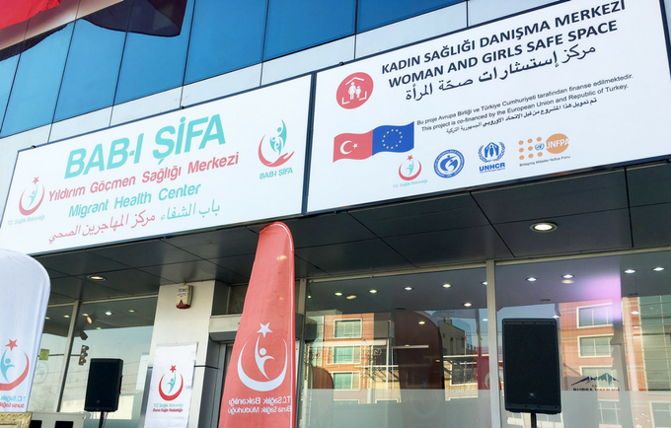In Turkey, women and children constitute the majority of the migrant population, and 15 per cent of women are in their reproductive age. This group is characterised by greater vulnerability and with many, though in most cases neglected, specific needs especially when armed conflicts and crisis occur. In cooperation with a number of international and national organizations, the Government is ensuring a safe, dignified and healthy life – especially with respect to reproductive health - for women and girls, as it is of great importance both for the welfare of their families and societies they are part of. Hence, health centres were opened to protect and empower women and girls who have been forced to flee their homelands due to war.

At the beginning of 2018, the Yıldırım Migrant Centre and Women and Girls Safe Spaces were opened officially in Bursa. The centre is run by the Provincial Health Directorate of Bursa, United Nations Population Fund (UNFPA) and the Association for Solidarity with Asylum Seekers and Migrants (SGDD-ASAM). The European Union and the Republic of Turkey, through United Nations High Commissioner of Refugees (UNHCR), finance the centers. Mr. İbrahim Vurgun Kavlak, General Coordinator of SGDD-ASAM said during the opening ceremony:

*“Turkey is the country that has opened its doors to the largest group of refugees, … such centres play a major role with regard to the migrants’ health in Turkey.*

**Session Four: Building Confidence and self-awareness**

*What factors contribute to building your confidence and self-awareness? How do you achieve it?*

Women leadership

Efforts have been carried out to turn the crisis into an opportunity for Syrian women to enhance their leadership. The approach towards working with women in the camp has started to make a positive shift, when Syrian women were not perceived as mere vulnerable groups only, but also as great assets and individuals with high potential; and if the displacement could be perceived, instead of only a dramatic crisis, as a golden opportunity for these women, originating from a patriarchal system, to finally be independent decision-makers and leaders. This could be approached through a gender and social analysis to the barriers and connectors within the community after the displacement that could support such a vision, planning to address these barriers, and supporting the Syrian women to unleash their potential and turn this crisis into a positive turning point for their lives.

Again, there is a strong relation between women’s Resilience and family Resilience, and children in the aftermath of crises have more chances to adopt resilient behaviors in the presence of a supportive parent who can be the resource of Resilience and unconditional support to them (Khalifeh 2017).

Women leaders have played a critical role in providing services to survivors and encouraging survivors to come forward to seek assistance. Women leaders, when trained as awareness campaign promoters or peer counsellors, have acted as a social force raising SGBV issues in the community and ensuring that gender issues are not left aside.

Refugee women’s Committees Against SGBV

Some SGBV issues can be difficult to address when they are strongly supported by refugee culture. Examples of this include domestic violence and the forced marriage of minors. This is why it is important to have groups or committees of refugees who come together to discuss all aspects of SGBV.

The entire refugee community must be involved in SGBV prevention and response activities. This includes the involvement of males and females of all age groups from all ethnic and religious groups. Furthermore, there is a need to mobilize Syrian women refugees and community leaders to participate in spreading information, raising awareness and community protection

Humanitarian organizations need to manifest a clear organizational commitment to promoting gender equality, which must be embedded into all aspects of programming. Gender and social analysis must be conducted as part of all emergency responses. Sex and age-disaggregated data should be collected, analyzed, and used in planning and implementation of aid projects. Refugee women and men’s anxieties and fears about their changing gender roles need to be acknowledged and addressed. This can be used as an entry point for challenging attitudes that have traditionally limited women’s participation in social, economic and political life, and also for changing long-established social norms, such as women’s restricted freedom of movement. It is also an opportunity to give much greater attention to engaging men and boys on gender issues, and providing targeted counseling and mental health services for men who are struggling to cope with low self-esteem and help deal with their inability to fulfill their traditional gender roles. (Research finding Abaad/ Oxfam GB 2013)

Similar experience from neighbouring countries hosting Syrian Refugees

**Sawa for Development in Lebanon** implemented the ‘Resilience and Empowerment of Syrian Women Refugees’ project. The project aims to empower Syrian women in Lebanese camps by raising awareness on their rights, and legal aspects that will empower them to stand up against violence. The second objective is Economic empowerment via Income generating activities, training, and market support. The third objective is: to Mobilize Syrian women refugees and community leaders to participate in spreading information, raising awareness and community protection.

The project identified that…’ Poor access to education and/or information regarding their rights make women easy victims and unable to stand up for their rights… Not only little knowledge about their rights, missing institutional knowledge about the judicial system and legal processes hamper the fight against gender-based violence during conflict… economic barriers and poverty are a plausible reason for women not to claim rights…

**UN Women In Za’atari** operates three Oasis centres that offer 16,000 people a year refuge from the harshness of camp life as well as the chance to earn desperately needed income. Since 76% of cash-for-work (C4W) opportunities target men, UN Women responded by starting the camp’s largest female-focused C4W programme.

Role models and inspiring stories

*Mother’s dedication inspires 20-year-old to academic success in Turkey:* A bomb killed her mother in the family’s café in Aleppo. Now Fatima is studying civil engineering with ambitions to move further up the academic ladder.

In 2015 in Reyhanli, a small border town in southeastern Turkey, six Syrian women established the ‘Up to the Top’ Committee with the goal of creating a female empowerment network for refugee women. The Committee provides Turkish and English language and basic computer classes. It also educates women on their rights in Turkey and offers advice on steps to take if those rights are violated. They also offer awareness-raising programs to educate the communities about the consequences of early marriages and gender-based violence. Through their work they promote an increased participation of women in the society alongside men, whom they see as partners and allies. The committee is very technology-savvy in order to improve their awareness raising strategy among the community. On prevention of early marriage, for example, they bring together fathers and mothers because they believe it is crucial to work with men as partners. We also invite religious leaders and psychologists who expose all risks and negative consequences of early marriages.” (UNHCR Turkey).

|  |  |
| --- | --- |
| exercise | ‘Code of co-existence’ between refugee women and women from host communities, what are the principles you will include?  In groups, draft what you believe should be the code of existence to be included |
| mage result for powerpoint presentation  materials | Flip chart and felt pen  Small coloured cards |
| to recap | * In a conflict, women are not just victims, they are also agents of change and can be a main source of resilience to members of their family and the community at large * A conflict is a large factor for changing gender roles. Refugee women take on more responsibilities and roles due to the hardship in the new environment * Refugee women face the risk of increased violence, both at public levels and household levels, as migration often leads to diminishing men’s self esteem, which in turn can increase risks of domestic violence. |
| refrences | Khalifeh, Rozan (August 2017), Women’s Refugees are not only vulnerable, they are Resilient too – Swedish Institute, Uppsala Universitet  Fakhry, Alia (2017) Gendered resilience among Syrian women in Amman, Jordan – Conflits et migrations, <https://lajeh.hypotheses.org/787>  SawaForDevelopment (February 2016) Resilience and Empowerment of Syrian Women Refugees – Sawa for Development  Islam, Ingham, Hicks & Manock (2014) The Changing Role of Women in Resilience, Recovery and Economic Development at the Intersection of Recurrent Disaster – Sage Journals |

**Module Two: Women’s human rights and deconstructing harmful gender norms**

*"We would like to know more about Human Rights, what it says and how it implies, (A member of the Syrian Women’s Committee of the Future, during discussion in Gaziantep)*

*The training on this module is intended to support all project’s stakeholders, including peer leaders for gender equality clubs, and Implementing partners (IPs) on gender equality, women’s human rights and deconstructing harmful and discriminative gender norms, values and traditions*

|  |  |
| --- | --- |
|  | *Ask the participants the following questions and facilitate a discussion:*   * *Which is more difficult, being a woman or being a man in the community? Why?* * *Who has more influence, power in the society, and Why?* * *The community gives men power over women, is that the main reason for GBV?* * *Are power and rights connected? i.e. the more power you have the more rights you have and vice versa…* |
|  | *At the end of the session, participants will be able to:*   * *Understand that gender differences are socially ascribed and differ from society to society and can change with time.* * *Identify what GBV means and list the different forms of violence in the community,* * *Understand that women’s rights are fundamental part of human rights* |
| 1.15 – 1.25 | 20 – 30 minutes presentation;  20 minutes discussions, questions and answers,  20 minutes group work: *identify the types of GBV, and give example for each type*  15 minutes presentation of the group work |
|  | **Discrimination Against Women:** any difference in treatment on the grounds of sex which:   * Intentionally or unintentionally disadvantages women; * Prevents society as a whole from recognizing women’s rights in both the private and the public spheres; * Prevents women from exercising the human rights and fundamental freedoms to which they are entitled. |
|  | GBV is a ‘very’ sensitive topic and can be difficult to talk about & tackle  GBV is a life-threating, global health and human rights issue, yet unlike lack of food, water or shelter, GBV is often not seen as life threatening.  GBV violates international law & principles of gender equality  GBV protection must be central to all humanitarian response  Therefore, when conducting training on GBV, keep in mind the following important ‘must commit to’ issues:   * The learning environment for the workshops should be friendly. * Participants should feel safe and protected. * Mutual trust must prevail among the trainers/ facilitators and the participants. * Confidentiality of information and respect of experience and knowledge shared.   GBV is happening everywhere. However, it is under-reported worldwide, due to fears of stigma or retaliation, limited availability or accessibility of trusted service providers, impunity for perpetrators, and lack of awareness of the benefits of seeking care. |

**Session one: Understanding what violence is, and the different types of violence**

*‘There are things we take for granted, and we don’t consider as violence, such as when a man shouts and starts using bad language, we just say he is angry and has to bring it all out to cool down. Even a little violence, such as slapping his wife or children, no one makes a big deal out of it, anyway, this is all inside the house, and no one should interfere in what is going on between family members (A member from the Syrian Future Committee in Gaziantep explaining the general norms and traditions among Syrian families (40s year old participant in the discussion group, SADA, Gaiziantep)*

*Start by asking participants What is their definition of violence, and if they can categorize the different types of violence.*

Violence is defined as "the intentional use of physical force or power, threatened or actual, against oneself, another person, or against a group or community, which either results in or has a high likelihood of resulting in injury, death, psychological harm, mal-development, or deprivation." (WHO)

Violence is not limited to physical harm. It can also manifest in the following manners:

|  |  |  |
| --- | --- | --- |
| **Physical Violence**  Using a body part or an object to control another person’s actions | **Sexual Violence**  Coercing someone, partner, stranger, friend, to take part in sexual activity | **Emotional Violence**  Saying/Doing insulting things to make someone feel bad (worthless, stupid, hopeless) |
| **Psychological Violence**  Using threats, intimidation or isolation to control another person | **Cultural Violence**  Causing harm to someone as a result of cultural, religious, or traditional practices | **Neglect**  Not providing care or to a person, despite having the duty & responsibility to do so |
| **Verbal Abuse**  Using language – spoken or written – to cause harm to someone | **Financial/ Economic Abuse**  Controlling a person’s financial resources without their consent | **Religious Violence**  Using someone’s spiritual beliefs to manipulate, dominate, or control them |

What is Violence Against Women?

Violence against women is any act of gender-based violence that results in, or is likely to result in, physical, sexual or mental harm or suffering to women, including threats of such acts, coercion, or arbitrary deprivation of liberty, whether occurring in public or in private life. *(UN Declaration on the Elimination of Violence against Women, 1993)*

Every year, violence in the home and the community devastates the lives of millions of women. Globally, at least one woman in every three has been beaten, coerced into sex, or otherwise abused in her lifetime. *(Amnesty International)*

What is Violence Against Children?

Child abuse or child maltreatment is physical, sexual, or psychological maltreatment or neglect of a child or children, especially by a parent or other caregiver. Child abuse may include any act or failure to act by a parent or other caregiver that results in actual or potential harm to a child, and can occur in a child's home, or in the organizations, schools or communities the child interacts with (WHO). Hence, Child Marriage, Child Labour, Child Trafficking… are forms of child abuse and violence

Child Labour

Promote greater awareness of the risks of illegal child labour, which denies children opportunities to fulfil their other rights, such as education. Support proven mechanisms to promote children’s health, safety, welfare, education and right to play, in line with global law and standards.

**Session Two: GBV in international framework on women’s rights**

*The “training” …*

*Start by asking participants if they have heard of UN Universal Declaration of Human Rights and what they know about it.*

Since the founding of the United Nations, equality between men and women has been among the most fundamental guarantees of human rights. Adopted in 1945, the Charter of the United Nations sets out as one of its goals “to reaffirm faith in fundamental human rights, in the dignity and worth of the human person, [and] in the equal rights of men and women”. Furthermore, Article 1 of the Charter stipulates that one of the purposes of the United Nations is to promote respect for human rights and fundamental freedoms “without distinction as to race, sex, language or religion”. This prohibition of discrimination based on sex is repeated in its Articles 13 (mandate of the General Assembly) and 55 (promotion of universal human rights).

In 1995, United Nations world leaders of 180 governments and hundreds of NGOs met in Beijing, China, for United Nations conferences on the status of women. These meetings gave rise to the Beijing Platform of Action—one major area of which was Women and Armed Conflict (Critical Area E). It said, “An environment that maintains world peace and promotes and protects human rights, democracy and a peaceful settlement of disputes…is an important factor for the advancement of women. Peace is inextricably linked with equality between women and men and development.” The international governments’ conference found humanitarian law to be systematically ignored in current forms of armed conflict, with massive violations of human rights, including planned rape of women.

The Beijing Declaration found these and other conflict atrocities impacting women “abhorrent practices that are strongly condemned and must be stopped immediately, while perpetrators of such crimes must be punished.” It said, “violations of the human rights of women in situations of armed conflict are violations of the fundamental principles of international human rights and humanitarian law. All violations of this kind, including, in particular, murder, rape, including systematic rape, sexual slavery and forced pregnancy require a particularly effective response.” The Platform locked on the importance of women’s participation in the processes of preventing war, protecting civilians, resolving conflict and making and keeping the peace

The equal access and full participation of women in power structures and their full involvement in all efforts for the prevention and resolution of conflicts are essential for the maintenance and promotion of peace and security. Although women have begun to play an important role in conflict resolution, peace-keeping and defence and foreign affairs mechanisms, they are still underrepresented in decision-making positions. If women are to play an equal part in securing and maintaining peace, they must be empowered politically and economically and represented adequately at all levels of decision-making[10]. While symbolic gestures have been made, women remain significantly underrepresented in conflict resolution processes[11].

The elimination of all forms of violence against women and girls and of all harmful practices are also now part of the 2030 Agenda for Sustainable Development, and included as specific targets (i.e. targets 5.2 and 5.3) in the Sustainable Development Goals, providing a strong mandate for moving forward:

5.2 Eliminate all forms of violence against all women and girls in the public and private spheres, including trafficking and sexual and other types of exploitation

5.3 Eliminate all harmful practices, such as child, early and forced marriage and female genital mutilation

**Session Two: The Declaration on the Elimination of VAW,**

*Ask participants if they have heard of any specific Declaration for women’s Rights.*

The Declaration on the Elimination of Violence against Women (DEVAW) was proclaimed by the United Nations General Assembly resolution 48/104 of 20 December 1993. It covers physical, sexual and psychological violence as well as violence both at home and elsewhere in society.

The definition of violence against women that the UN presents in the Declaration is currently the most widely accepted definition.

According to the Declaration, violence against women is rooted in the historically unequal power relations between women and men. It also explains that violence against women is ‘one of the crucial social mechanisms by which women are forced into a subordinate position compared with men.’

The UN member states are therefore urged to legislate against the violence, work preventively and improve the situation of victimised women.

**Declaration on the Elimination of Violence against Women (DEVAW)**

**National commitment Against Violence in Turkey**

The Istanbul Convention

The İstanbul Convention is a 2001 treaty that has created a framework to protect women against all forms of violence. İstanbul Convention is regarded as a golden standard in this field in the world.”

the integrated policy” that is embedded in the İstanbul Convention as a significant aspect of the document and foresees taking the preventive steps in every field from education to politics.

the İstanbul Convention prohibits the use mediation or reconciliation to resolve disputes, underlining that such approaches could only be effective between people having equal conditions.

The Syrian Refugee Crisis has captured international attention due to its unprecedented scale of population displacement. The countries receiving refugees face major challenges in dealing with the situation and in supporting host communities.

Hosting the world’s largest refugee population, the Turkish government has long stood out for its national ownership, leadership and financial investment in responding to the needs of refugees and asylum seekers residing in its territory.

While addressing humanitarian needs has been at the forefront of the response, increasingly the focus is shifting to livelihoods support.

**Session Four: UN Women tools and frameworks on EVAW**

*Ask participants what steps they believe should be taken to eliminate VAW?*

Many of the responses to violence against women have focused primarily on intervening with affected individuals after the violence has occurred. Such strategies are essential to mitigate the devastating mental, physical, social and economic effects for women experiencing violence, ensure justice and accountability, and prevent its recurrence. It is important to continue to improve these responses. At the same time, there is also an increasing need to address the broader factors that contribute to prevalence at a population level, and to implement programmes that prevent such violence from occurring in the first place. Hence, the UN Women framework for eliminating violence against women takes a comprehensive view as follow:

Anticipated short-term outcomes (the conditions required in the short term to secure longer term impacts)

*Anticipated outcomes of laying foundations:*

* Increased recognition of VAW as a prevalent, preventable, serious and unacceptable human rights violation,
* Governments actively fulfil their international obligations to prevent VAW.
* Systems engage a range of sectors established to plan, implement, coordinate, monitor and evaluate prevention, build the evidence base and share learning.
* Civil society groups, including autonomous women’s/girls’ organizations and organizations that promote the engagement of men and boys in gender equality take an active role in supporting prevention and responding to backlash.
* National human rights institutions
* Support for prevention from senior leadership across sectors,
* Increased expertise and skills in prevention planning, coordination and implementation
* Tools and resources to support prevention are developed.
* Response and prevention systems that support consistent action and communications
* Increased engagement in and capacity to undertake activity to prevent VAW by and within organizations across the government, non-government and corporate sectors

*Anticipated outcomes of implementation:*

* Discriminatory legislation repealed and policies promoting gender equality implemented.
* Strong formal and informal sanctions against violence and disrespect are established and enforced.
* Strengthened peer associations between women and girls, especially those experiencing social isolation.
* Increased positive portrayals of masculinities, femininities that are based on equal and respectful relationships between women and men and responsible reporting of violence in the media and popular culture.
* Greater value accorded to the roles of women and girls.
* More equitable distribution of resources and power between men and women in both the public and private spheres, and greater fluidity in gender roles and expressions of masculinity and femininity.
* Improved knowledge and skills of individuals to prevent VAW and strengthen gender equality in public and private life.
* Individuals affected by prior exposure to violence are identified and have access to support to assist them in mitigating its impacts.
* Increased collaborative activity with those addressing overlapping issues (e.g. alcohol misuse, poverty).

*Anticipated Longer-term impacts*

* Reduction of VAW, including that perpetrated against women affected by multiple discriminations.
* Reduced acceptability of VAW among women and men and overall improvements in egalitarian or gender equal norms
* Increased perception of safety among women and girls
* Reduced health burden associated with VAW
* Reduced economic costs associated with VAW
* Increased equality, including economic and political empowerment of women and girls
* Reduced levels of violence against children
* Improved capacity of institutions, organizations, communities and nations to meet goals pertaining to gender equality, human rights and economic and human development

|  |  |  |  |  |  |  |  |  |  |
| --- | --- | --- | --- | --- | --- | --- | --- | --- | --- |
|  | (Each group) identify the types of GBV, and give example for each type   |  |  |  |  | | --- | --- | --- | --- | | **Physical** | **Sexual** | **Psychological** | **Economic** | | Hitting, slapping, burning, pushing, stabbing,  harmful practices to women (FGM). | Unwanted touches, forced sex, forced marriage, sexual harassment and intimidation at work, school and other public institutions | Emotional or mental abuse, depression, such as isolation, insecurity, fear, anger, shame, self-hate, self-blame, withdrawal, hopelessness, verbal abuse, threats shouting, humiliation etc. | Abandonment, financial support, well as preventing a partner from working or owning assets, refusing a partner participating in decision-making | |
| mage result for powerpoint presentation | Flipchart, coloured papers, felt pen and tape, |
| to recap: | * The EVAW Framework * Understanding what human rights and fundamental freedoms * Understanding what GBV is, and what it encompasses of * The seven steps of UN Women tools and frameworks on EVA * Anticipated short-term/ long-term impact in intervention to eliminate GBV |
|  | UN Women (2015), *A Framework To Underpin Action To Prevent Violence Against Women*  United Nations Human Rights Office of the High Commissioner (2014) *Women’s Rights are Human Rights* |

**Module Three: Girl Child Rights**

*‘ Back in Aleppo, my female cousins and I were all married by the time we reached fifteen. It is the norm in our family. I am expected to do the same for my daughters, to protect them. Yet, I want better things for them, to be in a better status’ (30s year old Participant in the hairdressing class at SADA Center for Women, Gaziantep).*

*‘I was married off at the age of sixteen, and my husband’s family kept nagging at my husband till he married off our daughter at the age of sixteen also. She was doing well at school and wanted to continue her studies, but at the same time she didn’t want to disobey her father, so she accepted’ (40s year old Participant in the hairdressing class at SADA Center for Women, Gaziantep).*

Training on this module is intended to raise awareness on the impact of child marriage

|  |  |
| --- | --- |
|  | *Ask the participants the following questions and facilitate a discussion:*   * *Which age do you believe that girls should be married off?* * *Why are girls married off at an early age?* * *What will happen if they do not get married at an early age?* * *What are the positive vs. the negative outcomes of marring a child at an early age?* * *Which outweighs? The positive or negative outcomes?* * *What does the law say about early marriage?* |
|  | *At the end of the session, participants will be able to:*   * *Understand the consequences of early marriage on the girls and the families* * *Understand that despite all the ‘justifications’, there is nothing but harmful consequences on marrying of a child* * *Become familiar with international standards and conventions on child rights and child marriage* |
| 100 - 110 | 30 – 40 minutes presentation;  20 minutes discussions, questions and answers,  30 minutes group work*: identify the negative consequences for GBV*  20 minutes presentation of the group work |
|  | The main concepts  **Forced marriage:** Marriage that occurs without the free and full consent of one of the parties or both of them or when one of the parties or both of them do not have the capacity to terminate the marriage or to opt for separation for several reasons (legal, the law not acknowledging the right of the wife to divorce, the use of force, social or family pressures).  **Early marriage:** Marriage that occurs before the age of 18, i.e. before reaching the legal age set by the law. However, such a marriage may be accepted in several countries for those below that age since the legal age in these countries is below 18 or marriage by itself grants them the legal age.  **Child marriage:** marrying off a child before they reach the age of 18, as set by the Convention on the Rights of the Child (CRC)  **The United Nations Convention on the Rights of the Child (CRC)** is a human rights treaty, which sets out the civil, political, economic, social, health and cultural rights of children. The Convention defines a child as any human being under the age of eighteen, unless the age of majority is attained earlier under national legislation. |
|  | The Middle East has one of the highest child marriage rates in the world, after Africa. The practice has increased following the crisis in the region leading to a whole generation of lost children.  Discrimination against the girl child in upbringing, and gender inequality between the girls vs. boys are some of the main factors leading to child marriage and abuse against the girls and eventually women. |

**Session One: Girls Child Rights in International Standards**



*Ask participants what age do they consider as child marriage?*

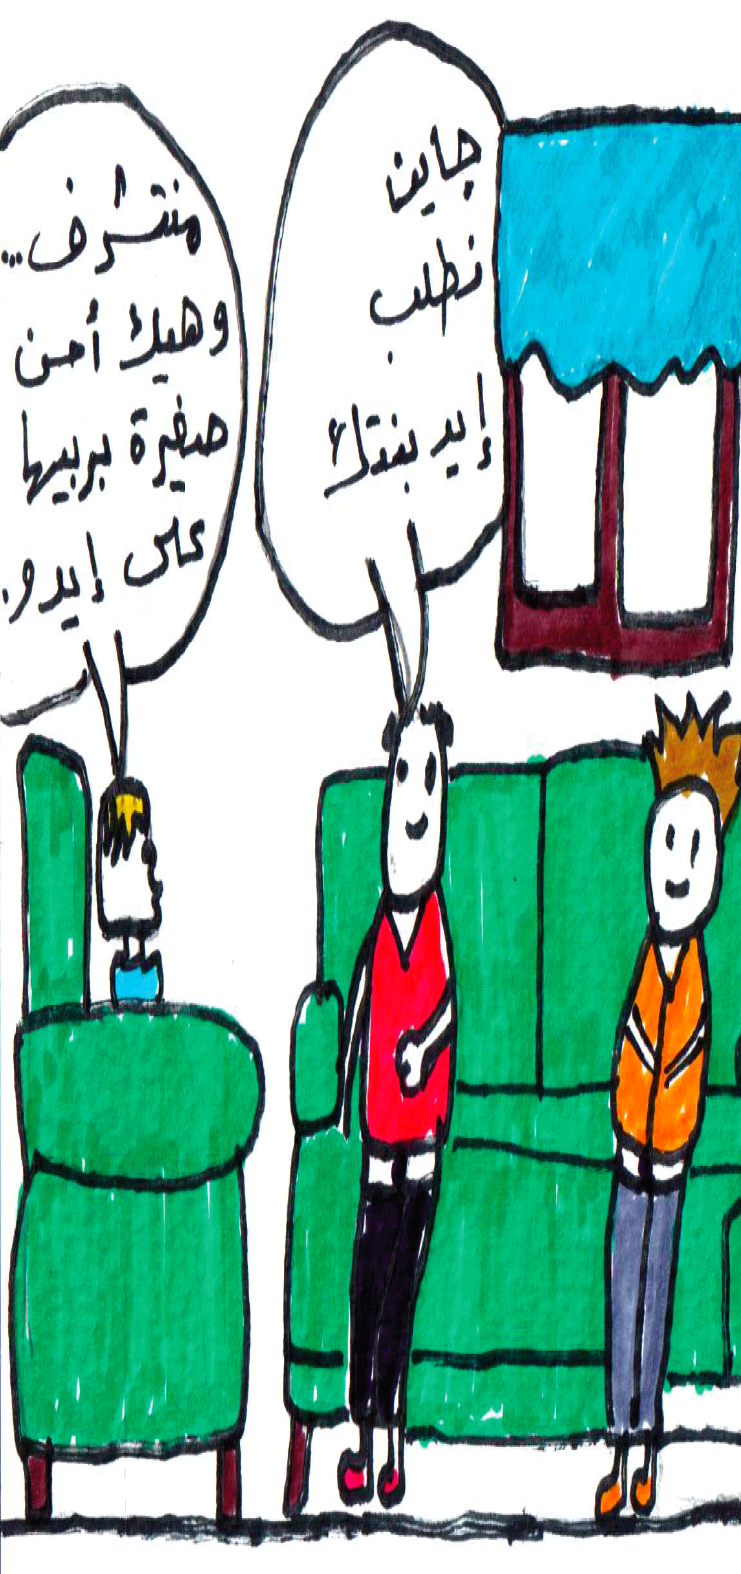Article 1 of the Convention on the Rights of the Child (CRC) defines a “child as a person below the age of 18, unless the laws of a particular country set the legal age for adulthood younger.” This Article has given several countries the chance to end the age of childhood before 18 and the possibility to get children married, particularly girls. For this reason, the Committee on the Rights of the Child called the State Parties to reconsider the legal age for adulthood in case it is set to below 18. In view of these three terms that are used altogether since they encompass all aspects of marriage and marriage contracts violating human rights, in general, and the child’s and girls’ rights, in particular, and for the purpose of the present paper, we will use the term “early marriage of girls” to describe the phenomenon of marrying them before the age of 18 or even over that age, in case of marriage without their consent, before the completion of their sexual, psychological and physical development or by depriving them, at a later stage, of the possibility of divorce or separation.

Figure 1: 1p: ‘We want to propose to your daughter’; 2nd p: “I’ll be honoured, it’s better to marry her off young, you could bring her up the way you want. *Abaad Centre for Gender Equality, Beirut*

According to UNICEF, every year millions of girls marry before turning 18. The west and central African regions have the highest percentage of married adolescents (27 percent), followed by eastern and southern Africa (21 percent) and the Middle East and North Africa region (14 percent).

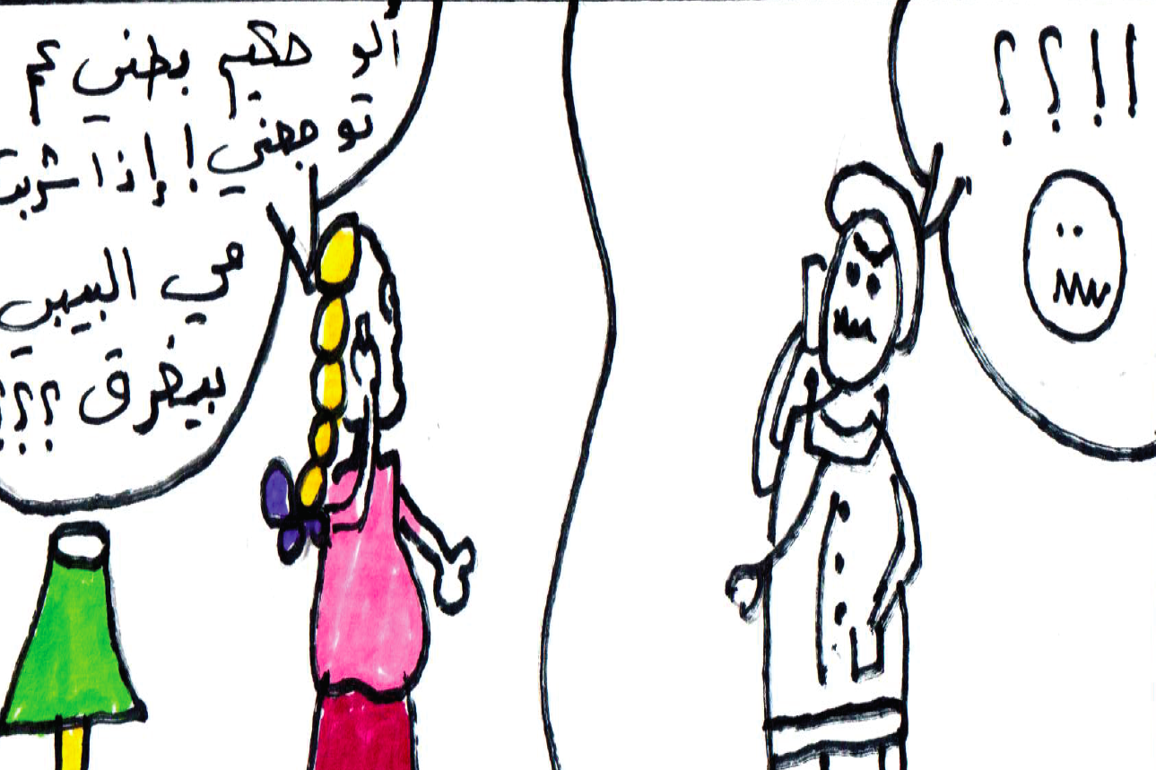From a development point of view, child marriage leads to lower educational achievement and lower earnings in adulthood for girls as a result of their limited ability to work. It also leads to higher fertility and population growth putting more pressure on economies and resources. The practice affects negatively the health of child brides and their children, who are more exposed to malnutrition and poverty.

Figure 2: 'I have a tummy ache doctor, if I drink water will the baby drown'? *Abaad Centre for Gender Equality (Abad for Gender Equality, Beirut)*

Furthermore, the practice epitomizes a lack of voice and agency for women as well as harming their health, psychological status leading to social isolation and increased risk of domestic violence. Apart from being a fundamental violation of human rights, ending child marriage is also a smart economic investment considering its high economic and development cost.

Many factors contribute to placing a girl at risk of marriage, including poverty, the protection perception, family honor, social norms and customary and religious laws that condone the practice. Therefore, there is a need for an adequate legislative framework that makes civil registration of marriages mandatory as a mean to fight the practice.

Although the number of girls married before the age of 18 has decreased during the past three decades, this phenomenon is still common in rural areas and in poor “urban” areas, due mainly to cultural and legal factors, as well as the prevailing socio-political situation.

Cultural factors They are usually related to stereotyped ideas regarding the sexual life of women and girls and their roles within the society, exclusively consecrated to the house and the household. Early marriage then provides protection for girls against sexual aggressions and sex before marriage, and thus preserves “the honor of the family”.

Social factors Girls marriage is also attributed to social factors, mainly pertaining to the economic situation of the household, particularly poverty, girls not enrolled in schools or dropping out early from schools.

Therefore, early marriage of girls is a means to ensure economic sufficiency, especially for those who lack the capacity of independently accessing economic resources and those who live in extreme poverty. In some cases, girls marriage is a financial resource to the household through the dowry which is settled upon the conclusion of the marriage. This is even more dangerous for girls in case of a temporary marriage (contractual marriage: See the Committee for the Elimination of All Forms of Discrimination Against Women (CEDAW), General Comment No 21) or in case of marriage to foreigners, thus developing the phenomenon of women and girls trafficking.

Political/Security factors The phenomenon of girls marriage increases in situations of conflicts (whether internal or international). Households marry off female minors whether for economic/financial reasons (poverty) or to protect them against sexual aggressions, especially that households usually think that their girls are in a secure situation with marriage4.

Legal factors Several legal factors help in providing the necessary legal character to some traditions and cultures. Numerous laws in many countries decrease to below 18 the legal age of adulthood or distinguish between the age of childhood in general, below 18 years, and the age of marriage for girls (14, 15 or 16 years, sometimes), thus opening the door for early marriage. Moreover, numerous laws do not stipulate compulsory education for girls and do not set a specific age to leave school, thus preventing girls from enrolling in schools or making them drop out early from schools.

These multiple factors, particularly legal ones, go basically against the international legal framework regarding the early marriage of girls.

**Session Two: Combating Child Marriage**



*Ask participants to identify what the law says about the minimum age of marriage, and if it differ from the actual age that marriage takes place in the society?*

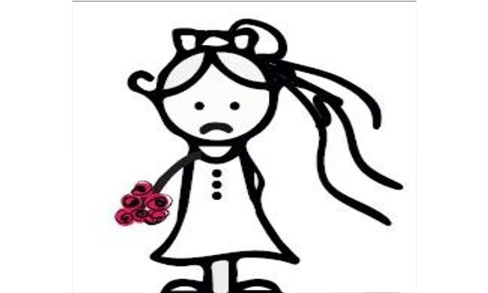

Many international conventions and agreement addressed the issue of child marriage. For example, the Convention on the Elimination of All Forms of Discrimination against Women (CEDAW) covers the right to protection from child marriage in article 16, which states: “The betrothal and the marriage of a child shall have no legal effect, and all necessary action, including legislation, shall be taken to specify a minimum age for marriage….”

The right to “free and full” consent to marriage is recognized in the Universal Declaration of Human Rights, which says that consent cannot be “free and full” when one of the parties involved is not sufficiently mature enough to make an informed decision about a life partner. Although marriage is not mentioned directly in the Convention on the Rights of the Child, child marriage is linked to other rights; such as the right to freedom of expression, the right to protection from all forms of abuse, and the right to be protected from harmful traditional practices and is frequently addressed by the Committee on the Rights of the Child.

Other international agreements related to child marriage are the Convention on Consent to Marriage, Minimum Age for Marriage and Registration of Marriages,

**Conditions for free and full consent**

International conventions and instruments related to human rights unanimously concur over the necessity to have free and full consent in a marital relationship, as stipulated in the International Covenant on Civil and Political Rights (ICCPR) (Article 23, Para. 3 and in the International Covenant on Economic, Social and Cultural Rights (ICESCR) (Article 10, Para. 1). Within this context, the United Nations Convention pertaining to consent in marriage, the legal age of marriage and the registration of marriage contracts stipulate that “both parties shall personally give their consent in the presence of a concerned authority5. ” Article 16 of the CEDAW stipulates that State Parties shall ensure, on a basis of equality between men and women, “the same right to freely choose a spouse and to enter into marriage only with their free and full consent. Furthermore, the Supplementary Convention on the Abolition of Slavery, the Slave Trade, and Institutions and Practices Similar to Slavery bind its State Parties to “take all practical and necessary legislative and other measures to bring about progressively and as soon as possible the complete abolition or abandonment (…) of the following institutions or practices whereby:

(i) A woman, without the right to refuse, is promised or given in marriage on payment of a consideration in money or in kind to her parents, guardian, family, or any other person or group; or

(ii) The husband of a woman, his family, or his clan, has the right to transfer her to another person for value received or otherwise; or

(iii) A woman on the death of her husband is liable to be inherited by another person6.

The personal, free and full consent in marriage constitutes a common principle for all these international covenants and conventions, upheld by the Protocol to the African Charter on Human and Peoples’ Rights on the Rights of Women in Africa (2003, Article 6a), ASEAN Declaration of Human Rights (2012, Article 19), and the American Convention on Human Rights (1969, Article

17). This clear-cut international trend in favor of full consent is asserted by the jurisprudence of international committees of human rights. Indeed, the Committee on the Elimination of All Forms of Discrimination Against Women and the Committee on the Rights of the Child underscore the importance of setting up additional legal guarantees to ensure to all individuals the right to freely contract marriage, even in case of different legal systems encompassing customary and legislative rules. (See later child marriage)

**Conditions of equality and non-discrimination**

The right to equality and non-discrimination is considered among the constants of the international law pertaining to human rights. Therefore, child marriage, early marriage and forced marriage are considered as a form of gender-based discrimination, significantly impacting women and girls.

Within this context, the Committee on the Elimination of All Forms of Discrimination Against Women and the Committee on the Rights of the Child consider that forced marriage and child marriage are an aspect of discrimination against women and girls, violate their rights and prevent girls from totally enjoying their rights.

**Discrimination Against Girls**

Forms of discrimination against girl children are numerous and vary depending on the traditions, history, and culture of a particular society. Favoring the son is one of them and can lead to inflicting abuse against the girl.

|  |  |
| --- | --- |
|  |  |
| *Son: I want to become an engineer;*  *Father: Yes, Bravo… Why would you want to study (speaking to daughter), your future is in the kitchen.*  *(Abad for Gender Equality, Beirut)* | *Girl: I’m hungry*  *Mum: feed yourself, I fed your brother,*  *That’s what’s important for me*  *(Abad for Gender Equality, Beirut)* |

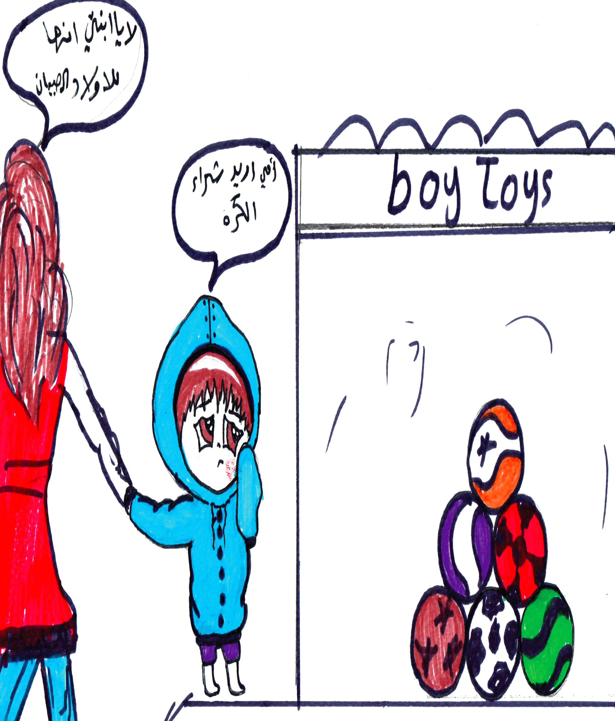**Defining Gender roles for children is one form of discrimination**

The distinct roles and behaviors that are defined for boys and girls, and men and women in a society may give rise to gender inequalities, i.e. differences between men and women that systematically favor one group.

Gender roles are defined at an early stage which leads to different behaviour and role in life for girls & boys. Usually it is the boy who is in a leading, controlling position, and the girl follows.

*Girl: I want a ball Mum: this is for boys*

*Abaad for Gender Equality, Beirut*

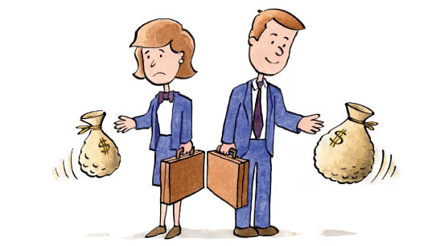**Direct Discrimination**

**It** is when you're treated differently and worse than someone else for certain reasons, a less favourably way.

It Exists when unequal treatment between people of different race, colour, sex, age, appearance, disability, social class… etc. It is explicitly justified by the law, or rules or practices, making an explicit difference between people on these grounds.

Usually at work, there

*I desperately needed a job in Gaziantep, because now I have no one to rely on. I found an announcement that was seeking to hire a young woman and a young man. They will pay the woman 200 Lira a week, and the man 450 Lira just because he’s a man.*



**Indirect Discrimination**

Refers to the Rules and practices, which appear neutral but in practice lead to disadvantages. For example, setting job requirements which, are seemingly neutral but are irrelevant to the job (such as requiring a minimum height or weight for a manager).

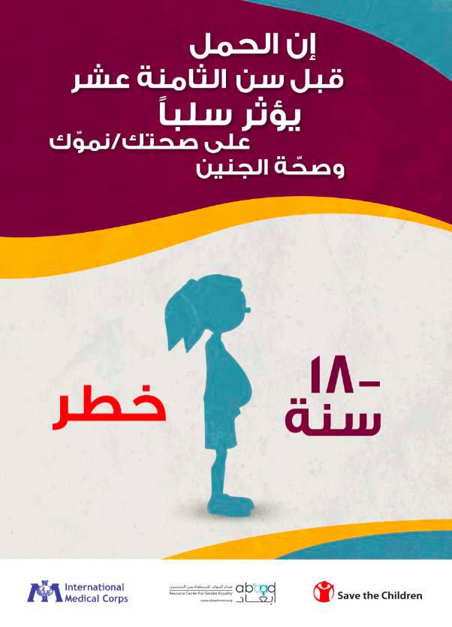**Session three: Consequences of Child Marriage**

*Ask participants what they believe are the good vs. bad aspects of child marriage*

In 2012, a joint declaration for the Committee on the Rights of the Child, the Committee on the Elimination of All Forms of Discrimination Against Women, the United Nations Special Representative of the Secretary General on Violence Against Children, the Special Rapporteur on the trafficking of children, child prostitution and child pornography, the Special Rapporteur on Contemporary Forms of Slavery, the Special Rapporteur on Violence Against Women, and the Special Rapporteur on Trafficking in Human Beings, especially girls and women, was published, calling to increase the age of marriage to 18 for girls and boys alike, without any exception, clearly stating that child marriage cannot, in any way whatsoever, be justified by traditional, religious, cultural and economic reasons.

This joint declaration summarizes an international trend to unify the age of marriage, regardless of the traditional, religious and cultural specificities, and clarifies that Article 1 of the Convention on the Rights of the Child, setting the age of a child up to 18 years, with exceptions regulated by the State Parties, does not apply to marriage. Such a trend is confirmed by all general and specialized committees on human rights and by the United Nations Human Rights Committee: the latter called for setting the age of marriage in a way that enables each spouse to freely express its full personal consent according to the conditions stipulated within the law.

The Committee on the Rights of the Child: The Committee called to consider some provisions of the Convention on the Rights of the Child as provisions applied to child marriage, including taking efficient and appropriate measures to eliminate traditional practices harming the health of children (Article 24, Para. 3), non-discrimination (Article 2), best interests of the child (Article 3), the right of the child to be heard depending on his age and his maturity (Article 12), the protection of the child against all forms of violence (Article 19), the protection of the child against all forms of sexual abuse and sexual violation (Article 34) and the protection of the child against all harmful forms of abuse (Article 36).

The Committee on the Rights of the Child (and the Committee for the Elimination of Violence Against Women) concluded that States are to eliminate exceptions regarding the minimum age of marriage and set up the minimum age of marriage for boys and girls with or without the approval of the parents to 18 years10. Within the same context, the Committee on the Economic, Social and Cultural Rights recommended the States to increase the minimum age of marriage to be equal for boys and girls.

The Committee for the Elimination of Discrimination Against Women: The Committee deems that child marriage is a practice which causes physical, mental and sexual harm, suffering, or the threat to resort to such acts and long and short-term implications to that, and negatively impacts the capacity of the victims to fully enjoy their rights (Closing remarks regarding Montenegro, Mauritania, Togo, Zambia, and Bulgaria). It confirmed the elimination of exceptions regarding the minimum age of marriage to be set to 18 years for boys and girls alike. Within this context, the Committee called upon the States to record the cases of birth and marriage in order to better control the age of marriage and support the implementation and enforcement of laws pertaining to the minimum age of marriage.

The Committee Against Torture (CAT)

CAT reckoned that child marriage may be a cruel and inhumane and humiliating human treatment, especially if governments haven’t set a minimum age of marriage abiding by international standards.

In a nutshell, child marriage, including girls before the age of 18, is a threat to a large range of their rights, among which:

* Right of girls in life, since early marriage may threaten the life of many girls, during pregnancy and delivery and may lead to the death of a great number of them;
* Right to health and healthcare, since early marriage impacts the health of girls whose physical and psychological development hasn’t been completed yet, becoming mothers while they are still children.
* Right to education, since marriage or the promise of marriage usually puts an end to girls’ school enrollment, girls staying at home to get prepared to become housewives and care for their family.
* Right to work, since early marriage prevents girls from having an education and acquiring the appropriate skills to work at a later stage.
* Right to dignity, since early marriage subdues girls, exposes them to abuse and inferiority, makes them feel inferior, develops in them a negative personal view and, in several cases, exposes them to the risk of exploitation under all its forms: economic, sexual, etc.
* In order to face these violations caused by the early marriage of girls, it is necessary to apply and enforce the duty of protection and care to be assumed by the State, the society and the family.

**Session Four: UN Women and UN partners approach to**

**Addressing the needs of Syrian Women Refugees in Turkey**

*Ask participants if they believe empowerment as essential, why? And how to achieve it?*

**International Labour Organizations (ILO),**

*ILO has identified a number of vocational skills that refugee women need in Gaziantep, at SADA centre. This includes hairdressing, computer, language, producing soap, sewing embroidery shoes… some of which we’ve already started, and some of which we will soon start*[12]*”.*

*“ILO projects provides a number of vocational training capacity building skills for refugees, and tries to ensure that there is equal access to both men and women from the refugee communities*[13]*”.*

ILO is working on social integration and inclusion issues that involve child labour, women’s empowerment etc. To support the refugees, ILO is playing a significant role in the livelihoods cluster of the response in the Regional Refugee and Resilience Plan (3RP) coordinated by UN agencies and development partners. The Country office is implementing projects on child labour; Syrian refugees; occupational safety and health; social dialogue and sustainable enterprises; More and Better Jobs for Women; Women’s Empowerment through Decent Work in Turkey” project in cooperation with Turkish Employment Agency

The ILO Office for Turkey is working with many institutions including: the Ministry of Labour and Social Security, the General Directorate of International Labour Force, the Turkish Employment Agency, the General Directorate of Migration Management, the Ministry of National Education, General Directorate of Lifelong Learning, Ministry of Family and Social Policy, South-eastern Anatolia Project Regional Development Administration (GAP RDA), Gaziantep and Şanlıurfa Chambers of Artisans and Craftsmen, Harran Governorate, municipalities dealing with Syrian refugees in the labour market.

In 2015, ILO Office for Turkey introduced a comprehensive strategy and inclusive response towards Syrian refugee crisis. It consists of three main pillars:

* Increase skills and access to decent work for Syrian refugees and Turkish host communities;
* Create jobs by providing an enabling environment for business entrepreneurship opportunities for both Syrian refugees and Turkish host communities;
* Support institutions and mechanisms to assist in implementing inclusive development strategies.

ILO Office in Turkey is focusing on women’s employment and has developed a policy to create decent jobs for women, as well as to increase women's employment and close male vs. female labour force participation rates which is almost 40 percent.

Gender-sensitive labour market reports were likewise prepared in project provinces to provide gender-sensitive information and policy suggestions, also revealing occupations that offer high potential for women’s employment from the perspective of employers.

Women who received entrepreneurship training under the project implemented by the International Labour Organization (ILO) Turkey Office to promote women’s employment, now provide training “as role models” to Syrian refugee women and host country women in the context of work on employment of Syrian Under Temporary Protection in another ILO project.

*ILO’s Response to Syrian Influx in Turkey’ Project*

To response to Syrians refugee employment needs in Turkey, ILO is: Strengthening the national and local capacities dealing with refugee crisis in Turkey; improving knowledge-base on the Syrian refugee crisis and its impact on the labour market and child labour;

* To promote labour market integration of Syrian refugees and host communities.
* To raise awareness among refugees, host communities and wider stakeholders on the new legislative measures and its implications on labour market.

*Main achievements of ILO Turkey, in response to women’s refugees needs*

SADA Women Development and Solidarity Centre established under the project “Gaziantep Women-Only Centre: Providing Livelihood Support” jointly implemented by ILO Turkey Office, UNWomen and SGDD with financing from the Government of Japan operates as a special service office for Syrian and host country women.

The objective is to enable women and girls using the centre to have stronger self-confidence and skills and access various training and job placement programmes in Gaziantep.

Vocational, basic skills and Turkish language trainings carried out in ÇATOMs were also covered by the project in cooperation with ‘Improving Livelihoods and Decent Work Opportunities for Syrian Refugees and Host Communities’ project.

**United Nations Refugee Agency (UNHCR)**

*“The Turkish Government is the main service provider for Refugees. It has developed a number of procedures and regulations to address and facilitate the current influx to the country. UNHCR, along with other UN and International agencies, are providing support, especially technical support, to the Government, to facilitate its approach to addressing the crisis” [14].*

As of mid- February 2017, there were over 2.9 million Syrian refugees registered to UNHCR in Turkey, women and girls represent the half. Today, it is estimated that there are over 3.5 million refugees with a ‘Temporary Protection’ status.

The Turkish Government is providing all the technical, legislative, logistic and financial support to respond to the needs of the refugees and asylum seekers on its land. It claims ownership and leadership while the UN, local & international organizations are supporting the Government by providing needed technical support.

The 2013 Asylum Law was the first to regulate the status of refugees and asylum seekers in Turkey. It was a respond to the situation, and regulating refugees and asylum seekers access to services, protection and their rights. The law was the first to specify persons with special needs, and people who experienced SGBV. They were identified as priority and accordingly, referral mechanisms were developed including: Social Service Centres and Violence Prevention Centres. Hence, all UNHCR programmes and activities prioritise specific needs of vulnerable asylum seekers and refugees, including women and female-headed households.

UNHCR is supporting the Turkish authorities in addressing these needs through a set of targeted interventions including improvement and strengthening of the pathways and the response mechanisms available in Turkey; expansion of safe spaces for women; conducting awareness raising activities on issues like Sexual and Gender Based Violence (SGBV); the support to the establishment of refugee and women committees in both camp and urban locations and of Refugee Outreach Volunteer (ROV) networks working to raise awareness on SGBV; provision of income-generating training to refugee women as well as Turkish language courses.

UNHCR is the secretariat for the SGBV working group, together with UNFPA. It is co-chaired by Ministry of Family and Social Policies and AFAD in Ankara. It provided trainings to national institutions and civil society on the rights of refugee women, under international law, the responsibilities that the host country has in protecting these rights, and specific actions that can be taken to increase protection for refugee women under the State’s jurisdiction. There has been more targeting on children protection and response to needs.

**World Food Programme (WFP)**

*“The cash has been a good opportunity for Syrian Refugee to feel less vulnerable, lessen their poverty, and to better integrate in the society. However, there is still a need for a sustainable integration plan for the post-cash period[15]”.*

In collaboration with the World Food Programme, the Turkish Red Crescent and Turkish government institutions, the EU launched its biggest humanitarian programme: the Emergency Social Safety Net (ESSN), a single card social assistance scheme that allows up to 1.3 million of the most vulnerable (taking into consideration the vulnerable women) … to access a fixed amount of money every month. They use the money for basic needs: food, fuel, rent, medicine and bills. The multipurpose cash can be withdrawn at any of the 15,000 HalkBank ATM spread throughout Turkey.

Application is made for the ESSN at the nearest Government Social Assistance office in the applicant’s district, or the nearest dedicated ESSN Service Centre. Appointments are provided to reduce waiting times. There are separate queues for men and women, and in some cases women are asked to come at a different time of day to men.

In addition to poverty alleviation among the refugees, the aim of the card is also to promote social cohesion and create a positive impact on host communities by allowing the refugees to participate in the daily life of the community and contribute to the local economy. Refugee families currently receive 120 Turkish Liras (€30) per family member per month, with an additional quarterly top-up depending on the size of the family.

The precondition to the card is formal registrations, which implies that the beneficiary has a “kimilk” (ID) Card, proper address and no access to social security.

One Syrian student came from Syria alone to continue her studies at the university. She applied for ESSN and received it.

WFP in Turkey incorporates gender and protection in programme design, implementation, and M&E activities, both for the e-Food Card Programme in refugee camps, and the Emergency Social Safety Net (ESSN) nationwide. Men and women are included without any major differences in both WFP programmes in Turkey (e-food card and ESSN), and the usage of the assistance is closely monitored in terms of decision-making, household dynamics, and food consumption.

March – June 2018, WFP will conduct a gender analysis approach to food security data collection. This will help in better integrating gender into the programming.

International Organization for Migration (IOM)

IOM Turkey conducted a workshop for the gender focal points (GFPs) network to enhance gender equality throughout the humanitarian response. The aim of the workshop was to familiarise participants with basic gender concepts and to develop more coordinated approach to gender related matters in humanitarian response.

**United Nations Population Fund (UNFPA)**

*“UNFPA support Refugee women who have been subject to SGBV. We have opened a number of referral and health centres in different governorates especially for refugees, and some are especially for refugee women. Our referral centres can completely deal with all cases of VAW. So, I suggest that we cooperate in this area. If UN Women identifies cases of VAW, refer them to UNFPA specialized centres. Furthermore, we can work together on data collection via a GBVIM system to ensure that accurate and updated data are collected for SGBV cases[16]”.*

Capacity Building activities for Health service providers, governors, religious leaders on the improving health status of Seasonal Migrant Agricultural Workers

UNFPA Turkey Office promotes gender equality and works for preventing gender based violence through its humanitarian programme. As per its mandate, UNFPA has been providing refugees with reproductive health and gender based violence services through 40 Women and Girls Safe Spaces (WGSS) which act as primary level health care centres with certain clinical and psychosocial services on RH and GBV and also empowerment activities for women and girls.

UNFPA Turkey Office is also working for strengthening the institutional capacity of public institutions. To this end, a series of pre- and in-service training programmes has been given to staff of Turkish Armed Forces, Judiciary and Law Enforcement Officials such as police and gendarmerie, Religious Affairs on prevention and response to sexual and gender based violence in order to improve the services. A new set of trainings were planned and will be conducted in the year of 2017 to support the capacity of police forces and gendarmerie for effective response to GBV victims/ survivors.

The Women’s Health Counselling Centres run by Hacettepe University’s Women’s Research and Implementation Centre (HUWRIC) and Directorate of Public Health of Ankara, the implementing partner of UNFPA, and financed by the Office of European Civil Protection and Humanitarian Aids Operations (ECHO)

Since 2011, UNFPA Turkey Office has been offering services for refugee girls and women as the primary target group in the fields of health, empowerment and violence against women in cooperation with its esteemed partners such as the Ministries of Health and Family, and HUWRIC, in an attempt trying to reach girls and women, already with 41 centres in 20 provinces as per the end of 2017. In 2018, we will continue to expand our activities intended for refugees in 75 centres.’’

*UNFPA’s Women and Girls Safe Spaces (WGSS)*

UNFPA Turkey Office has been offering capacity development, service provision, reproductive health services and hygiene supplies in women's health and violence against women within the scope of the Humanitarian Aid Program since 2011.

The official opening of the WGSS was held on 24 March 2016 at Ulubey Refugee Healthcare Center in Ankara. UNFPA Turkey Country Office in collaboration with Turkish Republic Ministry of Health and Turkish Republic Ministry of Family and Social Policies established eight new Women and Girl Safe Spaces (WGSS) providing clinical and psychosocial services on reproductive health and gender based violence for refugees in Ankara, İstanbul and İzmir with the financial support of EU Humanitarian Aid and Civil Protection Department (ECHO). Ministry of Health Provincial Health Directorates have been supporting the execution of the centers at the provincial level.

The centres were established in various cities in 2017 with the support from the European Commission Civil Protection and Humanitarian Aid Operations (ECHO), US Government, Swedish Government and Japanese Government mainly operate in sexual and reproductive health, gender based violence, psycho-social support, empowerment and supply distribution for asylum seeker women and girls.

About 80% of the refugees are women and children and a quarter of them are women of reproductive age. For this purpose, Women and Girl Safe Spaces (WGSS) have emerged as a key strategy for the protection and empowerment of women and girls whom are more vulnerable in emergencies and have specific needs that are often ignored in crises.

Approximately 75 per cent of the refugees in Turkey are estimated to be women and children under 18 years old. A quarter of refugees are women of reproductive age. Four percent of the population are pregnant and delivering refugee women with newborns every year. 15 percent of pregnancies are expected to face high-risks and need tertiary care – Cesarian section, operations/ blood transfusion, intensive care. UNFPA is one of the major United Nations humanitarian response organizations with a mandate to meet the reproductive and maternal health needs of persons in emergency situations.

WGSS are run by the Provincial Health Directorate of Bursa, United Nations Population Fund (UNFPA) and the Association for Solidarity with Asylum Seekers and Migrants (SGDD-ASAM) is financed by the European Union and the Republic of Turkey through United Nations High Commissioner of Refugees (UNHCR).

*Potential collaboration with SADA*

Since UNFPA have the technical requirements to address GBV cases (they have both the expertise and referral centers), it is suggested that a collaborating mechanism is developed to enable SADA to revert all identified cases of GBV to UNFPA.

Since UNFPA has developed an GBV information management scheme tailored for the needs in Turkey, it is also suggested that UN Women collaborate with UNFPA on the data collection via a locally tailored GBVIM system.

**World Health Organization (WHO)**

*WHO Staff: We conducted training for 300 Syrian Nurses;*

*Gender Consultant: did any male participants apply for the training?*

*WHO Staff (smiling): actually over 85% of the participants were females. So we thought that it is common to find male nurses in Syria,*

*Gender Consultant: It wasn’t common to find male nurses in Syria, and usually only females go to Nurse Schools,*

*WHO Staff: most of the participants used to work in the emergency sections. It seems that women feel unsecure to participate. On the other hand, there are almost 30% Syrian female doctors among the more experienced technical cadre that is being trained[17]*

WHO in Turkey works to ensure that the impact of gender inequalities in women’s health is addressed in national health policies and programmes. It works closely with the health sector to strengthen their capacity in preventing and dealing with gender based violence through clear guidelines and protocols for health care providers. The WHO

Regional Office for Europe published a report titled “Women’s health and well-being in Europe: beyond the mortality advantage” outlines the impact of socioeconomic determinants and gender, which covers 53 Member States.

WHO Country Office Turkey makes every endeavour to strengthen the capacity of essential health service delivery and referral care for general Syrian refugee population in Turkey, putting a considerable emphasis on increasing access to sexual and reproductive health services for particularly vulnerable groups, namely women and girls as part of their program objectives.

Within the scope of their program they were able to and still continue to support classroom and hands-on practical training opportunities to the Syrian Health professionals making efforts to encourage more women to take part in the program and eventually join the workforce in the Migrant Health Centres to promote gender equality and combat gender based violence.

Creating awareness about violence and informing the refugee girls and women about the support mechanisms they can benefit from. Therefore, it is hoped that more female Syrian Health providing staff, especially nurses will join the courses offered by Turkey Ministry of Health and WHO. This will be essential in reaching out to most vulnerable.

A Policy Dialogue will take place between the MoH and Ministry of Family Affairs in April 2018. It is hoped that this will eventually lead to the adoption of a GBV Strategy.

**United Nations Development Programme (UNDP)**

*“UNDP ensures that all its project have a gender component, and hence equally target men and women, including projects that are targeting refugee women. Like UN Women, MADAD is the most important project to address refugee women’s need, and especially in terms of Economic Empowerment and Participation. There are opportunities for cooperation with UN Women under the MADAD funded projects in areas of job creations, SMEs and vocational training, livelihood, social cohesion, technical support to government partners… etc.[18]”.*

Within the Syria Crisis Response and Resilience Programme, which aims at increasing self-reliance of Syrian population and strengthening the resilience and capacities of host communities and public service providers to cope with and to recover from the impact of forced displacement, gender equality is one of the main concern and cross cutting issue. UNDP is also involved in a program that provides legal support for survivors of sex and gender based violence (SGBV).

In Turkey, working with the municipalities, over 112,560 refugees and host community members have benefited from improved access to basic services, including municipal solid waste management which facilitates the collection, transportation and recycling of waste. As a result, the volume of waste ending up in landfills was significantly reduced.

**The United Nations Children's Fund (UNICEF)**

*“Child Marriage is one of the main issues addressed by UNICEF in Turkey, especially among the Syrian refugees, which is prevalent. In cooperation with UN Women, UNICEF has produced a training package to address Child Marriage. In relation to child protection, UNICEF has established a number of Child Friendly Spaces “Farah where we provide capacity building of girls, to lift them up from the status of being vulnerable potential girl brides, to becoming strong adolescents, capable of negotiating their rights[19].”*

According to the Demographic and Health Survey (DHS), there is a 14% of child marriage among Syrian children who are less than 18 years old. UNICEF is still not sure of the exact number, but the finding reveals that child marriage was decreasing in Syria, and after the crisis it started to increase once more in host communities. Girls are seen as vulnerable potential brides both among the Syrian and host communities.

UNICEF in Turkey is committed to mainstreaming gender equality in all its work for children. In line with the UNICEF Gender Action Plan (GAP), targeted gender priorities are to advance girls’ secondary education, to end child marriage and to address gender based violence in emergencies.

Advancing Girls’ Secondary Education: UNICEF is working with Ministry of National Education (MEB) on the development and implementation of “Intervention” and “Orientation” models to prevent students from dropping out of school. Furthermore, MEB and UNICEF are planning to implement a new Gender and Child Rights Education Programme at the upper-secondary level in the coming months.

There is a focus on more integration between Syrian and Turkish children at school, as more Syrian children are integrated into Turkish school, and the eventual closing of Syrian only schools.

UNICEF is ensuring the implementation of EVAW law 6284 that protects every single person and forces penalties on violation of human rights.

Five UN Agencies, including UNICEF and IOM, are working on a three year programme to combat trafficking, including child trafficking.

Child Marriage Prevention and Response Model:

UNICEF in Turkey has developed a Child Marriage Prevention and Response Model, initiated in Gaziantep as a pilot programme in 2016. The programme is in the process of being expanded to other provinces across Turkey. First and foremost, the programme aims to strengthen the capacity of protection systems to effectively mitigate, identify and respond to cases of children at risk of marriage.

Gender-based violence: UNICEF programmes focus on both: 1) Violence Prevention, aiming at reducing the factors that place children at risk of violence and abuse; and 2) Violence Response, aiming at improving access to justice for child survivors of violence and reducing their secondary victimization by the criminal justice system.

**CATOM**

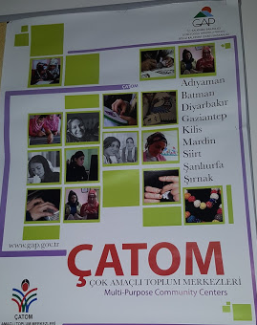*“Since its establishment in the 1970s, CATOM has the experience of working with vulnerable women, especially those residing in the rural areas. It is using this experience now to reach out to refugee women in rural areas of Gaziantep. It had managed to harmonize relations between Syrian women and host communities, working on social cohesion, in addition to vocational and language training… and eventually providing livelihood opportunities for Syrian women, as it had once provided for local women in the area[20]”.*

Turkey, Koton (a Turkish garment company), CATOM (Multi-purpose Social Center) and the Southeastern Anatolia Project Regional Development Administration (GAP RDA) also provided income generating activities to more than 800 women. In addition, more than 300 Syrian women refugees have benefitted from income generating opportunities through Koton under a successful pilot project.

|  |  |  |  |  |  |  |  |  |  |  |  |  |  |  |  |  |  |  |  |
| --- | --- | --- | --- | --- | --- | --- | --- | --- | --- | --- | --- | --- | --- | --- | --- | --- | --- | --- | --- |
|  | (Each group) identify the negative vs. positive consequences of early Marriage, according to different categories according to the impact   |  |  |  | | --- | --- | --- | | **Category** | **Positive** | **Negative** | | Physical | None | Interferes with growth | | Social | A new family | Puts an end to opportunities | | Psychological | None | Overwhelming responsibility | | Economic | Someone to bear the costs of living | Always dependent on others | |  |  |  | |
|  | Violence throughout the Life Cycle of a female   |  |  | | --- | --- | | Phase | Type of violence | | Pre-birth | Sex-selective abortion; battery during pregnancy  Coerced pregnancy | | Infancy | Female infanticide; emotional and physical abuse  Differential access to food and medical care | | Girlhood | Child marriage; Differential access to food, medical care and education | | Reproductive age | Sequence pregnancies, domestic violence | | Womanhood | Abuse of widows, including property grabbing | |
| mage result for powerpoint presentation | Flipchart, coloured papers, felt pen and tape, exercises. |
|  | * Child marriage is a clear violation of child right, especially girl child rights * Child marriage had damaging effect on both the girl, the family and society at large * All UN Agencies in Turkey are addressing refugee girls and women need, each according to its mandate and field of work |
|  | [www.abaadmena.org](http://www.abaadmena.org)  <https://www.girlsnotbrides.org/child-marriage/turkey/>  <https://data.unicef.org> |

**Module Four: GBV basic case management**

*The training on this module is intended to support Implementing Partners, community based women’s organizations, groups and networks, that covers topics including protection, GBV prevention and response, on basic case management and psycho-social skills, training skills, advocacy and coordination skills*

|  |  |
| --- | --- |
|  | *Ask the participants the following questions and facilitate a discussion:*   * *What are the needs of survivors of GBV?* * *Identify organizations/facilities in community that provide services to GBV survivors?* * *What are some security risks a survivor might be exposed to after GBV?* * *Where are some “safe settings” where survivors might feel more comfortable disclosing an experience of sexual violence?* |
|  | *At the end of the session, participants will be able to:*   * *Understand the basic principles of the work with GBV survivors,* * *Use basic communication skills for contact with GBV survivors,* * *Identify the psychological needs of GBV survivors,* * *Understanding the different needs and supports of GBV survivors, and becoming familiar with IASC intervention Pyramid* |
| 100 – 110 | 30 – 40 minutes presentation;  20 minutes discussions, questions and answers,  30 minutes group work*: List psychosocial providers – including women’s groups – in a matrix, indicating which types of services each can provide for GBV survivors/victims:*  20 minutes presentation of the group work |
|  | **Psychosocial** term is used to emphasize the interaction between the psychological aspects of human beings and their environment or social surroundings. Psychological aspects are related to our functioning, such as our thoughts, emotions and behaviour (USAID 2017).  **Psychosocial support** is the process of facilitating resilience within individuals, families and communities [enabling families to bounce back from the impact of crises and helping them to deal with such events in the future]. By respecting the independence, dignity and coping mechanisms of individuals and communities, psychosocial support promotes the restoration of social cohesion and infrastructure (The Psychosocial Framework of 2005 – 2007 of the International Federation)  **Case management** originally refers to an approach that evolved from the recognition that people seeking health and mental health care often have a range of other social service needs, and that a function is needed to coordinate these often fragmented services. Thus, the ‘case management’ function became a specialized role within health and social services, providing information and coordination of care and services to individuals and families, while advocating for the quality of care and services (USAID 2017).  **GBV Case management** is a structured method for providing help to survivors. It involves one organization, usually a psychosocial support or social services actor, taking responsibility for making sure that survivors are informed about all the options available to them, and that issues and problems facing a survivor are identified and followed up in a coordinated way. It has unique characteristics that distinguish it from other approaches to case management. The approach is called “survivor-centred.”  A **survivor-centred approach** to violence against women seeks to empower the survivor by prioritizing her rights, needs and wishes. It means ensuring that survivors have access to appropriate, accessible and good quality services including: Health care. Psychological and social support. It aims to create a supportive environment in which each survivor’s rights are respected and in which the person is treated with dignity and respect.  The ‘**do no harm’** concept means that humanitarian organizations must strive to “minimize the harm they may inadvertently be doing by being present and providing assistance.” Such unintended negative consequences may be wide-ranging and extremely complex. Humanitarian actors can reinforce the ‘do no harm’ principle in their GBV-related work through careful attention to the human rights-based, survivor-centred, community-based and systems approaches (IASC 2015).  **Confidentiality:** is an ethical principle that is associated with medical and social service professions. Maintaining confidentiality requires that service providers protect information gathered about clients and agree only to share information about a client’s case with their explicit permission. All written information is maintained in a confidential place in locked files and only non-identifying information is written down on case files. Maintaining confidentiality means service providers never discuss case details with any unrelated person. |
|  | GBV in all of its forms has tremendous physical, emotional and social consequences for the person victimized by it, who is often referred to as a ‘survivor’. Survivors of GBV have the right to receive quality, compassionate care and support that addresses the harmful consequences of violence in order to help them heal and recover.  Be aware of the existing GBV services in your community, including legal, health and social support services, so that you can refer dialogue participants to them if necessary.  The term ‘psychosocial’ is used in place of ‘psychological’ to recognize that a person’s mental well-being is not just determined by her/his psychological makeup, but also social factors. The ‘social’ and ‘psychological’ factors also influence each other. |

**Session One: Prevention, Protection, and response**

*What measures should be taken to minimize occurrence of GBV? What measurements are needed for the protection of GBV survivors?*

To minimize the consequences of GBV, survivors need a number of tangible and empowering services which includes: Safety and protection; Cure and treatment; Care and understanding; Practical support; Connectedness within the family and the community; Livelihood for her/his family; Self-efficacy (believing in one’s own abilities); and Hope for the future. This calls for key activities to Prevent, protect and response to GBV survivors needs.

*Prevention*

Preventing GBV involves addressing the factors that increase risks of GBV in emergencies, such as the disruption of social and legal protection mechanisms and displacement and dependency on others for meet­ing basic and survival needs. Prevention factors of GBV include: assessing and monitoring GBV cases; protecting GBV survivors especially those in shelters; ensuring that they have adequate access to distribution and services; ensure that they are accommodated in safe and secure places; raising awareness among community on GBV prevention mechanism…

*Protection*

Protection encompasses all activities aimed at securing full respect for the rights of individuals — women, girls, boys and men — in accordance with the letter and the spirit of the relevant bodies of human rights, humanitarian and refugee law. protection activities aim to create an environment in which human dignity is respected, specific patterns of abuse are prevented or their immediate effects alleviated, and dignified conditions of life are restored through reparation, restitution and rehabilitation.

*Response*

Response to GBV includes a number of services and needs including: referral systems, safety/security, health, psychosocial and legal. The basic knowledge needed for multi-sectoral response is as follow (Gender Protection Cluster 2014):

|  |  |  |  |
| --- | --- | --- | --- |
| **Health** | **Psychological** | **Safety/ Security** | **Legal** |
| Understands the basics of clinical management | Understands the survivor-centered approach and case management | Analyses the context related to security and its capacity to respond to the needs of GBV survivors | Understands the legal framework for GBV in context including laws |
| Can assess health sector partners to assure that there is basic referral capacity | Can provide psychological first aid to GBV Survivors |  | Understands the risk that the justice process can pose for survivors, and work with local actors to minimize the risks |

Response of GBV calls for:

* Improved cooperation between medical care, law enforcement and justice system, which will result in improved collection of evidence
* The cooperation between NGOs, medical care and police improved the reception of victims of rape.
* The police issue emergency contraception to rape survivors and give referrals to medical care.

But first, and most importantly, there should be a staff well trained and prepared to handle GBV incidents in a manner that prioritises confidentiality, respect, sensitivity and the dignity of the survivor. Therefore, ensure that staff receives appropriate training on responding to the needs of survivors, including interview techniques and comprehensive knowledge of referral mechanisms and options available to them.

*Providing support to reduce physical insecurity, anxiety and emotional stress*

The appropriate actors and agencies should ensure that refugees from Syria – women and men, boys and girls – have access to counselling services to help them deal with their, often traumatic, experiences and the tensions that changing gender roles are giving rise to, for individuals, families and communities. Mental health services should be aware of men who are may be experiencing a loss of self-esteem.

Promoting joint activities that build understanding between refugees and host communities is important for increasing tolerance, but tools and methods to assess the security situation are needed and such assessments need to happen on an ongoing basis. Development practitioners need to work with others, including government authorities and local leaders, to enforce laws to protect refugees from Syria in Lebanon. Work is also needed to improve refugees‟ knowledge of their rights and how they can claim justice.

Short-term interventions should be developed with a view to promoting longer-term empowerment. Agencies need to build the capacity of women and girls and men and boys to claim their rights, and of the government and other national stakeholders to deliver those rights. Assigning leadership positions to women and supporting them to maintain these in groups and committees in all response initiatives will help to create female role models, who will promote women‟s immediate needs and also advocate for long-term positive change. Engaging women‟s organizations in these and other relevant tasks is essential for achieving such change.

Ensuring that access to aid is equitable and appropriate

Distribution of non-food items must meet the different needs of women, men, boys and girls. Programme designers need to be aware of women‟s specific concerns – for instance, about privacy – as well as designing solutions to WASH problems that reduce the burden of care for women.

Urgent attention is needed to enable refugee boys and girls from Syria now living in Lebanon to continue their education. Priorities include providing more schools, increasing security for refugees, and making transport more affordable; in addition, there needs to be more research into the factors preventing children from going to school, including the need to work to contribute to family income and coping strategies such as child marriage. Children‟s voices must be heard and incorporated into all such programme design.

Protection work must be central to all interventions, from immediate responses (such as addressing housing and privacy concerns) to the longer-term work needed to help people re-establish their livelihoods. It is important to help families seek alternatives so that they can avoid resorting to harmful coping strategies; income-generating activities should be targeted to those who are most at risk of resorting to such strategies.

All actors involved in the response should promote measures to prevent sexual exploitation of refugees and establish mechanisms for safe and confidential reporting of incidents. Humanitarian agencies are also responsible for tracking possible incidents of sexual exploitation and working with survivors in a confidential and sensitive manner to ensure that they have the option of referral to specialist service providers.

*Minimum standards for Prevention and Response to GBV in Emergencies (UNFPA)*

Minimum Standard is an action that is universal and applicable in ‘All’ humanitarian contexts and needed to achieve in order to prevent and respond to GBV and deliver multi-sector services to survivors in humanitarian settings. The purpose of the Minimum Standards is to:

1) Promote safety of women & girls by improving access to quality services in humanitarian contexts

2) Provide clear guidance and tools to prevent & respond to GBV in emergencies

3) Increase accountability – to make addressing GBV in emergencies unquestionable, and

4) Improve the quality of/access to essential services for women and girls who have experienced violence in the areas of health, police/justice, social services and coordination & governance (development context).

|  |  |  |  |
| --- | --- | --- | --- |
| **Foundational Standards** | | | |
| **Standard 1** | **Participation** | | Communities, including women and girls, are engaged as active partners to end GBV and promote survivors’ access to services. |
| **Standard 2** | **National Systems** | | Actions to prevent, mitigate and respond to GBV in emergencies strengthen national systems and build local capacities. |
| **Standard 3** | **Social and Gender Norms** | | Emergency preparedness, prevention and response programming promotes positive social and gender norms to address GBV. |
| **Standard 4** | **Collection and Using Data** | | Quality, disaggregated, gender-sensitive data on the nature and scope of GBV and on the availability and accessibility of services informs programming, policy and advocacy. |
| **Mitigation, Prevention, and Response Standards** | | | |
| **Standard 5** | **Healthcare** | GBV survivors, including women, girls, boys and men, access quality, life-saving healthcare services, with an emphasis on clinical management of rape. | |
| **Standard 6** | **Mental Health & Psychosocial Support** | GBV survivors access quality mental health and psychosocial support focused on healing, empowerment and recovery. | |
| **Standard 7** | **Safety and Security** | Safety and security measures are in place to prevent and mitigate GBV and protect survivors | |
| **Standard 8** | **Justice and Legal Aid** | The legal and justice sectors protect survivors’ rights and support their access to justice, consistent with international standards | |
| **Standard 9** | **Dignity Kits** | Culturally relevant dignity kits are distributed to affected populations to reduce vulnerability and connect women and girls to information and support services | |
| **Standard 10** | **Socio-Economic Empowerment** | Women and adolescent girls access livelihood support to mitigate the risk of GBV, and survivors access socio-economic support as part of a multi-sector response | |
| **Standard 11** | **Referral Systems** | Referral systems are established to connect women, girls and other at-risk groups to appropriate multi-sector GBV prevention and response services in a timely and safe manner. | |
| **Standard 12** | **Mainstreaming** | GBV risk mitigation and survivor support are integrated across humanitarian sectors at every stage of the programme cycle | |
| **Coordination And Operational Standards** | | | |
| **Standard 13** | **Preparedness & Assessment** | Potential GBV risks and vulnerable groups are identified through quality, gender-sensitive assessments and risk mitigation measures are put in place before the onset of an emergency | |
| **Standard 14** | **Coordination** | Coordination results in effective action to mitigate and prevent GBV and promote survivors’ access to multi-sector services | |
| **Standard 15** | **Advocacy & Communication** | Coordinated advocacy and communication lead to increased funding and changes in policies and practices that mitigate the risk of GBV, promote resilience of women and girls and encourage a protective environment for all | |
| **Standard 16** | **Monitoring & Evaluation** | Objective information, collected ethically and safely, is used to improve the quality and accountability of GBV programmes | |
| **Standard 17** | **Human Resources** | Qualified, competent, skilled staff are rapidly recruited and deployed to design, coordinate and/or implement programmes to prevent and respond to GBV in emergencies | |
| **Standard 18** | **Resource Mobilization** | Dedicated financial resources are mobilized in a timely manner to prevent, mitigate and respond to GBV in emergencies | |

*Standard Operating Procedures (SOPs) for GBV prevention and response*

SPOs are developed through a collaborative process that includes UN agencies, government and non-governmental organizations, community-based organizations, and representatives of the community affected by the emergency (conflict or disaster). Standard operating procedures are specific procedures and agreements among organisations that reflect the plan of action and individual organisations’ roles and responsibilities. As such, SOPs are companion documents that support the GBV plan of action. Development of SOPs is a process that must involve all relevant actors. The process of developing SOPs is as important as the final SOP product. The process itself can be considered an intervention, in that it engages all of the relevant actors and will involve collaboration, inter-organizational and inter-sectoral dialogue, community participation, negotiation, and thereby increase all participants’ understanding of how to prevent and respond to gender-based violence.

The development of SOPs for prevention and response to GBV involves all actors responsible for and/or engaged in prevention and response to GBV. At a minimum, development of SOPs should include representatives from:

* Health, psychosocial, safety/security, and legal/justice/protection sectors (UN agencies, national and international NGOs, community-based organizations, and relevant government authorities when appropriate)
* Community-based women’s organizations
* Community leaders (women, men, girls, boys)

*Case Management*

Case Management in GBV response programming is a collaborative, multisectoral process which assesses, plans, implements, coordinates, monitors and evaluates available resources, options and services to meet survivors’ needs and to promote quality, effective outcomes. It is useful for survivors with complex needs who access services from a range of service providers (UNFPA 2012). Case management is the process of helping individual survivors, or children and their families through direct social-work type support, and information management (IASC 2014).

Due to its relevance to and history of being used to support vulnerable populations requiring a range of services across sectors, case management has become a common approach in humanitarian settings, drawing largely from the field of social work. Because GBV results in harmful physical, emotional and social consequences that often require information and care from multiple service providers, social work case management has become an integral part of the response to GBV in humanitarian settings. GBV case management is a structured method for providing help to a survivor. It involves one organization, usually a psychosocial support or social services actor, taking responsibility for making sure that survivors are informed of all the options available to them and that issues and problems facing a survivor and her/his family are identified and followed up in a coordinated way, and providing the survivor with emotional support throughout the process. Case management has also become the primary entry point for survivors to receive crisis and longer-term psychosocial support, given the lack of more established health and social support service providers in humanitarian settings (IRC 2017).

*Referral pathways*

Coordinate with UNFPA

Guiding principles and approaches for addressing GBV

The following principles are inextricably linked to the overarching humanitarian responsibility to provide protection and assistance to those affected by a crisis. They serve as the foundation for all humanitarian actors when planning and implementing GBV related programming.

* GBV encompasses a wide range of human rights violations.
* Preventing and mitigating GBV involves promoting gender equality and promoting beliefs and norms that foster respectful, non-violent gender norms.
* Safety, respect, confidentiality and non-discrimination in relation to survivors and those at risk are vital considerations at all times.
* GBV-related interventions should be context-specific in order to enhance outcomes and ‘do no harm’.
* Participation and partnership are cornerstones of effective GBV prevention.

Hence, the principles and approaches underpinning the 18 Minimum Standards for Prevention and Response to Gender-Based Violence in Emergencies are:

*1. Human Rights-Based Approach*

A human rights-based approach seeks to analyse the root causes of problems to redress discriminatory practices that impede humanitarian intervention. This approach is often contrasted with the needs-based approach, in which interventions aim to address practical, short-term emergency needs through service delivery. Although a needs-based approach includes affected populations in the process, it often stops short of addressing policies and regulations that can contribute to sustainable systemic change.

By contrast, the human rights-based approach views affected populations as ‘rights holders’, and recognizes that these rights can be realized only by supporting the long-term empowerment of affected populations through sustainable solutions. This approach seeks to attend to rights as well as needs; how those needs are determined and addressed is informed by legal and moral obligations and accountability. Humanitarian actors, along with states (where they are functioning), are seen as ‘duty-bearers’ who are bound by their obligations to encourage, empower and assist ‘rights-holders’ in claiming their rights. A human rights-based approach requires those who undertake GBV-related programming to:

* Assess the capacity of rights-holders to claim their rights (identifying the immediate, underlying and structural causes for non-realization of rights) and to participate in the development of solutions that affect their lives in a sustainable way.
* Assess the capacities and limitations of duty-bearers to fulfill their obligations.
* Develop sustainable strategies for building capacities and overcoming these limitations of duty-bearers.
* Monitor and evaluate both outcomes and processes, guided by human rights standards and principles and using participatory approaches.
* Ensure programming is informed by the recommendations of international human rights bodies and mechanisms.

*2. Survivor-Centred Approach*

A survivor-centred approach means that the survivor’s rights, needs and wishes are prioritized when designing and developing GBV-related programming. The following contrasts survivor’s rights (in the left-hand column) with the negative impacts a survivor may experience when the survivor-centred approach is not employed.

A survivor-centred approach creates a supportive environment in which the survivor’s rights and wishes are respected, their safety is ensured, and they are treated with dignity and respect. A survivor-centred approach is based on four main principles: Safety; Confidentiality; respect; and non-discrimination. The following guiding principles explains the principles and compares them to what survivors will suffer from if not implemented:

|  |  |  |
| --- | --- | --- |
| **To be treated with dignity and respect:** All actions taken should be guided by respect for the choices, wishes, rights and dignity of the survivor. The role of helpers is to facilitate recovery and provide resources to aid the survivor. | VS.  VS.  Vs.  Vs.  Vs. | Victim blaming |
| **Right to choose:** Survivors have the right to choose to whom they will or will not tell their story. | Feeling powerless |
| **Access to privacy & confidentiality:** The safety and security of the survivor and her/his children is the primary consideration. Confidentiality should be paramount in all aspects of support for survivors. | Shame and stigma. This mostly result in withdrawing from family and society |
| **Non- discrimination:** Survivors should receive equal and fair treatment regardless of their age, gender, race, religion, nationality, ethnicity, sexual orientation or any other characteristic. | Discrimination on the basis of gender, ethnicity, age... etc. |
| **Informed consent:** informing the survivor of the nature of the proposed action, possible alternative actions, and the potential risks and benefits of the action. | Being told what to do which may go against survivors will |

Key Elements of the Survivor-Centred Approach for Promoting Ethical and Safety Standards

1) Safety: The safety and security of the survivor and others, such as her/his children and people who have assisted her/him, must be the number one priority for all actors. Individuals who disclose an incident of GBV or a history of abuse are often at high risk of further violence from the perpetrator(s) or from others around them. Strategies for ensuring safety include:

* Making sure that survivors can seek access systems of care that are private and respectful.
* Helping individual survivors identify and address immediate safety risks using available resources and op­tions.
* Assessing the safety needs of others involved, including children, family members and those who have helped the survivor.
* Maintaining confidentiality at all times.
* Never taking action without the informed consent of the survivor.

2) Confidentiality: Confidentiality reflects the belief that people have the right to choose to whom they will, or will not, tell their story. Maintaining confidentiality means not disclosing any information at any time to any party without the informed consent of the person concerned. Confidentiality promotes safety, trust and empowerment. Strategies for ensuring confidentiality include:

* Conducting interviews in private.
* Only sharing relevant information with others at the request of the survivor and after obtaining informed consent.
* Keeping all documents secure and having a plan to move or destroy case files in the event of an emergency.
* Even if individual names are not used, it is important not to share general characteristics about clients (eth­nicity, age, family situation). There is always a risk that an individual can be identified.

3) Respect: The survivor is the primary actor, and the role of helpers is to facilitate recovery and provide resources for problem-solving. All actions taken should be guided by respect for the choices, wishes, rights and dignity of the survivor. Strategies for ensuring respect include:

* Maintaining confidentiality.
* Ensure the availability of female staff for interviewing and examining women and child survivors.
* Ensure that those working with survivors demonstrate appropriate values, knowledge and skills.
* Ensure that those working with survivors are non-judgmental and sensitive to the cultural and social context of the intervention.
* Minimizing the number of times a survivor needs to retell her or his story.

4) Non-discrimination: Survivors of violence should receive equal and fair treatment regardless of their age, gender, race, religion, nationality, ethnicity, sexual orientation or any other characteristic (UNFPA 2012). Strategies to ensure non-discrimination include:

* Addressing values, attitudes and beliefs among staff that may promote non-discrimination.
* Having a clear written policy on non-discrimination.
* Training staff on human rights, humanitarian principles, and relevant agency policies.
* Ensuring that services and service delivery reflect the specific needs of particular groups of survivors, such as men and boys or people with disabilities.

*3. Community-Based Approach*

A community-based approach insists that affected populations should be leaders and key partners in developing strategies related to their assistance and protection. From the earliest stage of the emergency, all those affected should “participate in making decisions that affect their lives” and have “a right to information and transparency” from those providing assistance.

The community-based approach:

* Allows for a process of direct consultation and dialogue with all members of communities, including women, girls and other at-risk groups.
* Engages groups who are often overlooked as active and equal partners in the assessment, design, implementation, monitoring and evaluation of assistance.
* Ensures all members of the community will be better protected, their capacity to identify and sustain solutions strengthened and humanitarian resources used more effectively (adapted from UNHCR, 2008).

*4. Systems Approach*

Using a systems approach means analyzing GBV-related issues across an entire organization, sector and/or humanitarian system to come up with a combination of solutions most relevant to the context. The systems approach can be applied to introduce systemic changes that improve GBV prevention and mitigation efforts (and, for some sectors, response services)—both in the short term and in the long term. Humanitarian actors can apply a systems approach in order to:

* Strengthen agency/organizational/sectoral commitment to gender equality and GBV-related programming.
* Improve humanitarian actors’ knowledge, attitudes and skills related to gender equality and GBV through sensitization and training.
* Reach out to organizations to address underlying causes that affect sector capacity to prevent and mitigate GBV, such as gender imbalance in staffing.
* Strengthen safety and security for those at risk of GBV through the implementation of infrastructure improvements and the development of GBV-related policies.
* Ensure adequate monitoring and evaluation of GBV-related programming (adapted from USAID, 2006).

*5. Humanitarian principles:*

The humanitarian principles of humanity, impartiality, independence and neutrality should underpin the implementation of the Minimum Standards and are essential to maintaining access to affected populations and ensuring an effective humanitarian response (UNFPA 2015).

*6. ‘Do no harm’ approach:*

A ‘do no harm’ approach involves taking all measures necessary to avoid exposing people to further harm as a result of the actions of humanitarian actors (UNFPA 2015).

**Session Two: Basic case management and psycho-social skills, training skills**

*What are the strategic (more empowering) needs of GBV survivors?*

After achieving practical needs, and Building on a Client-Centred Approach to Comprehensive Support Service, discussions should evolve around the women’s experiences in trainings and role that can be played in skills building, a space for them to express their thoughts and feelings about GBV, priorities and applicable needs, and their roles as leaders in their communities.

*)*

Preconceived notions about GBV and taboos and sensitivity around GBV are very strong. One widespread reaction is to blame survivors themselves for the violence. Helpers, as well as community members, can be drawn into ‘victim-blaming.’ This can happen in a subconscious way in the type of questions that are commonly asked, for example, “Why did you go there alone?” or “Why did you wear those clothes?” All psychosocial activities must therefore be non-judgmental, holistic, meeting the needs of the affected.

*Practical and Strategic Needs to be met*

Whatever strategy is employed to reach the goal of the equal enjoyment of human rights by women, girls, boys and men, the approach should eventually result in women’s and girls’ empowerment. “Empowerment” implies a shift in the power relations that cause a particular social group to suffer low social status or systematic injustice. It also implies that the subordinated party has the resources and agency to claim rights and change oppressive circumstances. “Empowerment” is not something that can be given or delivered like emergency food supplies or shelter. It implies a social change strategy that involves the group in question. For example, in the case of women who have been disempowered through the uneven distribution of resources and rights between the sexes, the empowerment might involve efforts directed towards self-reliance and control over resources. While it is usually challenging to contribute to long-term process of empowerment in humanitarian settings, there are many short-term interventions that can promote empowerment in the long term, and it is helpful to distinguish between the practical and strategic needs of women and girls to see how this is so.

Women, girls, boys and men have immediate, “practical” survival needs particularly in humanitarian crises. They also have longer-term “strategic” needs linked to changing the circumstances of their lives and realizing their human rights. Practical needs of women may include needs associated with their roles as caretakers, needs for food, shelter, water and safety. Strategic needs, however, are needs for more control over their lives, needs for property rights, for political participation to help shape public decisions and for a safe space for women outside the household, for example women’s shelters offering protection from domestic violence. Practical needs focus on the immediate condition of women and men. Strategic needs concern their relative position in relation to each other; in effect strategic needs are about resolving gender-based inequalities. A girl’s practical need for an education can be addressed in a strategic way if that education includes a rights-based curriculum that expands her horizons and enables her to consider a life different from one that is predetermined by her gender. A woman’s practical need for health care can be addressed in a strategic way if it includes access to services giving her greater control over her reproductive decisions. In the context of radical changes in people’s lives, loss of livelihoods and changed social roles (when, for instance, women take sole charge of families), humanitarian interventions can either address people’s needs in ways that can confirm traditional gender roles or can contribute to greater gender equality by, wherever possible, addressing strategic needs for changes in gender relations.

IASC intervention Pyramid

People affected by crises and disasters have different needs and need different kinds of support depending on their situation. The layers in the pyramid represent the different kinds of psychosocial support people may need, whether at times of crisis, at an early stage of reconstruction or in ongoing situations of distress experienced by people over many years. GBV case management services can help survivors access basic needs (first level) as well as reconnect with family and community support systems (second level). In situations where it is determined that a survivor requires a higher level of mental health care (fourth level), GBV case management services can facilitate a survivor’s access to such care. The diagrame below illustrates the layerd system:

Not all survivors will want or need case management services. You can provide psychosocial support or connect a survivor to other psychosocial services without having to take a survivor through the entire case management process. In addition, in some settings trained case management specialists may not be available, and actors first receiving a disclosure from a GBV survivor may be from other humanitarian response sectors: child protection – food security – health – Humanitarian mine action – livelihoods – protection – shelter – water, sanitation and hygiene -

According to the survivor-centred approach, each survivor is different and unique, and has equal rights to care and support.

|  |  |
| --- | --- |
| **Function & sector** | **Emergency preparedness** |
| **1- Coordination** | • Determine coordination mechanisms and responsibilities  • Identify and list partners and GBV focal points  • Promote human rights and best practices as central components to preparedness planning and project development  • Advocate for GBV prevention and response at all stages of humanitarian action  • Integrate GBV programming into preparedness and contingency plans  • Coordinate GBV training  • Include GBV activities in inter-agency strategies and appeals  • Identify and mobilise resources |
| **2- Assessment and Monitoring** | • Review existing data on nature, scope, magnitude of GBV  • Conduct capacity and situation analysis and identify good practices  • Develop strategies, indicators, and tools for monitoring and evaluation |
| **3- Legal, Social and Physical protection** | • Review national laws, policies, and enforcement realities on protection from GBV  • Identify priorities and develop strategies for security and prevention of violence  • Encourage ratification, full compliance, and effective implementation of international instruments  • Promote human rights, international humanitarian law, and good practices  • Develop mechanisms to monitor, report, and seek redress for GBV and other human rights violations  • Train all staff on international standards |
| **4- Human Resources** | • Ensure SG’s Bulletin is distributed to all staff and partners and train accordingly  • Train staff on gender equality issues, GBV and guiding principles, and international legal standards  • Develop a complaints mechanism and investigations strategy  • Minimise risk of sexual exploitation and abuse (SEA) of beneficiary community by humanitarian workers and peacekeepers |
| **5- Water & Sanitation** | • Train staff and community WATSAN committees on design of water supply and sanitation facilities |
| **6- Food Security and Nutrition** | • Train staff and community food management committees on design of food distribution procedures  • Conduct contingency planning  • Preposition supplies |
| **7- Shelter and Site Planning, and Non-Food Items** | • Train staff and community groups on shelter/site planning and non-food distribution procedures  • Ensure safety of planned sites and of sensitive locations within sites  • Plan provision of shelter facilities for survivors/victims of GBV |
| **8- Health and Community Services** | • Map current services and practices  • Adapt/develop/disseminate policies and protocols  • Plan and stock medical and RH supplies  • Train staff in GBV health care, counselling, referral mechanisms, and rights issues  • Include GBV programs in health and community service contingency planning |
| **9- Education** | • Determine education options for boys and girls  • Identify and train teachers on GBV |
| **10- Information Education Communication** | • Involve women, youth, and men in developing culturally appropriate messages in local languages  • Ensure use of appropriate means of communications for awareness campaigns |

**Session Three: Community Engagement and Mobilization**

*How can community become more involved to address GBV? What steps are needed to mobilize the community?*

Community mobilization is capacity-building process through which community individuals, groups, or organizations plan, carry out, and evaluate activities on a participatory and sustained basis to improve their health and other needs, either on their own initiative or stimulated by others.

Communities should be mobilized to become the number one provider of services and need for GBV survivors. Hence, communities should be targeted and engaged, their capacities built to be able to reach out to GBV survivors.

Community outreach centres have been established in humanitarian crisis driven communities to provide safe places for women and youth to participate in recreational activities, receive the needed training and pursue opportunities (UNOCHA, Global Humanitarian Overview 2016).

*What is community participation?*  Community members, leaders, and/or groups participate in one or more phases of an activity or project. Participation may involve contribution of ideas, priorities, resources, time or decision-making, implementation, and evaluation. The goal of participation is to give the communities ownership, the ability to express themselves, to learn from them, and ultimately to empower them through the transfer of skills, abilities, and knowledge. Participation is a process, often leading to some other end product.

*Different levels of participation*

* Passive participation (tokenism) e.g. attending meetings, sharing information, taking part in consultations but not actively contributing.
* Participation in project-centered development: This involves people taking part in a project that has been planned by people outside the community, by NGOs or government. This include discussion at public meetings, involvement in building, providing labor and attending training, managing the project, determining and monitoring its objectives.
* Participation in people-centered development: This involves people from within the community themselves initiating and managing change, making plans and “owning” development.

*Barriers to participation*

• Reluctance to challenge those in authority

• Loss of power, position or influence

• Fear of the consequences of change

• Self-interest

• Lack of self-confidence

• Lack of social skills or experience of participation

• Lack of resources – time and money

• Lack of information about the process and the mechanisms for facilitation

• Not invited to participate – marginalized by the facilitating organization

• Lack of ownership of the process or lack of faith in the facilitating institution

• Language

• Culture of dependence – prefer being told what to do

• Knowledge is power – fear that if it is shared, power will be lost.

*Steps to successful community engagement and mobilization*

According to Global Communities’ Community Development Model, there are five steps for successful community engagement and mobilization. Ensuring that women are effectively engaged and mobilized in community activities, the following should be included

1. Women in the community should be included in the transparent community selection process: community results should be shared, and the community selection process should be transparent and the selection criteria should be publically shared.
2. Women’s needs should be taken into consideration when mapping the community’s priorities, and also women should be selected when identifying community leaders. Women community leaders can be selected based on the question: ‘who does the community member turn to when they need help or when there is a community issue that may be resolved’.
3. Hold preliminary meetings with community leaders and enlist their support to mobilize community participation and engage women members of the community through different channels such as the mosque, the church, and radio program talks…
4. Establish community development councils

Why is community mobilization necessary?

Community mobilization allows people in the community to: Identify needs and promote community interests. Promote good leadership and democratic decision making Identify specific groups for undertaking specific problems Identify all the available resources in the community Plan the best use of the available resources Enable the community to better govern itself.

Why community mobilization? Community mobilization is a proven development strategy that has helped people around the world identify and address pressing issues. It helps people improve their health and living conditions, but by its very nature strengthens and enhances the ability of the community to work together for any goal that is important to its members. End results of a community mobilization effort are not only a “problem solved” but the increased capacity to successfully address other community needs and desires as well.

What do we need to change for community mobilization process? Change attitudes and behaviors: from top-down, directive attitudes and behaviors Approaches and methods used: to participatory approaches and methods which give communities decision-making responsibility at all stages of project development and implementation Institutional context and support: top-down planning must be radically changed.

Guiding principles of community mobilization The individuals and communities most affected own the process and content of communication Should be empowering, horizontal, give a voice the previously unheard members of the community, and be biased towards local content and ownership Communities should be the agents of their own change.

Shifts from persuasion and the transmission of information from outside technical experts to support for dialogue, debate, and negotiation on issues that resonate with members of the community Emphasis on outcomes should shift away from individual behavior to social norms, policies, culture, and the supporting environment

The Principles of community mobilization

Evidence of the impact of community mobilization is leading to increasing understanding of the principles that can be used to support the process.

****Session Four: GBV Case Managers**

*What are the main characteristics of case managers?*

It is essential to be aware that developing messages aimed at achieving advocacy objectives is only one piece of the advocacy process. Careful selection of targets, methods of communication, tracking of activities, and monitoring of results must all be part of advocacy. The target audience is the individual or group or institution from which you are seeking action.

*GBV Case workers*

Individuals working within a service providing agency, who have been tasked with the responsibility of providing case management services to clients. They are trained appropriately on client-centered case management and adhere to a specific set of systems and guiding principles designed to promote health, hope and healing for their clients. Caseworkers are also commonly referred to as social workers, case managers, among others.

They work directly with GBV Survivors, are responsible for advocating for them - and not to mediate on their behalf. They are also responsible to manage the overall GBV Case Management. Accordingly, their work involves: Gathering as much information as possible about the process of the mediation; be aware of the local laws and procedures; providing information to the survivors; influencing the meditators to build better processes for survivors, and support the survivor in every step.

*The steps of GBV Case Management*

|  |  |
| --- | --- |
| **Steps** | **Task** |
| **Step 1: Introduction and Engagement** | Greet and comfort the survivor.  Build trust and rapport.  Assess immediate safety.  Explain confidentiality and its limits.  Obtain permission (informed consent) to engage the person in services. |
| **Step 2: Assessment** | Understand the survivor’s situation, problems and identify immediate needs.  Provide immediate emotional support.  Give information.  Determine whether the survivor wants further case management services. |
| **Step 3: Case Action Planning** | Develop a case plan based on assessment with the survivor.  Obtain consent for making referrals.  Document the plan. |
| **Step 4: Implement Case Action Plan** | Assist and advocate for survivors to obtain quality services.  Provide direct support (if relevant).  Lead case coordination. |
| **Step 5: Case Follow-up** | Follow up on the case and monitor progress.  Re-assess safety and other key needs.  Implement a revised action plan (if needed). |
| **Step 6: Case Closure** | Assess and plan for case closure. |

*Establishing GBV Standard Operating Procedures (SOPs)*

SOPs are specific procedures and agreements among organisations that reflect the plan of action and individual organisations’ roles and responsibilities. Standard Operating Procedures (SOPs) for GBV prevention and response are developed through a collaborative process that includes UN agencies, government and non-governmental organizations, community-based organizations, and representatives of the community affected by the emergency (conflict or disaster).

Development of SOPs is a process that must involve all relevant actors. The process of developing SOPs is as important as the final SOP product. Developing agreed-upon standard operating procedures (SOPs) must be a collaborative process that occurs through a series of consultations with key stakeholders and actors in the setting.

The process itself can be considered an intervention, in that it engages all of the relevant actors and will involve collaboration, inter-organizational and inter-sectoral dialogue, community participation, negotiation, and thereby increase all participants’ understanding of how to prevent and respond to gender-based violence.

At a minimum, development of SOPs should include representatives from:

* Health, psychosocial, safety/security, and legal/justice/protection sectors (UN agencies, national and international NGOs, community-based organizations, and relevant government authorities when appropriate)
* Community-based women’s organizations
* Community leaders (women, men, girls, boys)

|  |  |  |  |  |  |  |  |  |  |  |  |  |  |  |  |
| --- | --- | --- | --- | --- | --- | --- | --- | --- | --- | --- | --- | --- | --- | --- | --- |
|  | *List psychosocial providers – including women’s groups – in a matrix, indicating which types of services each can provide for GBV survivors/victims:*   |  |  | | --- | --- | | **Name of Organization** | **Type of service provided** | |  | e.g. GBV emotional support/counseling | |  | GBV case management | |  | Women’s or girls’ peer support group  Women’s center | |  | Skills training program | |  | Income generation project | |  | Small loan program | |
| mage result for powerpoint presentation | Flipchart, coloured papers, felt pen and tape, case studies, and/or exercises. Some group work may require extra materials such as a ball or strings, |
|  | * Understanding the different support that people affected by crises and disasters need depending on their situation. * Understanding the principles of a survivor-cantered approach and how they are important to survivors wellbeing and survival * The steps taken during GBV Case Management |
|  | United Nations Population Fund. 2012. ‘Module 2’ in Managing Gender-Based Violence Programmes in Emergencies, E-Learning Companion Guide, [www.unfpa.org/sites/default/files/pub-pdf/GBV%20E-Learning%20Companion%20Guide_ENGLISH.Pdf](http://www.unfpa.org/sites/default/files/pub-pdf/GBV%20E-Learning%20Companion%20Guide_ENGLISH.Pdf)  Gender-based Violence Information Management System (2017), *Interagency Gender-Based Violence Case Management Guidelines*: GBVIMS Steering Committee, International Rescue Committee (IRC); USAID; GBV IMS; International Medical Corps (IMC); UNHCR; UNFPA; UNICEF; Primero  Inter-Agency Standing Committee (IASC) (2005), *Guidelines for Gender-based Violence Interventions in Humanitarian Settings: Focusing on Prevention of and Response to Sexual Violence in Emergencies*. <http://www.reliefweb.int/library/documents/2005/iasc-gen-30sep.pdf>  IASC (May 2008*) GBV Resource Tool: Establishing GBV Standard Operating Procedures (SOP Guide) IASC Sub-Working Group on Gender & Humanitarian Action*  IASC (May 2008) *Establishing Gender-based Violence Standard Operating Procedures (SOPs) for multi-sectoral and inter-organisational prevention and response to gender-based violence in humanitarian settings* |

**Module Five: Gender sensitization, and the role of men and boys as role models**

*“Men can be a great help in preventing violence against women. But the challenge is getting them together to speak about the issue. If only men can get together and really talk about the issue, they will realize that it is unmanly in the community eyes to hit a woman. They will help each other to stop the violence (Participant during TOT session)*

*The training on this module is intended to address men and boys to understand their role as models in combating and preventing GBV, and breaking the cycle of violence. The module focuses on gender sensitisation, explores notions of masculinity and manhood and how those can also be inhibiting to men and boys themselves.*

|  |  |
| --- | --- |
|  | *Ask the participants the following questions and facilitate a discussion:*   * *What is the role of the community in promoting gender equitable norms and speak out against GBV?* * *What are the roles of men?* * *What motivates men in taking action against GBV? What does not motivate them?* * *What are the consequences of intervening, in situation of GBV?* * *(Ask men) Have you had experiences of violence? How do they make you feel?* * *How can men be good allies?* |
|  | *At the end of the session, participants will be able to:*   * *To identify and understand ways that men and women can have equal relationships and to encourage men to take responsibility for the violence they perpetrate against women.* * *Understanding the different actions to prevent VAW, implemented with individuals and communities,* * *Understanding the impact of a ‘Masculinity culture’ on women, men and the society* |
| 80 – 90 | 20 – 30 minutes presentation;  20 minutes discussions, questions and answers,  20 minutes preparing for a role play*: Responding to opposing arguments:*  20 minutes presentation of the group role plays |
|  | **Masculinity** is the particular pattern of social behaviors or practices that is associated with ideals about how men should behave and their position within gender relations (UNFPA 2014). |
|  | *Gender-based violence is neither exclusively a women’s issue, nor a men’s issue, but it is a society wide issue. It is as much about women’s empowerment and reclaiming safe space as it is about deconstructing masculinity and dismantling privilege; as much about support and intervention for women, as it is about education, awareness and prevention for men.*  *Men need to be addressed as part of the solution, not just part of the problem. They need to be invited and challenged to critically reflect on the existence of patriarchy, male power and privilege; to analyze the costs to women and girls, but also the costs to men and boys. Finally, men and boys also need to be shown the benefits of gender equality, to women, girls, and all of humanity.*  *Most violence is committed by men; and men are more likely to listen to another man than they are to a woman. These two facts make it essential that more men get involved as active bystanders intervening to stop other men from being violent. It is important to mobilize men with power, including government, community, and community leaders, as well as policy-makers, to think of themselves as active bystanders in the effort to end violence.*  *Male engagement is a necessary means to addressing inequalities between women and men (Beijing Framework 1995).*  *When working with men and boys on preventing gender-based violence, one of the most powerful ways to generate empathy and understanding, is to ask men if they had experiences of violence, and how those experiences made them feel.*  *Building relationships with tribal leaders and religious leaders (imams) is essential to protect the rights of women.* |

**Session One: Gender sensitization, and the role of society in addressing GBV**

**

*Who in the society should be targeted to sensitize on GBV? Who should help to address the issue?*

One of the most explicit manifestations of gender inequality is men’s use of violence against women and girls. Various studies have affirmed links between rigid attitudes about gender roles, power inequalities, and men’s use of violence against women. There are links between men’s struggles to fulfil traditional gender roles and their use of violence against girls and women. Where men may face decreased earning power and greater difficulty fulfilling the role of provider, they may resort to violence to retain or regain control or authority. These findings do not excuse men in their use of violence against women; they serve to explain what factors drive such violence (UNFPA 2014).

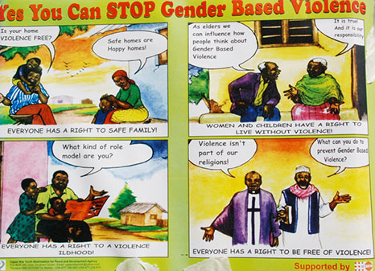

A national strategy to improve and strengthen work on GBV prevention with a focus on girls and boys is an important step towards eliminating GBV. The strategy should include spreading information and raising awareness among parents, teachers, religious and traditional leaders with the help of, among other things, male role models and statistics. For It is also noted that men and boys are integral parts of change and are often victims of the very same socio-cultural norms that create GBV. Men are often socialized to be violent and to commit acts of violence. The gender roles that both men and women are prescribed are deeply held and not easy to break. Men can be role models and allies. Men can be positive reflections of communities that value equality and those men who break the norm will need support.

While men usually have more agency than women in their lives, men’s decisions and behaviors are also profoundly shaped by rigid social and cultural expectations related to masculinity, as well as by power imbalances, which have costs for both of them and the women and girls in their lives.

Engaging men as partners in the fight against GBV allows men to challenge the negative gender stereotypes that are imposed on them as well. Often they internalize the expectations and attitudes at the cost of damage to them­selves and others. The notion of strength, for example, can lead to violent behaviour, but it can also find expression in protecting oneself and loved ones from experiencing abuse.

*Actions to prevent VAW, implemented with individuals, communities, organizations and societal structures and institutions through a coordinated, multi-sectoral approach*

* Adoption and enforcement of legislation, policies and organizational and institutional reforms to promote and protect the human rights of all women and girls, promote gender equality, ensure accountability for violence, and prohibit all forms of VAW.
* Advocacy to strengthen organizational, institutional and community commitments to prevent VAW, and to ensure that governments meet obligations to prevent VAW
* Formal and informal education to strengthen social norms against inequality, discrimination, disrespect and violence
* Mobilizing and engaging communities, and government, non-government and private sector organizations to strengthen structures, cultures and practices supportive of gender equality and non-violence.
* Engaging the media to support prevention including through the portrayal of respectful and equal relationships between women and men
* Professional development and training to strengthen skills to undertake activity to prevent VAW
* Leadership development among women and girls and nonviolent men and boys in communities and organizations
* Economic, social and political empowerment to build women’s and girls’ personal skills and resources, and to transform relations between men and women
* Individual skills development to enable action to prevent VAW, undertake positive parenting and establish respectful relationships and positive constructions of masculinities and femininities
* Mitigating the consequences of prior exposure to violence
* Collaborating with other policy settings to address issues of common concern (e.g. constitutional reforms, economic empowerment) (UN Women 2015)

The key role of men and boys in achieving gender equality emerged as an issue in international discussions in the 1990s, most notably at the 1994 International Conference on Population and Development (ICPD) in Cairo and the 1995 Fourth World Conference on Women in Beijing. It mentioned that: ‘Developing a holistic and multidisciplinary approach to the challenging task of promoting families, communities and States that are free of violence against women is necessary and achievable. Equality, partnership between women and men and respect for human dignity must permeate all stages of the socialization process’. (Beijing Platform for Action, Chapter IV.D., paragraph 119)

*Engaging men and boys from the United Nations perspective*

Equality between women and men is a fundamental principle of international law as established in the UN Charter. Achieving gender equality is a societal responsibility that must fully engage both men and women. The role of men and boys in promoting and realizing gender equality has, however, only been given significant attention during the past 20 years.

The Cairo Programme of Action (1994) and its 1999 review highlighted the need to encourage men to take responsibility with respect to child-rearing and housework, family life as well as parenthood and sexual and reproductive behaviour.

The Beijing Platform for Action (1995) restated the principle of shared power and responsibility; and argued that women’s concerns could only be addressed in partnership with men. It also identified priority areas for action: education and socialization of children, sexual and reproductive health, gender based violence, and balancing work and family responsibilities. (United Nations Beijing Declaration and Platform for Action, 1995)

The outcome of the 23rd Special Session of the UN General Assembly (2000) reaffirmed earlier commitments and noted obstacles to the implementation of critical areas of concern. For example, persistent gender stereotyping, unequal power relationships between women and men which hindered women’s ability to insist on safe and responsible sex practices, lack of communication and understanding between women and men on women’s health needs, were identified as areas where men needed to be engaged.

At its 48th session in 2009, the UN Commission on the Status of Women adopted agreed conclusions on “(t)he role of men and boys in achieving gender equality” that put forward a series of recommendations to ensure men’s involvement in efforts towards gender equality and the advancement of women:

* Promote reconciliation of work and family responsibilities;
* Encourage the active involvement of men and boys in eliminating gender stereotypes;
* Encourage men to participate in programmes designed to prevent and treat all forms of transmitted diseases;
* Design and implement programmes to enable men to adopt safe and responsible sexual and reproductive behaviour;
* Support men and boys to take an active part in the prevention and elimination of gender-based violence; and
* Implement programmes to accelerate socio-cultural change towards gender equality, especially through the upbringing and educational process (United Nations Commission on the Status of Women, 2009).

****Session Two: the inhibiting notions of masculinity/manhood**

*What is the meaning of being a man? Can men help to reduce violence? How?*

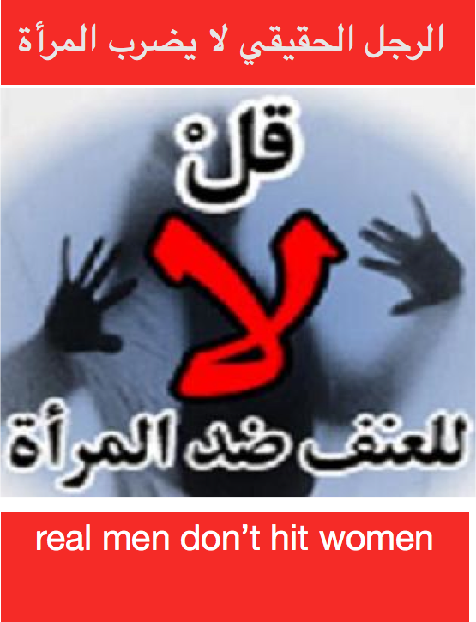Masculinity is often associated with characteristics such as aggressiveness, competitiveness, dominance, strength, courage and control. These characteristics result from a combination of biological, cultural and social influences, and relate to our understanding of power in society as a whole. Although it is difficult to determine the extent to which each of these factors has influenced current gender inequalities and causes of gender based violence, an understanding of all three provides a framework within which to challenge and change the status quo.

By focusing on masculinity, the concept of gender becomes visible to and relevant for men. It makes men more conscious of gender as something that affects their own lives as well as those of women, and is a first step towards challenging gender inequalities and eliminating violence against women.

Men’s violence is a key determinant of the inequities and inequalities of gender relations that both disempower and impoverish women. Violence is a fundamental dimension of human poverty. Yet, men’s ‘natural aggression’ is often invoked as a defining characteristic of an essential gender difference and as an explanation for gendered hierarchical arrangements in the political and economic contexts of richer and poorer countries alike.

It is suggested that changes in the economy, social structures, and household composition are resulting in ‘crises of masculinity’ in many parts of the world. The ‘demasculinizing’ effects of poverty and of economic and social change may be eroding men’s traditional roles as providers and limiting the availability of alternative, meaningful roles for men in families and communities. Men may consequently seek affirmation of their masculinity in other ways; for example through irresponsible sexual behavior or domestic violence.

The global economy and rising long-term male unemployment has changed men’s roles and challenged their identity as breadwinners. Parallel changes in women’s roles - increasing participation in the public arena and in paid work, and recognition of women’s human rights - are also challenging the traditional division of labour and models of femininity. Since femininity and masculinity are determined in tandem and to some extent in opposition, such changes in women’s roles also challenge concepts of masculinity.

By moving from biological determinist to cultural constructionist accounts of masculinity, a number of men’s anti-violence programmes have been able to work with violent men to help them understand the ways that structural pressures, cultural messages and/or parenting practices, have contributed to their socialization into violence.

Placing men’s violence in a historical and cultural context helps overcome the naturalizing of men’s violence, or what might be called the ‘masculinizing of violence’. It highlights the role that the ways in which we think about and discuss masculinity play in exploiting what is claimed to be men’s ‘natural’ aggression and militarism for specific political purposes.

Instead of just focusing on each case of violence or on individual men’s acts of violence against women, the entire culture that creates current male roles and identities – defined as ‘masculinity’ – needs to be analysed and challenged. This means recognizing the various pressures placed upon men that may result in violent reactions, as well as the need for men to take responsibility for their actions. Predominantly, gender power relations have left a legacy whereby women are more likely to be disadvantaged relative to men, have less access to resources, benefits, information and decision making, and to have fewer rights both within the household and in the public sphere. In the past, these concerns and the struggle for gender equality have often been narrowly perceived as “women’s issues,” and gender programmes

have been designed to focus only on women (UNIFEM).

*The negative costs of patriarchy to men:*

* Health Costs: shorter lives, higher suicide rate, disproportionate representation in stress related illness (heart disease, stroke), addictions, far greater chance of dying in an accident or homicide, more likely to be in jail;
* Emotional Costs: alienation from ourselves and others, mental health, depression, disconnection, conformity into traditional masculine stereotypes;
* Economic Costs: work longer, lower overall prosperity for society, pressure to provide; and
* Societal Costs: war, violence, crime, fear of other men.

*Benefits of gender equality for men:*

* Being trusted, better relationships, better health;
* Not being lumped into a stereotypical group of "men", not having to conform to negative aspects of masculinity;
* More freedom to pursue any activities in which they are interested; People men care about (mothers, sisters, girlfriends, aunts, etc.) have a lesser chance of being harmed by violence and other gender inequities;
* Not bullied by other men for stepping outside the gender “box”;
* Less pressure to be the sole provider and protector, more economic prosperity for all; and
* More opportunities to be close to your children (White Ribbon 2011)

*What can be done with men to challenge GBV*

* Analyze the various forms of masculinity; reveal the violent forms, and work towards changing them.
* Reveal and question the values promoting or glamorising violence – competition, hardness, insensitivity, idolising winners in war, sports and business life.
* Analyze and question male roles and ideals, the concept of “male honour” prevailing in male cultures.
* Develop and value fatherhood; develop the skills and qualities of fatherhood among men and boys.
* Integrate a gender perspective into school education to create awareness of the different positions of boys and girls within the family, in culture and reproduction, and to promote their development into balanced personalities and into men and women in a relationship of equality and mutual respect.
* Develop legislation on violence against women to criminalize gender violence in all forms and provide women with protection when facing violence or being threatened.
* Increase the number of shelters for women and support the work of shelters and counselling services.
* Help men to abandon their violent behaviour by establishing support and therapy services and providing appropriate therapies.
* Encourage men to establish their own groups and voluntary activities to combat men’s violence against women, and support such movements.
* Increase the proportion of women in politics, foreign policy and international decision-making.
* Promote and further secure equality between women and men both through legislative and administrative means and through changing public opinion and shaping attitudes and values, thus building a culture of equality and peace (UNIFEM).

*The fundamental question has shifted from “why” we should work with men and boys, to “how” we work with men and boys*.

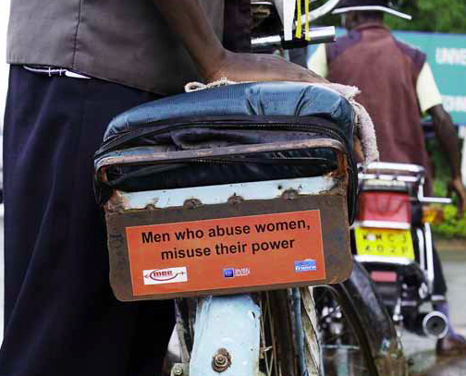

One of the most critical pieces for accelerating the pace of change is meaningfully engaging men and boys and thereby changing the power dynamics that drive masculinities. This calls for shifting our normative understanding of men’s role within the broader agenda for gender equality.

Engage men in the prevention of gender-based violence: Policies targeting gender-based violence should seek to change social norms and institutional cultures that perpetuate inequalities and violence. 200 Integrated and well formulated policies should include primary prevention targeting men and boys; Policies to engage men and boys in making public spaces free of violence for women and girls; programs for male perpetrators that are integrated with the judicial sector; and legal, financial and psychosocial supports for survivors of violence, both women and men. Given that men’s witnessing of violence is a key driver of their own use of it, policies should also provide for psychosocial support for boys who witness violence, to break the cycle (UNFPA 2014).

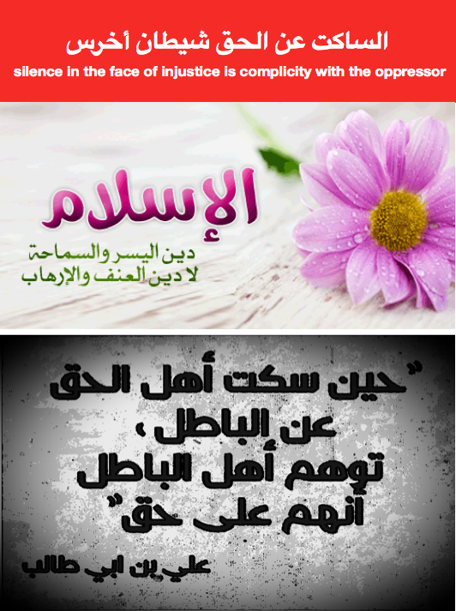1. Work with men and boys. As major perpetrators, the target audience for primary prevention, holders of the social norms and influencers on other men, men need to be engaged to reduce and prevent gender-based violence.

2. Work with men and boys can be effective. As the evidence base grows, evaluation data appears, lessons are learned, and best practices are shared, we know this may be the missing compliment to past decades of work.

3. Work with men and boys can have a positive, transformative impact for the lives of women and girls, but also for the lives of men and boys. There is a much broader spectrum of positive roles for men and boys to play than perpetrator or potential perpetrator of gender-based violence. These roles not only prevent and reduce violence against women, but also improve the lives of men and boys by freeing them from these harmful and limiting aspects of masculinities.

As a result, we can eliminate gender inequalities that hold back the development of our communities and nation, and ensure that women and girls men care about do not have to live a life in fear of violence (White Ribbon Campaign 2011).

**Session Three: breaking the cycle of violence: men & boys role to prevent GBV**

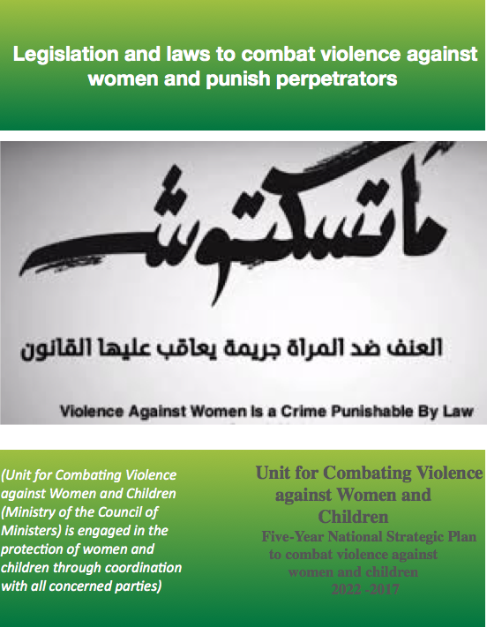**Exercise to begin of with: *(Ask the participants to stand in a circle and have a ball in your hand. Tell them that each one will say a word of what it means to be a man. You throw the ball to one of the participants and start. It doesn’t need to be in turns. After 90 seconds, do the same exercise again, but this time ‘What it means to be a woman’? The facilitator will write down the answers on a table on a flip chart, and will compare at the end of the exercise.*

Engaging men and boys in efforts to prevent and respond to GBV is critical for positively transforming harmful social norms that perpetuate gender inequality and for promoting the health and safety of women and girls. While some men and boys are perpetrators of GBV, others have the capacity to be partners, advocates and champions. They may be survivors themselves. Men and boys should also be consulted to ensure that services are appropriate to the needs of male survivors and to develop strategies to mitigate men and boys’ risk of experiencing GBV.

Efforts should be made to appeal to male leaders and gatekeepers, especially religious and community leaders, and to identify strategic allies for prevention of and response to GBV. Once positive male agents of change have been identified, they can model positive gender attitudes and behaviours, challenging discriminatory social norms. It is important to create environments within which men and boys feel comfortable and supported to step outside of traditional gender norms and practices. While gender roles and social norms that contribute to GBV are pervasive throughout the life cycle, young men and boys are sometimes easier to reach as partners in preventing GBV; in fact, they may be more open to gender equality messages or alternative notions of masculinity.

It is possible to retain a focus on women without marginalizing men. Male engagement must be viewed as an inclusive action towards violence prevention and response rather than a shifting of support and attention. This means that any effort to engage men and boys must address the roles of men and women as they relate to each other, as well as prevailing attitudes and behaviors toward males and females and their differential access to and control over resources based on gender roles. An emergency context may create new entry points at the individual, community or institutional level in which to work together to promote positive, non-violent interactions and foster collaboration (UNFPA 2015).

*What can be done to prevent GBV?*

**Break the silence**: Training and ongoing discussion can raise awareness and reduce reluctance to address the issue within teams and organizations. Be sure that voices of women are heard. Careful listening, empathy, and respect for their safety concerns will contribute to their security and empowerment.

Ensure safety. Humanitarian organizations should routinely assess gender security threats along with their other security protocols. Women should not be required to advocate strenuously for their own safety. It should be institutional policy to care for their security needs.

Zero tolerance. All organizations should make it clear in its written policies and protocols that there is zero tolerance for sexual harassment, gender discrimination, or other forms of GBV. Consequences for perpetrators should be immediate and severe.

Clear reporting guidelines. Guidelines for reporting should be accessible, clear, and communicated throughout the organization. The reporting process should ensure privacy, confidentiality, and absence of retaliation or other obstacles.

Identify local resources. Keep updated list of local medical, psychological, and legal providers who are specifically trained to be sensitive to issues of GBV.

Power & Authority: avoid an unequal gender distribution of power and authority in organizations and teams. The presence of women in leadership is one of the most effective tools in the fight against GBV.

*Identifying the costs of male privilege*

Male privilege has a negative cost not only for women, but also for men themselves. They are probably suffering in different ways even as they are enjoying the benefits that male privilege brings them. Men can pay a heavy price for the male privileges they enjoy. These privileges can cause disharmony among men, women, boys and girls and this affects development in homes, society and institutions.

|  |  |  |  |
| --- | --- | --- | --- |
| **Male Privilege** | **Costs for Men** | **Costs for Women** | **Changes observed** |
| • Carefree life  • No contribution to domestic chores  • Guaranteed inheritance  • High social value  • Minimal involvement in child bearing and rearing  • Control over and decision-making in use of resources  • Protector of the family /defender of the national  • Being served  • Favoritism in jobs  • Financial control  • Freedom to move, marry another wife  • Choose how many children you want  • Participate in community discussions | • Self-destruction  • Become dependent  • Stunted personal development  • Risk of transmitted infections  • Stress and strains, frustration  • Deprived of emotional attachment and lack of support in old age from children  • Live with guilt  • Alienation  • High mortality, low life expectancy  • Retaliation in later life by women  • Low self-esteem | • Stress  • Burdened with household feeding  • Stressed frustrated and at times become unfaithful  • Divorce leaving small children  • Poor sexual reproductive health  • Early death  • Early marriages by young girls running away from suffering at home  • Psychosocial problems | • Small change in the men  • Sharing some responsibilities  • Sharing domestic work  • More cooperative  • Share ideas with wives  • More understanding |

*Understanding Institutional Violence*

(Begin with analysis of power Look at conditions as well as behaviours Document the violence)

Mobilising men as activists to challenge GBV in institutional settings involves working to strengthen men’s consciousness of their own ability to make change (power within) as well as their capacity to take action (power to) together with others (power with). But it starts with developing a better understanding of violence as the use of power over a person or group of people (UNFPA 2012).

|  |  |  |  |
| --- | --- | --- | --- |
| **Power over** | **Power within** | **Power to** | **Power with** |
| The power that one person or group uses to control another person or group. This control might come from direct violence or more indirectly, such as from the community beliefs and practices that position men as superior to women. Using one’s power over another is injustice. | The strength that arises from inside ourselves when we recognize the equal ability within all of us to positively influence our own lives and community. By discovering the positive power within ourselves, we are compelled to address the negative uses of power that create injustice in our communities. | The belief, energy and actions that individuals and groups use to create positive change. Power to is when individuals proactively work to ensure that all community members enjoy the full spectrum of human rights, and are able to achieve their full potential. | The power felt when two or more people come together to do something that they could not do alone. Power with includes joining our power with individuals as well as groups to respond to injustice with positive energy and support. |

If violence is about ‘power over’, then GBV is about the use of power over an individual or group that is made possible by unjust ideas about gender and use of manpower. In nearly all societies, the dominant ideas about gender give men power over women and say that masculine is strong and the feminine weak. Men in general still have more political, economic and social power than women. Unjust and dominance can be analyzed at four different levels, in the ways in which:

|  |  |  |  |
| --- | --- | --- | --- |
| **Internally** | **Interpersonally** | **Institutionally** | **Ideologically** |
| Some women have adopted messages that provide justifications for men’s VAW. | Men use physical, sexual or emotional VAW because the system gives them the right. | Women are significantly under represented in parliaments and government ministries.  Women do most of the care work in families and communities but is not treated as real work in economic policy-making because it is unpaid.  Women do not receive equal pay for doing the same work as men. | Men’s greater political, economic and social power is seen as natural or normal;  Men are regarded as the breadwinners and women regarded as the homemakers. |

*Activism To End Violence Against Women*

Among the most visible and well-developed public efforts involving men’s activism toward gender equality have been campaigns and movements to end the use of VAW.

The White Ribbon Campaign (WRC) is one of the most widespread campaign led by men to end men’s violence against women. Started in 1991 by a group of men in Canada, WRC encourages men to wear white ribbons as an expression of their public opposition to men’s violence against women. WRC has since spread to more than 60 countries, using education, capacity-building, and media campaigns to reach and inspire men and boys to change.

The Men’s Action to Stop Violence Against Women (MASVAW) is a network of men and organizations working on gender issues, including gender-based violence, primarily in the north Indian state of Uttar Pradesh. Through workshops and advocacy campaigns, MASVAW raises awareness and recruits new activists who engage other men to bring about change. Since its founding in 2001, MASVAW has grown to include 500 individuals and nearly 200 organizations. (ABAAD in Lebanon organizes national media campaigns to engage men in questioning gender norms and ending violence against women).

**Session Four:**

*How can*

|  |  |
| --- | --- |
|  | Responding to opposing arguments: break into pairs and give each pair a statement, or saying or proverb, against women, and tell them to argue: e.g.  **Our culture has roles for men and women—and men are supposed to be decision-makers. Why are you trying to upset our culture?**  I am not trying to upset culture; I am just trying to make our communities and families healthier. Culture is meant to encourage healthy communities and maintain the communal bond through love, respect, and hard work. Culture should not condone violence. It has been proven that gender equality will lead to better health outcomes and stronger communities.  **Don’t have the financial resources for programs addressing GBV**  Interventions on GBV are not expensive. We need to get communities to start talking about gender-based violence. In addition, all projects need to integrate gender consciousness into their programming. It is time that we started taking into account the effect of gender expectations and relations on the outcomes of program activities. The health of our families and communities depends on it! |
|  | Introduce the activity by explaining that one of the main questions asked about men’s involvement in struggles for gender justice relates to men’s interests in challenging a system of gender power that in so many ways continues to benefit men - in short, ‘why should men change?’  Write up these six headings, one each on a separate piece of flip-chart paper and stick these papers up around the room:   * For the sake of the women, girls and boys in our lives * For our own sake, as men * For the sake of our community, and our society.   Break into six smaller groups, and have each group choose one of the flip-charts to work with. Ask each group to prepare a role play, showing one man talking to another man or group of men, using the reasons listed on the flip-chart, to persuade them of the importance of men challenging harmful norms and practices of masculinity and getting involved in struggles for gender justice.  Run the role plays, and after each role play, discuss with the following questions:   * What worked well in terms of trying to persuade other men to challenge harmful norms and practices of masculinity? * What did not work so well? * Why do you think this is? * What would work well in terms of talking to men in our communities about men’s interests in challenging harmful norms of masculinity? * As gender justice activists, what do we need to work on (knowledge? skills? confidence?) in order to do a good job of talking to men in our communities about men’s interests in changing harmful norms and practices of masculinity?   End the activity by summing up the discussion, highlighting the importance of holding out a positive vision for change in men’s individual lives, as well as for their community and the society as a whole, as being key to exploring men’s multiple interests in challenging harmful norms and practices of masculinity. |
| mage result for powerpoint presentation | Flipchart, coloured papers, felt pen and tape, case studies, and/or exercises. Some group work may require extra materials such as a ball or strings, |
|  | * It is important to become active bystanders and to oppose violence in the community * Men can play a critical role in setting a positive example for other men, by treating women and girls with respect and by challenging other men’s harmful attitudes and behaviours |
|  | UNFPA (2012) *Mobilising Men in Practice: Challenging sexual and gender-based violence in institutional settings, Tools, Stories, Lessons*  UNFPA (2014) *Men, Masculinities, and Changing Power: A Discussion Paper on Engaging Men in Gender Equality From Beijing 1995 to 2015*  White Ribbon Campaign Issue Brief (2011) *Engaging Men and Boys to Reduce and Prevent Gender-Based Violence* |

**Module Six: GBV Survivors Human Rights**

*The training on this module is intended to support GBV survivors, and women & girls who are at risk of GBV, by raising awareness on their human rights, as stated in the international conventions and national frameworks. It provides them with the means and approaches that should be adopted by them to demand and access justice and other needed services. The module also seeks to empower the survivors by exploring their needs and re-affirming their own inherent and internal strength, which will enable them to overcome the trauma of GBV experience.*

|  |  |
| --- | --- |
|  | *Ask the participants the following questions and facilitate a discussion:*   * *What do survivors say they want/need in terms of services?* * *What would help to encourage more survivors to seek support and services?* * *What interventions are needed to deal more effectively with perpetrators?* * *What changes in institutional practices and ‘culture’ would help to prevent GBV?* |
|  | *At the end of the session, participants will be able to:*   * *Identify the main terms related to GBV, VAW in a more contextual way* * *Understand the main steps to be taken to address GBV* * *Survivors need to access justice and the different factors related* * *Understand who to work with and how (campaign) to eliminate GBV* |
| 80 – 90 m | 20 – 30 minutes presentation;  20 minutes discussions, questions and answers,  20 minutes group work: *Identify the needs of women and girls survivors of GBV to overcome the trauma*  20 minutes presentation of the group work |
|  | *Survivor: Person who has experienced violence or other abuse. It highlights the gender dimension of these types of acts, i.e. the relationship between females’ subordinate status in society and their increased vulnerability to violence*  *Secondary Survivor: Person impacted by the experience of gender-based violence inflicted upon the survivor. May include family members or others close to the survivor.*  *Perpetrator: Person, group, or institution that directly inflicts or otherwise supports violence or other abuse inflicted on another against her/his will.* |
|  | Do not take the role of a psychology expert and do not act as a counsellor. Privately explain to any troubled participants that your role is a facilitator of the sessions. If you are familiar with support organizations that provide counselling services, you can refer them to such organizations,  The terms “victim” and “survivor” can be used interchangeably. “Victim” is a term often used in the legal and medical sectors. “Survivor” is the term generally preferred in the psychological and social support sectors because it implies resiliency.  It is important to note that men and boys may also experience gender-based violence, especially sexual violence. |

**Session One: GBV survivors and human rights**

*What rights should be claimed for GBV survivors?*

*Improve rights literacy of constituency*

Educating people about their rights in relation to GBV is an important strategy for Mobilizing Men partners. This involves improving people’s knowledge of their rights as well as their ability to claim their rights from responsible authorities and hold such authorities accountable for their failure to promote and protect such rights.

Important lessons that have emerged from this work include the following:

* *Making rights education accessible in ways that resonate with people’s lived experience:*International conventions on human rights, such as the Convention on the Elimination of All Forms of Discrimination Against Women, provide the foundation and framework for rights literacy work with campaign constituencies (those people who are most impacted by GBV). But such conventions, and the government authorities with the responsibility for upholding them, can seem very remote from people’s own lived experience. Mobilising Men partners sought to connect their rights literacy work with people’s own experience by creating specific educational materials using easy-to-understand language (as MEGEN did in relation to the Sexual Offences Act in Kenya), as well as by relating international human rights standards to local customs and practices relating to ethical conduct and notions of justice and fairness.
* *Focusing on skills as well as knowledge:* Crucially, Mobilising Men partners also used training activities with their affected constituencies to not only pass on information about rights, but to also strengthen people’s confidence and skills in being able to claim these rights, by using role plays and other experiential training methodologies.
* *Getting the support of powerful allies:* working with key stakeholders, such as local council officials and the police, to enlist them as allies and help promote an environment that is more conducive to upholding the rights of targeted constituencies,
* *Documenting and publicising rights abuses:* Rights literacy work will also be strengthened by careful documentation of rights abuses. This helps in reducing individuals’ sense of isolation when it comes to their experience of violence by reminding people that rights abuses are not isolated incidents but are widespread, and are enabled and enacted by the major institutions of society.
* *Working together as allies:* Women and men working as allies to seek change in institutional policy: Working as allies in struggles for gender equality and against SGBV is always important, but nowhere more so than in work to change institutional policy, whose decision making spaces are usually male-dominated. In this context, it is important that male activists model the change they would like to see in the world by not taking over the struggle from women or seeking to ‘protect’ women from ‘bad’ men, but rather working in relationships of equality and solidarity with women to argue for change in institutional policy.
* *Engage in the implementation of the National Strategic Plan to combat VAW:* The plan contains an action framework and activities that addresses five main themes: Good governance and rule of law; sustainable development; building institutional capacity; information management; and scientific research. Raise awareness among communities and get the support of men as leading agents of change in order to transform mind set and bring about behavior change amongst the communities with men being amongst the driving force in this process.

**Session Two: GBV survivors means and approach to access justice and services**

*What are GBVs survivors wins and risks when purchasing justice?*

The decision whether to pursue justice is an important one, and survivors need to have access to full information to think through such a decision. It is important for you to understand if what happened to the person is a crime within the legal framework of your setting, and if so, whether the person wants to take legal action.

Sometimes people working with GBV survivors assume that the person should report to the authorities because they think the perpetrator should be punished. While this may be what you want, you have to understand that there are great risks for a survivor in reporting to formal authorities. Often, responses from the police and legal systems can put the person at risk of harm from the perpetrator, family members or community. The process of taking legal action can also re-victimize the survivor. It may also take a long time and cost money.

Instead of pushing a survivor to make a decision, you should inform the person of their legal rights in this situation (if any) and provide them with information about what they can expect if they report to the police (i.e. who will interview them, who determines if it proceeds to court, what happens if you make a report and the police do not press charges) and what will happen if the matter proceeds to court (how much will it cost, how long it will take, what the survivor will need to do). Sharing accurate information about the likelihood that a case reported to the police will actually proceed to court and/or result in conviction is also important. This information will help the person analyse the benefits vs. costs or risks of reporting to the police.

Some organizations providing GBV case management services have found it helpful to have legal counsellors as part of their programme who can accurately explain legal options in a survivor-centred way. Supporting survivors to access legal services, including attorneys who can help them report and pursue their case, is important if that is the survivor’s wish.

*Other Protection Solutions and Services*

In some situations, survivors’ risk may be compounded by other protection issues, such as lack of documents, legal status or family separation. This is particularly likely in displacement settings. Bear in mind that some survivors may not know that services and support are available in these areas, and therefore may not raise all of the issues themselves. It is thus important to be aware of the issues that may affect those at risk of GBV in your context, and to ask survivors for the relevant information. For example, in a refugee setting, it could be important to ask whether a survivor is an asylum seeker or a recognized refugee, and what documentation they have, in order to understand what services are available to them.

* Documentation: In some cases, survivors may be lacking documents that can serve to protect them. This could range from individual identity documentation, civil documentation for themselves or their children, or proof of their legal status as an asylum seeker or a refugee. Supporting survivors to access such documentation can be essential to their protection, especially to avoid arrest or detention, or to access particular services and benefits. In some settings, this may involve helping survivors to approach relevant authorities or fill out necessary forms. In refugee settings, UNHCR can usually assist refugees and asylum seekers in obtaining documentation of their status in the country of asylum.
* Legal status: A person may have different access to health, accommodation and material support, legal, psychosocial, education, livelihoods and other services depending on their legal status in the country. In refugee settings, it may be possible to accelerate Refugee Status Determination (RSD) for particularly vulnerable individuals where this affects their access to protection and assistance. It is a good idea to coordinate with the national authorities responsible for RSD and/or the UNHCR in order understand which persons may be eligible for accelerated procedures.
* Re-establishing family links and family reunification: Where a survivor has been separated from family members, this can contribute to their vulnerability to GBV-related risks. Putting survivors in touch with organisations that can help them to find, contact and potentially reunite with husbands, wives, children, parents or other loved ones can be critical to their safety and well-being. In displacement and disaster settings, the International Committee of the Red Cross and National Red Cross and Red Crescent Societies will typically provide these types of services, and, in displacement settings
* Durable solutions: UNHCR has a mandate to identify durable solutions for refugees, including local integration, voluntary repatriation and resettlement to third countries. Depending on the context, survivors may have access to prioritized assistance to access particular durable solutions. Many survivors experience GBV-related risks as a direct consequence of their displacement, for example due to continuing security risks in the host area. Coordinating with UNHCR on durable solutions for refugees and appropriate referrals can be an important part of ensuring survivors’ safety (UNICEF 2014).

**Session Three: empowerment of GBV survivors to overcome trauma**

**

*What empowering factors do GBV survivors need to enhance their resilience?*

*One-stop services*

It is important to ensure that, while recovering from the physical and mental trauma of GBV, survivors do not become subjected to taunts and isolation by their community. It is unfortunately a common case that survivors of GBV frequently face unfair reprisals and stigma, and many cases are unreported because they are thought to bring shame to a survivor’s family.

Those who are too afraid or ashamed to seek help do not receive the quality, confidential medical care they need for long-term recovery. As mentioned earlier, GBV survivors need holistic set of essential services including access to medical care, psychosocial support, economic reintegration, vocational and literacy training, and support for legal reform. They need emotional support and a recovery plan developed by psychosocial specialists.

It is essential to advocate to change how the legal system responds to GBV survivors and ensure that police force respects legal protections.

Efforts to destigmatize gender-based violence also work to empower survivors by helping them to develop new skills that help them to express themselves.

|  |
| --- |
| **Comprehensive and Coordinated Response for GBV Survivors**  Coordinated response models, or “one-stop” services represent a promising model for providing comprehensive care to survivors of gender-based violence, offering medical, legal and psychosocial services either within one location—a hospital or a stand-alone center—or through a referral system that links services. The main aim of the coordinated response model is to increase survivor safety and perpetrator accountability by coordinating and linking core services, including providing immediate to longer term health care, access to police and legal services, and culturally and age appropriate counseling services. Although one-stop models are used in regions across the world, they are becoming an increasingly popular approach for addressing gender-based violence, particularly sexual violence, in Southern and Eastern Africa, with South Africa and Kenya leading the way.  One-stop models can be located in hospitals or as stand-alone sites. In South Africa, the Thohoyandou Victim Empowerment Programme (TVEP) established trauma centers adjoining hospitals, offering 24-hour medical and legal services, as well as on-site safe houses. Other models may actually entail more than “one-stop”, in that all services may not be located in the same facility, but are rather linked through referrals. Most commonly, medical and counseling services for survivors of sexual violence are provided within hospitals, and referrals are made to police (e.g., special victim units), legal services and shelters (e.g., South Africa’s Tintswalo Hospital and Kamuzu Central Hospital in Malawi). Some models have also piloted the feasibility of providing some immediate medical care at other service points of entry to improve response, such as Zambia’s Copperbelt Model of Comprehensive Care (CMIC), in which police provided emergency contraception to survivors and accompanied them to the hospital for further care.  (Care Gender & Empowerment, *One-Stop Model Of Support For Survivors Of Gender-Based Violence: Lessons From Care Zambia*) |

**Session Four: States role in preventing Human Rights violations**

*Ask participants what is the states commitment to prevent violations of Human Rights?*

There is a strong normative framework obliging governments to take comprehensive, strategic and well-resourced action to prevent VAW using a human rights-based approach. While all human rights instruments apply equally to women and men, some key documents that are specifically relevant to women’s right to live free from violence or the threat of violence.

Some basic foundations for the States to prevent Human Rights violation are as follow:

* State’s commitment to gender equality, accountability for violence and prevention;
* Awareness of VAW as a human rights violation and of the extent, consequences and causes of VAW and the place of prevention;
* Cross-sector partnerships and collaboration;
* Adequate resources (allocation of budgets, allocation of human resources and capacity strengthening to address VAW);
* Tools, knowledge and skills to support prevention;
* Multi-sectoral planning and coordination mechanisms at the organizational, national and community levels;
* Strong leadership by government, and increased funding and support to civil society, especially women’s organizations, and engagement of other non-government and private sector institutions.
* Systems for monitoring and evaluating, building the evidence base and sharing lessons learned.
* Linkages between the response and prevention systems to ensure a comprehensive and consistent approach;
* Strong legislation that prohibits VAW that is implemented through an accessible and effective legal system;

|  |  |  |  |  |  |  |  |  |  |
| --- | --- | --- | --- | --- | --- | --- | --- | --- | --- |
|  | *Identify the needs of women and girls survivors of GBV to overcome the trauma*   |  |  |  |  | | --- | --- | --- | --- | | Protection | Response | Rights | ? | |  |  |  |  | |
| mage result for powerpoint presentation | Flipchart, coloured papers, felt pen and tape, case studies, and/or exercises. Some group work may require extra materials such as a ball or strings, |
| to recap: | * GBV can cause bodily harm, psychological trauma, and economic breakdown. * The issue of gender-based violence is one that affects the entire community when it happens and everyone has a role to play in creating a supportive, safe, and peaceful environment for women, children, men and families. * Everyone has the power to speak out against violence. By creating these messages today, you have played an important role in taking action against gender-based violence. |
|  | UN Women (2015) *A Framework to Underpin Action To Prevent Violence Against Women* – ILO, UNDP, UNESCO, UNFPA, UNHROHC |

**Module Seven: developing IEC materials**

*The training on this module is intended to support Implementing partners and relevant stakeholders on how to develop IEC materials to use in delivering training on issues related to GBV and women’s access to justice.*

|  |  |
| --- | --- |
|  | *Ask the participants the following questions and facilitate a discussion:*   * *What are IEC materials? Why develop them?* * *Where do we use them? And for whom?* * *Why are they helpful in addressing the GBV issues?* |
|  | *At the end of the session, participants will be able to:*   * *Understand the importance of IEC to combat GBV* * *Develop effective prevention messages* * *End the stigma of talking about gender-based violence by writing about it and interviewing law enforcement professionals, medical personnel, experts, perpetrators, survivors and victims* |
| 90 - 100 | 20 – 30 minutes presentation;  20 minutes discussions, questions and answers,  30 minutes group work: *develop your advocacy messages on GBV prevention*  20 minutes presentation of the group work |
|  | *A communication channel is simply a means of communication, or a medium for communication.* |
|  | *Slogans and messages about GBV prevention are a powerful way to convey an important message in a short but memorable way (for example, ‘Stay Strong! Speak up against gender-based violence!” or “Violence is EVERYONE’s problem!”). They are also effective tools to initiate dialogue among people. Work with local artists.*  *Developing the right message is nearly half of the work. The other half is selecting the right communication channel(s) and the right messenger so that your audience receives the message.* |

**Session One: developing IEC materials for IPs and stakeholders training**

*Which is the best method to use to advocate for GBV issues, why?*

IEC materials are used as conversation triggers. Pictures/ images tend to work best, but sound can also be utilized depending on the situation (e.g. playing a radio ad using one’s phone as a trigger to start a conversation with a group of 10 people or less)

The aim of an IEC material is to help define team define their strategy:

* Which topics to focus their activities,
* With which groups in society,
* Which attitudes could be a barrier to behaviour change, therefore needing methodologies that address attitudes,
* Through which channel each group could be addressed.
* To have a baseline to measure any increase in knowledge

**Developing Communication Channels in Humanitarian Settings**

In humanitarian settings, where the emergency extends over a large geographic area, local coordination mechanisms should work through regional coordination mechanisms to share information with the national coordination mechanism and vice versa. Regional coordination mechanisms should also foster cross-communication amongst themselves. If regional coordination mechanisms do not exist, strategies should be developed to facilitate direct communication between national and local coordination bodies and to build communication across local coordination bodies. National coordination bodies must take into account local actors’ capacity to access internet; where internet and/or computers are limited, regular communication should be facilitated through scheduled telephone contact and information-sharing through hard-copy updates. The GBV coordination mechanism should ensure constant communication and monitoring of sectoral activities. Communication tools include community-wide or targeted information campaigns. They are used to ensure that the targeted population receive the information they need, in a comprehensive way that allows them to make practical decisions.

***Community mobilization*** aims at raising awareness, empower the community, and build community capacity to address the GBV related issues. Its target groups include the general public, and specific target groups (Government managers, NGOs, police, legal staff, donors…). There are several approaches to target community including:

**Community Health Fair:** A community health fair is a community event aimed at provision of educational information and services to promote health.

It is usually held in an *open space* surrounded by or is near a residential area. There should be sections/ desks/ tents or *bandas* allocated to varied partners for health services (e.g. voluntary counseling and testing, family planning options, condom distribution etc.) and for conducting one-on-one or small-group discussions related to GBV. A community health fair is important as an avenue for community members to access health information and services at their local environment. Send out invitations through community leaders, media houses, posters ...

**Community Health Talks/Peer Outreach**

Reaching out to groups of people (e.g. women’s groups, teachers, men’s groups) to enable a variety of interesting and informative talks on health issues. Invite health professionals to talk about how violence relates to negative health outcomes. During the talk, facilitators are able to respond to emerging questions and thus are one of the potentially powerful communication channels for facilitation of behavior change given their interpersonal and interactive nature.

**Concert**: A concert is an event where an individual musician or a group of musicians.

Concerts are important for project advocacy and provision of intended health information and services at once to the wider audience while offering individual services and counseling. In this case, the performances could be used to convey particular messages about GBV or to draw people to an event such as a health fair, where information and services can be accessed concurrently. Concerts can also be used to mobilize funds for response to a public health issue, e.g., a women’s shelter.

**Dramas:** A drama is a play or act performed by performers before an audience that assumes collaborative modes of production and a collective form of reception.

Dramas can employ dialogue, combine with music and/or dance, or be a silent drama that requires participants to observe the actors actions closely. Dramas are an entertaining, and sometimes provocative, way to share a message with community members. Preparation includes having a uniform message (e.g. Violence is everyone’s problem). Dramas should concentrate on positive messages and emphasize love, peace and harmony among community members.

**Marches/Rallies linked to Gender-Based Violence and HIV:** Marches and rallies are events whereby people are organized to portray a message by demonstrating as a group moving together along a route.

Rallies or marches work best when planned for a particular day (e.g. International Women’s Day) if the theme is relevant or when campaigning for an inevitable change in policy/law. Preparation includes having a uniform message (e.g. Violence is everyone’s problem), preferably printed on banners or other IEC materials that can be handed out.

**Mobile Video Shows**

Video drama with a strong story line and powerful messages can be recorded and used to elicit discussion on important aspects of gender-based violence. At the end, IEC materials with gender-based violence messages can be handed out to participants.

**Painting Murals:** A mural is a painting completed on a wall, that is usually designed to inform, stimulate reflection or discussion, or pass on specific messages.

They have also proved to be an effective tool in initiating dialogue among people, especially when placed in high-traffic areas. Ideas for depicted images/ messages could relate to what GBV means to community members, their vision of life without GBV, consequences of GBV etc. Care should be taken not to focus on negative messages and to also consult experts in the area of health promotion and behavior change for best results.

**Sports Events**

The popularity of sports among men makes this a powerful medium for engaging them and could also be an opportunity to conduct activities and disseminate messages related to GBV prevention. Key and relevant messages could be easily weaved into the positive aspects of the sport – physical fitness, leadership, teamwork, accountability and prompt action. In addition, if budget allows, equipment could also be printed with GBV prevention messages (e.g. Violence is everyone’s problem). During any sports related activity, the targets for GBV messages could be the players themselves and their coaches/ support staff, the onlookers/ supporters or both. Half-time and breaks could be used to play GBV radio ads and songs as well as conduct activities using various suggested materials as triggers. Sports stars are looked at as role models. They can thus be useful in promoting GBV prevention and response messages in the community.

****Session Two: The importance of Communication skills for GBV training**

*What is good communication? How do you develop a communication plan?*

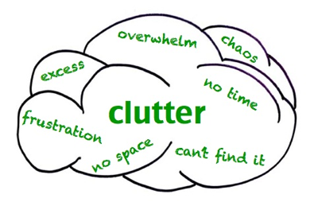Good communication cuts through the clutter, it doesn’t add to it. It does this by getting the right message, in the right medium, delivered by the right messengers, to the right audience.

Communications is about competence — and really, common sense in communications. Communication is not an end. It can be a powerful means to changing hearts and minds and changing votes. We live in the information age and negotiating our time and place in history requires good communications. (Kristen Wolf of FENTON)

What is Communication? Why is it important in training?

Communication is the process of transmitting ideas and information. For the trainer, that means conveying the true nature of your organization and the message it wants to convey, the issues it deals with, and its accomplishments to the targeted groups. Communication can take many forms, including:

* Word of mouth
* News stories in both print and power point presentation
* Handouts, concept notes, and instructions
* Visual and audio
* Outreach and presentations to other relevant organizations
* The workshop it self,
* Reaching out to the targeted unions, organizations, government institutions, and factories

To communicate effectively, it helps to plan out what you want from your communication, and what you need to do to get it. Different partners and beneficiaries require different approaches of communication strategy.

**Why develop a plan for Communication?**

* A plan will make it possible to target your communication accurately. It gives you a structure to determine whom you need to reach and how.
* A plan can be long-term, helping you map out how to raise your profile and refine your image in the community over time.
* A plan will make your communication efforts more efficient, effective, and lasting.
* A plan makes everything easier. If you spend some time planning at the beginning of an effort, you can save a great deal of time later on, because you know exactly what you should be doing at any point in the process.

**Steps to Plan for Communication**

Planning is a way to organize actions that will lead to the fulfilment of a goal. Your goal in this case is to raise awareness on the ‘overall’ benefit of women’s economic participation.

To develop a plan for communication, the following basic questions must be answered:

* What is the purpose of communicating with the ‘factories’?
* To whom do you want to communicate?  Who’s your audience?
* What is the message you want to communicate?
* How do you want to communicate it?  **(What communication channels will you use?)**
* Whom should you contact and what should you do in order to use those channels?  **(How will you actually distribute your message?)**
* How can we ensure that we get feedback from the audience? What will we do with the feedback?

To ensure that a gender perspective in communicating policy, i.e. both men and women are included, we consider the following:

* The message should address both women and men
* The design of any communication strategy must have a positive impact on both women and men
* Both men and women should participate, and from the beginning in the development of the communication strategy
* The different needs of women and men should be taken into consideration instead of assuming that they need the same messages all the time

**The main communication challenges you face are usually related to:**

* Trying to motivate and mobilize the target group that is too often stressed out, over extended, even apathetic.
* Even interested and well-meaning people are cynical, confused and difficult to reach. Public opinion is not easily moved.
* Marketing your ideas by focusing on the success factors that you focus on as a trainer and which include having: Tremendous public trust; Credibility; Inspiring issues; and Strong record.

**Third Session: Developing a Communications Plan to Address GBV**



*How do you ensure that you convey your message to address GBV in adequate matter? What steps do you ensure to take?*

*Getting the Right Messages Across in the Right Way*

The first step is to put yourself in the shoes of your audience. What do they need to know, and want to hear? What's their preferred way of receiving information? What will stop them listening to what you have to say? And how will you know that they have got the message?

So there's quite a bit more to good communications than preparing a good memo or presentation! This tool will help you through the preparation steps and so help you create an audience-focused communication plan that's sure to get your message heard.

To answer the questions, the following steps help to create a good communication plan for your association.

*Step 1. Be clear about your overall communication objectives.*

Ask the question: What do you want to achieve, when and why? Record the overall objectives in the plan. You can use a Communications Planning Template as the follow for example:

|  |  |  |  |  |  |  |
| --- | --- | --- | --- | --- | --- | --- |
| **Communications Plan For highlighting the impact of GBV on the economic destruction of a society** | | | | | | |
| **Overall Communication Objective: the different factors and negative long term impact of GBV on the society** | | | | | | |
| **Audience** | **Objectives** | **Message** | **Channel** | **Timing** | **Partners** | **What else?** |
| Ministries (social affairs, economy, education…)  NGOs working on GBV and economic empowerment | To reveal how the prevalence of GBV has an extended negative impact on society it includes economic recession | GBV is the main cause to a destructive society | TV, radio, posters, interactive theatre, talks, show, | Int. Labour Day,  Int. VAW Day | Relevant Gov. bodies;  Local NGOs,  Academics to do research | Use both qualitative and quantitative evidence based indicators for best results |

Note: This case also be used as a group work exercise

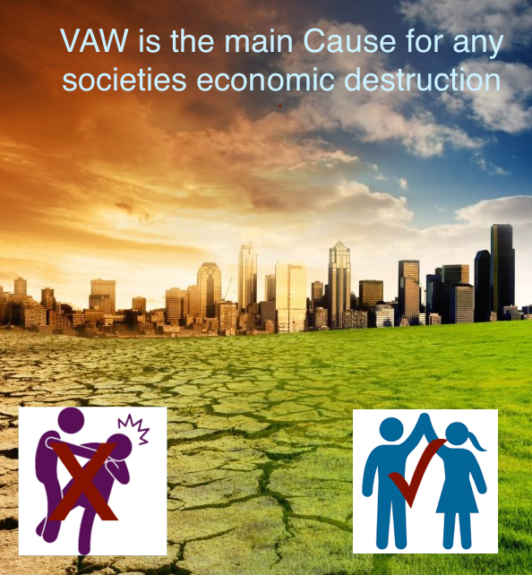What you want to say depends on what you’re trying to accomplish with your communication strategy. It may include one or a combination of the following:

* Becoming known, or better known, in the community
* Educating the public about the issue your association addresses
* Recruiting volunteers to help with your work
* Rallying supporters or the general public to action for your cause
* Announcing events
* Celebrating successes
* Raising money to fund your work

*Step 2. Identify and list your different target audiences.*

Who are you trying to reach? Knowing who your audience is makes it possible to plan your communication logically. You’ll need different messages for different groups, and you’ll need different channels and methods to reach each of those groups. You can group people according to a number of characteristics: Demographics. Geography. Employment.

*Step 3. Write down possible communications channels you know you could use.*

Think broadly and creatively! You probably already use lots of great ways to communicate in your association, and some new ones may help get your message across. Here is a list to get you started:

Email Newsletter Posters Lunchtime meeting Intranet article

Launch event Team meeting intranet

Fliers and brochures Promotional materials Comic books

Reading material Internet sites Letters to the Editor

Press releases Presentations national conferences, Fairs Music Exhibits Public art Movies TV Interactive theatre

*Step 4. One message may not be enough, so: Plan out the message for each audience,*

Start by thinking about the broadest audience groups first. As you consider each audience in turn, ask the following questions:

What does the audience need and want to know?

When do we need to communicate?

What is the regular or preferred channel for reaching this audience?

For this specific audience and message, what is the most effective way to get your message across?

Several messages over time may be required to meet the objectives of each audience. Therefore, make sure the messages you plan "add up" to meet the audience's objectives.

*Step 5. Get feedback on the communications you have planned and implemented.*

Ask people from different audiences how you are doing. Check they understand the messages you need them to hear. By getting timely feedback, you can tune any future communications that you have planned to better meet people's needs or fill any gaps so far.

*Step 6. Consider what emotions you want to appeal to.*

When creating your message, consider content, mood, language, and design. Are you trying to change people’s minds, behaviour, attitude, or are you bringing them to the next level of understanding? Hence, you should craft your message with your audience in mind; planning the content of your message is necessary to make it effective.

The mood of your message will do a good deal to determine how people react to it. Keeping your tone positive will usually reach more people.

Speak in a serious yet friendly tone

*Step 7. The use of financial and human resources*

Determine how much you can spend and how much staff and volunteer time it’s reasonable to use. Also determine if you are able to use the services from individuals, businesses, other associations, organizations, and institutions.

*Step 8. Anticipate obstacles and emergencies*

Crisis planning should be part of any communication plan, so you’ll know exactly what to do when a problem or crisis occurs. Crisis plans should include who takes responsibility for what, dealing with the media, correcting errors, deciding when something has to be redone rather than fixed, etc.

*Step 9. Plan and strategize how to connect with the media to spread the message*

Build strong working relationships with individual media representatives, influential individuals and institutions you’re trying to reach, and keep communication channels open. The individuals that can help spread your message can vary from formal community leaders, CEOs of local, businesses, decision-makers, etc. – to community activists and citizens.

*Step 10. Monitor and evaluate your communication plan*

If you evaluate your communication plan in terms of both how well you carry it out and how well it works, you’ll be able to make changes to improve it. It will keep getting more effective each time you implement it.

*Principles of Advocacy communication*

* Communicate core messages with a clear call to action that motivates and inspires stakeholders to get involved;
* Personalize your story and make emotional connections; especially if you are targeting vulnerable women
* Engage in two-way communication with stakeholders; establish a web portal with discussion forums to share best practices
* Listen to both the positive and negative feedback, and make sure you respond to questions, criticism and be moderate about praises…
* Where you hold your meeting is very important, not 5 stars hotels, but rather a ward for orphanage children (e.g.)

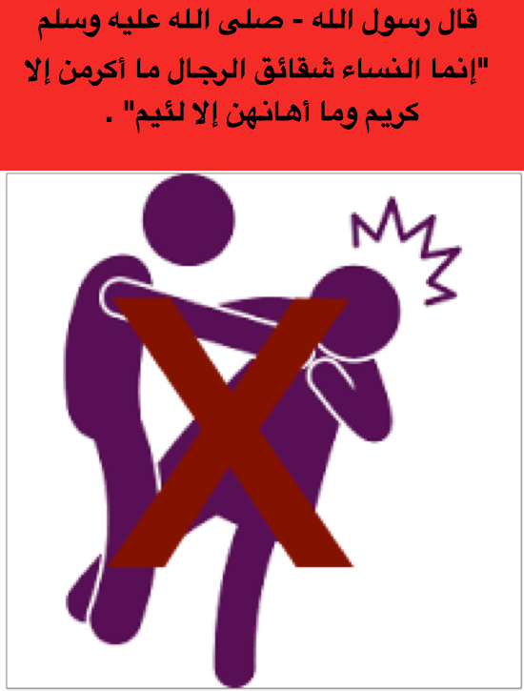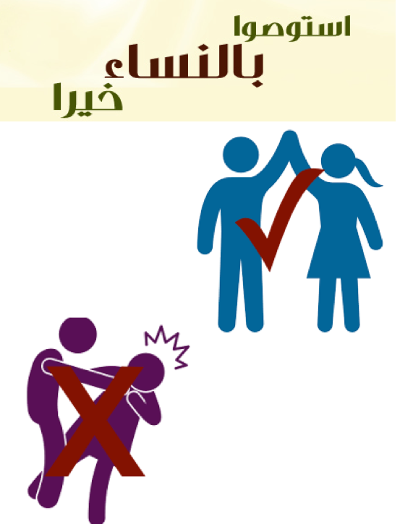

**Session Four: Considering different IEC materials to address GBV**

*Facilitator presents facts and statistics on gender-based violence in the country of training and engages participants in a discussion focusing on reported prevalence of various types of gender-based violence. They examine media coverage of GBV and use it to guide the discussion and analyse it.*

Awareness raising on GBV rely on a variety of well designed and effective IEC materials to help ensure success. From experience, certain fundamentals pertaining to the development of IEC materials are obvious. Every brochure, poster, videotape or other piece of IEC material is the product of a decision, supported by research, to deal with a specific GBV concern, and to be well received and persuasive among a specific audience.

The success and impact of IEC materials depends largely on the understanding of the target audience by the IEC material design team. Working with target audience members throughout the development of IEC materials, and in developing usage strategies for those materials, helps ensure that IEC materials meet the needs of the intended target audience.

There is a straight six-step approach for developing IEC materials (IEC Material Production Guidelines):

* Select the most appropriate IEC materials based on an understanding of the strengths and limitations of different materials;
* Know your target audience;
* Use specific criteria, and a mix of different materials for more impact
* Develop a creative brief,
* Prepare draft and conduct a pretest
* Monitor the use and impact of IEC materials

GBV has presented particular challenges to the media. The silence surrounding these issues contributes to lack of information among the media and a general to hesitancy to exposing important issues of gender-based violence. The media has the potential to play a lead role in changing perceptions of gender-based violence that in turn can help galvanize a move for change. The session attempts to develop tools for media representatives to address some of the issues that may arise when reporting on GBV.

|  |  |
| --- | --- |
|  | (Each group) must develop their own advocacy messages on GBV prevention. Keep in mind the following:   1. Consider what you want to achieve with the message 2. Messages should be designed to inform, stimulate reflection or discussion, or pass on specific messages. 3. Keep messages clear and simple 4. Think about your target audience (e.g. men versus women or both) and use different messages for different audiences 5. Messages should not be offensive and should not promote violence or mob justice in any way 6. Messages should not be confrontational or accusatory 7. Care should be taken not to focus on negative messages   Each group will read out their message to the other groups for general discussion and feedback.  The groups should vote to select the best message, and explain why the message was selected. |
|  | 1. Role Play: Facilitator divides the participants into smaller groups and distributes role-play scenarios on a specific incident(s) of gender-based violence, so that each group has to role play a different scenario. Facilitator assigns roles to the participants (for example, reporters, survivors, perpetrators and other sources [i.e. police, NGO staff, prosecutors, judges, lawyers, doctors, family]) and gives the participants 35 minutes to prepare the role-play. *Prepare the role-play scenarios beforehand and write them down on sheets of colored paper* 2. After 35 minutes, small groups act out their respective role-plays. Discussion in a larger group follows. |
| mage result for powerpoint presentation | Flipchart, coloured papers, markers, felt pen and tape, case studies, and/or exercises. Some group work may require extra materials such as a ball or strings, |
|  | Recapping of main points raised, clarifying remaining questions and summarizing the main three to five key points learned during the session |
|  |  |

**References**

GBV AoR (2011) *Handbook for Coordinating GBV in Humanitarian Settings*

Global Protection Cluster (2014) *Gender-based Violence in Emergencies, Advocacy Handbook*

IASC (2006) *Women, Girls, Boys and men, Different needs – Equal Opportunities*; Inter-Agency Standing Committee, Gender Handbook in Humanitarian Action; Interagency Standing Committee (ISAC)

IASC (2005), *The Guidelines for Gender-based Violence Interventions in Humanitarian Settings*

ICRC (2009) *Professional Standards for Protection Work: Carried out by Humanitarian and Human Rights Actors in Armed Conflict and Other Situations of Violence*; International Commission of the Red Cross and Red Crescent (ICRC)

Interagency Standing Committee (2015) *Guidelines for Integrating Gender-based Violence Intervention in Humanitarian Action*, Geneva, IASC

International Federation of Red Cross and Red Crescent Societies (2015), ‘*Sexual and gender-based violence: A two-day psychological training*’; Training guide, Psychological Center

SaferWorld (2010) *Addressing Violence Against Women in Security and Justice Programmes*, Briefing – SaferWorld: Working to Prevent Violent Conflict

UNFPA (November 2015) *Minimum Standards for Prevention and Response to Gender-Based*

*Violence in Emergencies*

UNFPA (2010) *Building Survivor Centered Responses Training Pack*; United Nations Population Fund (UNFPA)

UNFPA (2008), *Managing Gender-based Violence Programmes in Emergencies, E-Learning Companion Guide*

UNHCR (2003) *Sexual and gender-based violence against refugees, returnees, and internally displaced persons: guidelines for prevention and response*, United Nations High Commission on Refugees (UNHCR)

USAID (2017) *Interagency Gender-based Violence Case Management Guidelines*; Providing Care and Case Management Services to Gender-Based Violence Survivors in Humanitarian Settings – First Edition. USAID, GBV IMS, Primero, International Rescue Committee, International Medical Corps, UNHCR, UNFPA

USAID (2013) *Community Dialogues on Gender-Based Violence: Facilitator Guide*; ‘Pamoja Tuwalee’ World Education, Inc./ Bantwana Initiative

1. Fostering Resilience: Protective Agents, Resources, and Mechanisms for Adolescent Refugees’ Psychosocial Well-Being - Stevan Merrill Weine, M.D.,1,* Norma Ware, Ph.D.,2 Leonce Hakizimana, B.A., Toni Tugenberg, M.S.W.,2 Madeleine Currie, Ed.D.,2 Gonwo Dahnweih, M.S.W.,1 Maureen Wagner, M.A.,2 Chloe Polutnik, M.P.H,1 and Jacqueline Wulu, M.S. (<https://www.ncbi.nlm.nih.gov/pmc/articles/PMC4274391/>)
2. Resilience and vulnerability among refugee children of traumatized and non-traumatized parents

   Atia Daud, corresponding author1 Britt af Klinteberg, and Per-Anders Rydelius <https://www.ncbi.nlm.nih.gov/pmc/articles/PMC2292147/>
3. United Nations and Partners Humanitarian Response for Syrian Refugees in Jordan; Inter-Agency Task Force (IATF) Basic Needs Sector Gender Analysis Report, May 2017
4. Hutchinson, Mary and Pat Dorsett (2012), What does the literature say about resilience in refugee people? Implications for practice – Journal of Social Inclusion , Griffith University
5. 3RP (Regional Refugee Resilience Plan) Turkey Monthly Updates.

   https://data.unhcr.org/syrianrefugees/documents.php?page=1&view=grid&Org%5B%5D=25
6. 3RP (Regional Refugee Resilience Plan) Turkey Monthly Updates, July 2016.

   http://reliefweb.int/sites/reliefweb.int/files/resources/TurkeyHealth3RPDashboard2016JulyCompiledVer02.pdf
7. Directorate General For Internal Policies - Policy Department A: Economic And Scientific Policy - Turkey: Labour Market Integration And Social Inclusion Of Refugees – Study – Dec. 2016
8. Lenette, Caroline, Mark Brough, Leonie Cox (September 2013) *Everyday resilience: Narratives of single refugee women with children* Available from: <https://www.researchgate.net/publication/258182537_Everyday_resilience_Narratives_of_single_refugee_women_with_children> .
9. <http://turkey.unfpa.org/en/news/women-tracing-light-hope>
10. (Beijing Declaration, Platform for Action, E.131, E133, E134…U.N. Doc. A/CONF.177/20, Oct. 17, 1995; 35 I.L.M. 401 (1996) at Appendix II)
11. United Nations International Research and Training Institute for the Advancement of Women, Women and Armed Conflict: New Challenges, Beijing at 10: Putting Policy into Practice (2004)
12. Meeting with ILO Staff at SADA (14 Feb.) Gaziantep
13. Meeting with ILO Staff in Ankara (17 Feb)
14. During the UNHCR Case Management Group Meeting (Gaziantep 13 Feb.) and meeting with Gökçe Saraydın, UNHCR Ankara (21 Feb).
15. Meeting with Onyango Makogango – WFP (Wed. 21 Feb. Ankara)
16. Meeting Bora Özbek, UNFPA, Ankara (17 Feb), attending the SGBV sub working group meeting (14 Feb) Gaziantep
17. Meeting with Dr. Serap Sener (WHO), Wed. 21 Feb. 2018
18. Meeting with Gökçe Bayrakçeken – UNDP (22 Feb) Ankara
19. Meeting with Pınar Öktem – UNICEF (22 Feb) Ankara
20. Meeting with CATOM, discussing services provided to refugee women (14 Feb) Gaziantep,